GREAT READING ADVENTURE PRESS RELEASE

Wallace and Gromit join the UK’s biggest ever reading adventure

Embargoed to 00.01 Thursday 10 November 2005
Bristol-based celebrities Wallace and Gromit are taking time out from tracking down the Were-rabbit to promote the Brunel 200 Great Reading Adventure it was announced today.

The Great Reading Adventure, in which everyone across the South West will be encouraged to read Jules Verne’s Around the World in Eighty Days, runs from 5 January 2006 for 80 days. Wallace and Gromit – who are big fans of the book and reading generally – lead the campaign. A full-text edition of the novel published in the Oxford World’s Classics’ series will feature the charismatic characters on the cover and they will also appear all over the region on posters and other promotional material.
Project director, Andrew Kelly, welcomed Wallace and Gromit’s contribution to the project:

It’s great to have Wallace and Gromit back supporting the Great Reading Adventure, especially at such a busy time.
The Great Reading Adventure aims to bring the people of the South West together through the joy of reading. In addition to the tens of thousands of copies of the book distributed free of charge, readers will be able to obtain a fully illustrated guide, which provides the history of the book and author. And all ages can take part with a specially written and illustrated children’s version available.

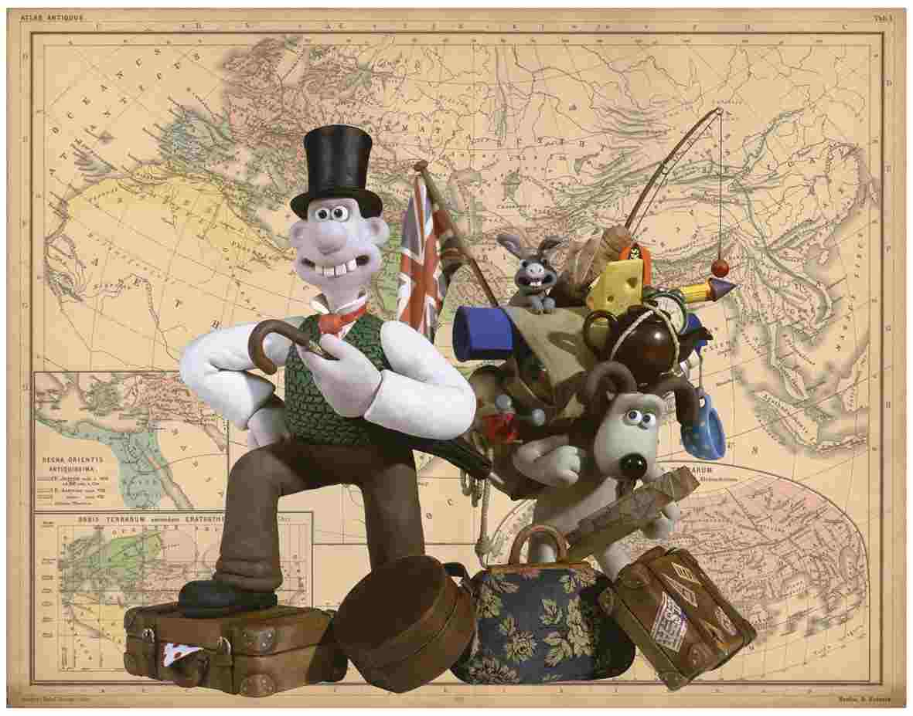
ENDS

Contacts
Andrew Kelly +44 (0)1275 370816
Mobile: 07778 932 778
andrew.kelly@businesswest.co.uk

Lucy Wendover +44 (0) 1454 859000
lucy.wendover@aardman.com

Coleen Hatrick +44 (0) 1865 353240
coleen.hatrick@oup.com

Wallace and Gromit image © 2005 Aardman Animation Ltd www.aardman.com
The Curse of the Were-Rabbit is on general release. See the website www.wallaceandgromit.com for details.

Oxford World’s Classics http://www.oup.co.uk/worldsclassics/
2005 Great Reading Adventure http://www.bristolreads.com
2006 Great Reading Adventure (not yet on line) http://www.swreads.com

Brunel 200 is a collaborative project initiated by Bristol Cultural Development Partnership –

Arts Council England South West
Bristol City Council
Business West

– working with a range of partners throughout the region and elsewhere.

Brunel 200 is funded by

The National Lottery through Arts Council England and the Millennium Commission
Heritage Lottery Fund

A lo-res version of the Wallace and Gromit image is pasted in this email for your information. If you require a higher-res version for printing (file size 50 MB) please contact

Melanie Kelly +44 (0) 1225 470 180
brunel200@btopenworld.com

The Aardman copyright and url must always be shown alongside the image.

We can also provide hi-res versions of the cover of the full-text edition of Around the World in Eighty Days, which features Wallace and Gromit, and of the illustrations by James de la Rue for the children’s edition of the book.

NOTES TO EDITORS

The Great Reading Adventure
Between January and March each year, everyone in Bristol is encouraged to read the same book. The book chosen is one that is either set in Bristol, is by a Bristol author, or is about issues that are of interest to people in Bristol. Books so far that have been chosen are Robert Louis Stevenson’s Treasure Island, John Wyndham’s The Day of the Triffids and Helen Dunmore’s The Siege.

For 2006 the Great Reading Adventure becomes a project for the whole of the South West. It has been launched as a build-up to Brunel 200 – the regional year-long programme celebrating the life and work of Isambard Kingdom Brunel for the bicentenary of his birth in 2006. Around the World in Eighty Days is an apt choice as Jules Verne wrote about the opening up of the world through transport and technology. He also sailed on the Great Eastern – Brunel’s last great ship.

Key details are:

- Over 40,000 copies of Around the World in Eighty Days will be distributed free of charge in the South West.
- Over 50,000 copies of a specially commissioned and illustrated children’s version will be distributed free of charge.
- Over 50,000 copies of a 52 page full-colour guide will be distributed free of charge.
- All 15 library authorities in the South West are participating.
- Over 80 schools in Bristol and 70 in Swindon have already joined in the project.
- Anticipated that 100,000 people will take part.
- Extensive local media coverage including the serialisation of the children’s edition in the Bath Chronicle, Bristol Evening Post, Swindon Advertiser and other newspapers.

A special website – www.swreads.com - will be launched in January.

Brunel 200
Brunel 200 is responsible for the overall 2006 celebrations. It is an initiative of Bristol Cultural Development Partnership (BCDP). BCDP is a partnership of Arts Council England South West, Bristol City Council and Business West. It promotes long-term cultural development in Bristol. Projects include: At-Bristol, Brief Encounters Short Film Festival, Animated Encounters, Bristol Legible City, the new Bristol Festival of Ideas, and the annual Great Reading Adventure, when everyone is encouraged to read the same book at the same time. BCDP led Bristol’s short listed bid to be European Capital of Culture in 2008. As a result of this work, Bristol was designated one of five British Centres of Culture. Creative Bristol is the name given to the initiative that aims to deliver as much of the proposed 2008 programme as possible. Brunel 200 is part of that programme.

Brunel 200 is funded by Arts Council England South West, Bristol City Council and Business West. It is supported by funding from the National Lottery, including over £500,000 from the Urban Cultural Programme (Arts Council England and the Millennium Commission) and a grant of £980,000 from the Heritage Lottery Fund.

Brunel 200: South West is an initiative of Bristol Cultural Development Partnership and Culture South West and is responsible for the coordination of the regional programme outside Bristol.

The Brunel 200 website at www.brunel200.com includes extensive background information about Brunel as well as news of activities planned for the celebrations.

Highlights of the Brunel 200 activities planned include:

- On Brunel’s birthday weekend, 8-9 April 2006, there will be a procession and street party culminating in the switching on of the new lighting scheme at the Clifton Suspension Bridge.
- Major exhibitions at ss Great Britain, At-Bristol and Bristol’s City Museum and Art Gallery covering the story of Brunel’s life and work, the science and engineering of Brunel, and the art of the industrial age.
- Free distribution of 100,000 copies of a 96pp graphic biography of Brunel’s life and work for readers aged 11 and upwards. Other publications include Brunel: ‘in love with the impossible’, with 16 newly commissioned essays and over 350 illustrations.
- Massive education programme ensuring that every school child in Bristol will have the opportunity to learn about Brunel, visit the exhibitions and Brunel attractions. Other educational projects include reopening the competition to design the Clifton Suspension Bridge for schools; work to encourage more people – and especially women – to go into engineering; and the placing of 400 artists, scientists and engineers in residence.
- A re-creation of the Royal Dinner of 1843, which launched the ss Great Britain.
- Widespread promotion of engineering, architecture, design and the arts.
- 35 arts projects in Bristol.
- 30 heritage-themed projects and other Brunel-linked initiatives across the South West including major celebrations in Swindon.
- Promotion of Bristol and South West as a tourist destination.

