Portrait of a Nation: Bristol

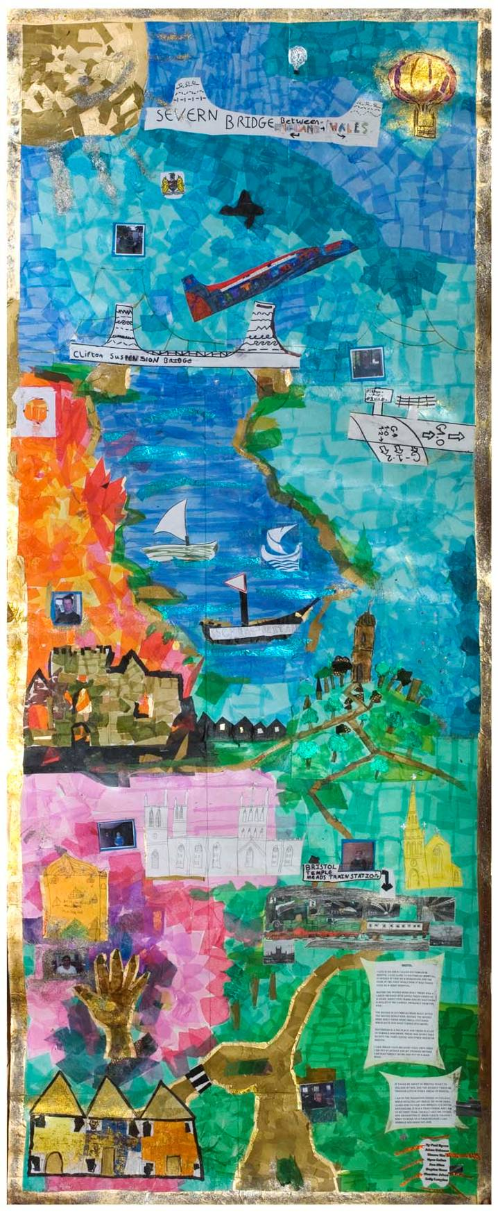
Collage by students from City of Bristol College, Lawrence Weston

Portrait of a Nation: Bristol

The Portrait of a Nation initiative is being run by the Liverpool Culture Company, member cities of the Cultural Cities Network and the Heritage Lottery Fund. It began in 2007 and will develop into a high profile strand of the European Capital of Culture 2008 celebrations in Liverpool this year. Portrait of a Nation works with young people across the UK to showcase their own local, regional and national identities through a series of events that will feed into a December showcase which will close the Liverpool celebrations.
In Bristol the project was linked to the Great Reading Adventure, an annual event that encourages everyone to read the same book at the same time. The 2008 book was a specially commissioned graphic-style history of the city called The Bristol Story which was distributed free of charge to over 80,000 people through schools, colleges, libraries, heritage sites, hospitals, local businesses, bookshops and other locations. It was supported by an extensive website at www.bristolreads.com, activity packs for schools, an illustrated readers’ guide and an adaptation of the main book suitable for younger/ less confident readers called The Bristol Comic.

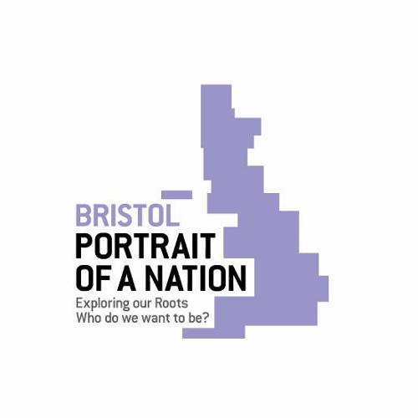

For Portrait of a Nation, a programme of 143 free, half-day workshops was provided for a total of 484 young people at selected Bristol schools and colleges between November 2007 and March 2008. The young participants created collages/banners, comic books, written work and drama pieces on the themes of identity, roots, heritage and culture, focussing in particular on the city neighbourhoods in which they lived and studied. They represented a wide age range, and a geographically and socially diverse spread of locations, and were chosen from the schools and colleges who had been particularly responsive to previous Great Reading Adventures.

This document brings together the teachers’ feedback on the project, along with photographs of the participants and their collages, sample strips from their comic-books and their written work (as at 15 May 2008). More photographs are on the Great Reading Adventure website, along with PDFs and scans. A disk containing all the digital material, including additional scanned work not shown on the website, is also available. Credit: all collage photos Martin Chainey. All workshop photos Vicky Washington except Avon Primary drama (Martin Chainey) and comic (Dympna Leonard).
The locations of the workshops

The main programme of workshops took place at:

Avon Primary School, Shirehampton
City of Bristol College, Lawrence Weston
City of Bristol College, Soundwell
Clifton High Lower School, Clifton
Colston’s Girls’ School, Cheltenham Road
Elmfield School for Deaf Children, Horfield
Fair Furlong Primary School, Withywood
Hannah More Primary School, St Phillips
Hillfields Primary School, Fishponds
Kingsweston School, Kingsweston
Little Mead Primary School, Southmead
New Oak Primary School, Hengrove
St George CE VC Primary School, Brandon Hill
St Mary Redcliffe and Temple Secondary School, Windmill Hill
Teyfant Community School, Hartcliffe
Weston Park Primary, Lawrence Weston

In addition eight comic-book workshops were held for approximately 30 children during the February half-term in public libraries as part of the project. These took place at:

Bedminster
Bishopston
Cheltenham Road
Stockwood

Note: these children are not included in the demographic information on participants that follows.
Map of locations

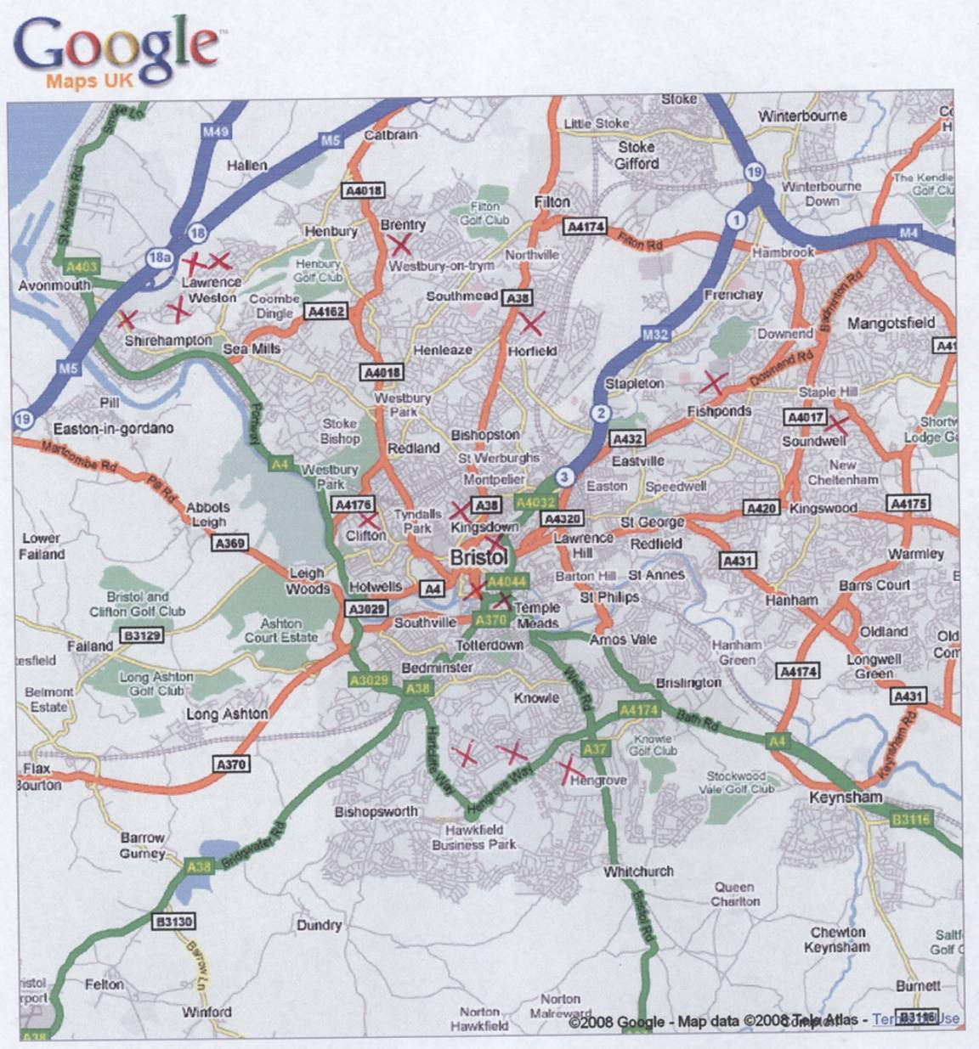
ACORN analysis of participants

Figures based on 465 Bristol-based participants where postcode was known.

Classification Group | Portrait of a Nation Profile | Bristol Population Profile
Wealthy Achievers | 4.3 % | 6.4 %
Urban Prosperity | 8.8 % | 24.1%
Comfortably Off | 20.2 % | 25.2 %
Moderate Means | 17.0 % | 20.5 %
Hard Pressed | 49.7 % | 23.8 %

Map of BS postcode coverage

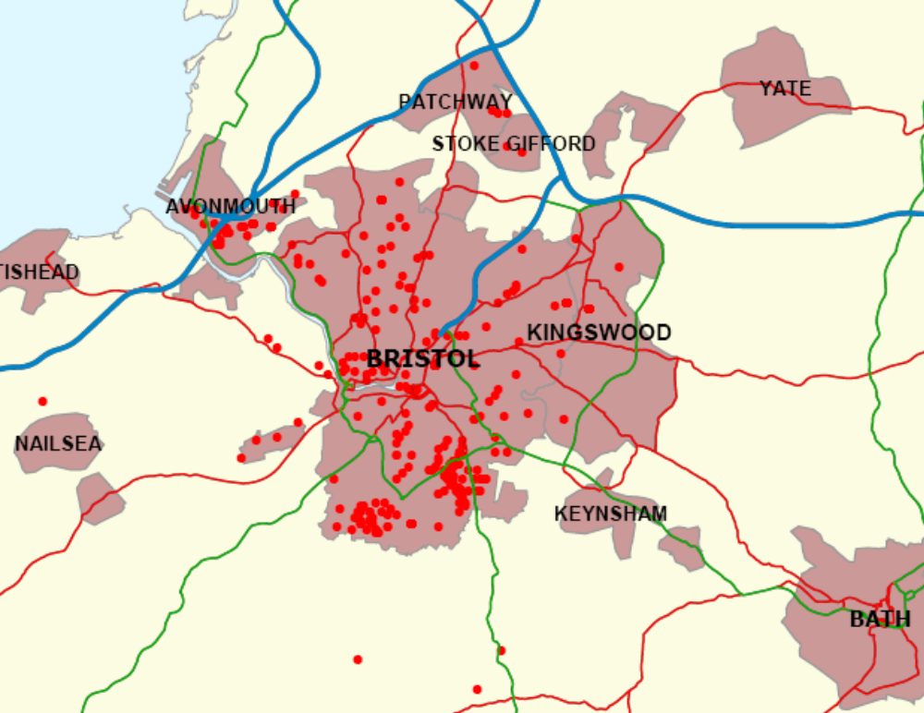

Gender of participants

Boys: 220
Girls: 264

Age of participants

Eleven and under (primary school): 342
Eleven to 16 (secondary school): 97
Sixteen and over (further education): 45

The collage workshops

With the exception of St Mary Redcliffe, all the main sites produced a large-scale collage in workshops led by artist Gloria Ojulari Sule. Most of the workshops were spread over four half-days. Gloria also spent a preliminary half-day in the school, discussing with a teacher the logistics of managing such a large piece of work and ideas that might be usefully explored with the students.

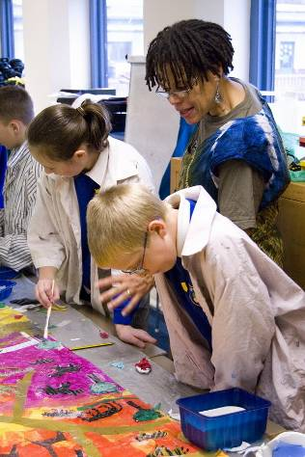
Gloria Ojulari Sule at New Oak Primary

Gloria encouraged the participants to research the history and culture of their local area, draw upon the imagery of local landmarks and include elements that reflected their own lives in the city. The collages had a card base and used bright tissue paper, black sugar paper, glitter, sequins and other materials, as well as drawings and photos made by the young artists.

The collages were then photographed and the image transferred onto a durable material to create a banner suitable for outdoor display. Four of these banners were hung in the city centre in January 2008 as part of the joint publicity for the Great Reading Adventure and Portrait of a Nation, and all will have been on public display in Bristol prior to being transported to Liverpool for the December showcase.

Photographs of all the collages are on the Great Reading Adventure website at www.bristolreads.com spread over four sections: Portrait of a Nation, Education, Education: Banners, and News and Press. The site also includes photos of some of the banners on display.

Teachers’ feedback on the collage workshops

Excellent workshops – very inclusive and creative. Work fitted in really well with our Geography for term 2 – our local area. Project really made the children look closely at their local area and what is special about it. We have a wonderful, lasting record of our work with Gloria. [Pupils benefited from] collaborative work, work in teams and pairs. Gloria got a lot out of the children with her questioning about the area. She readily accepted the children’s ideas about the content of the work. Pupil’s comments included – “we love our lilac motorway and giant River Avon fish!” and “We all had a go!”

It was great to have a series of four. It really provided an opportunity for the pupils to plan the work then have the experience of seeing the work progress and develop, as opposed to the one-off session we had last time [during the Great Reading Adventure]. The planning session really caused pupils to focus on living in Bristol as their own city and then seeing what was special/ unique to them as deaf citizens and then wanting to show other people/ share with them what makes them special in a visual way. Pupils’ comments: “I really liked the banner – I enjoyed working on this. I thank Gloria for helping us work on it.” “I liked the bright colours – come again, please, it was interesting. The banner is good to look at from upstairs.” “I drew a hand. It is grey. I enjoyed working as a group.” “I enjoyed the banner-making. I like it because it looks good, colourful and bright – I was surprised to see the finished banner look so great.” “I made a hand-tree because the tree links to our school elm. Hand means we use sign language. I love this craftwork. I like the idea of the banner, it is really eye-catching. I hope the whole school will come to see it and feel proud.” “I like the banner because it has links with Deaf issues/ features. Thanks for coming (to Gloria).” “I have drawn a sign number because people can learn sign that way. Sign language is a different language. Good work, I like that.” “There are lots of bits of our Elmfield School culture in this banner.”

The students liked working together as a team where cooperation was required to get things done. It was also very relaxing.

Gloria was superb; she inspired and enthused the children and instilled in them a genuine pride in their work. She also taught them new skills and techniques.

Resourced well. Children orientated and led. They really had to think about their local area and city.

I have [previously] worked with Gloria before in a whole school project to produce a mural. Also the class already knew a great deal about Gloria’s life from creating puppets for a production in The Fielden Theatre, City Academy – Inspirations: Black Bristolians Who Had Made a Difference. Once again, it has been a magical, inspirational experience! The children absolutely loved meeting the person they had learnt so much about. The banner is spectacular! Every single child – Education Behaviour Orders to Special Educational Needs – were able to benefit from the team building skills and were delighted with their final banner. The children also had a positive dual heritage role model! So important for many! The parents were thrilled to bits. “Everyone was able to participate and produce excellent images” – Liam (8). “I liked thinking about what we were going to put in our final banner” – Aliza (9). “I liked creating myself in tissue paper” – Kayus (8). “It was fun meeting and working with Gloria” – Joe (8). “We liked seeing our poem in our banner” – Tahmeena, Paris, Marcel (9). Thank you so much! We had a wonderful time. Wait until you see the banner!

Enjoyable, creative and imaginative. They enjoyed the opportunity to work off timetable and complete a large creative piece.

To have produced a published piece of art work that is to be displayed in their own city is marvellous. It allowed those children who have more creative talents to extend themselves further. The children had a wonderful experience especially because they could explore their own ideas and see them put into action.
The children had the opportunity to work with an artist which always heightens the interest in the work. Being able to make use of her expert advice helped the children to develop their knowledge and understanding of how to use colour and perspective. They were particularly interested in developing the ability to make their characters appear as if they were moving. The workshop time scale was useful in so far as the children were able to see that focused and intense sessions can produce an outcome quite quickly. Therefore I would recommend that this format is used again in the future. The equipment needed from the school was minimal which in these difficult days of funding is also very helpful. “The colours were vibrant and stunning.” “It was amazing to see the blank white piece of card turn into a brilliant banner”. “I feel really proud to think people in Bristol are going to see my work.” “It’s good that people in other parts of Bristol are going to see things about New Oak Primary School.”

Gloria organised the children well and they were keen to work. Resources not readily available in school were provided. Banners look fantastic and the children are proud that they participated. [Benefited from] boost to confidence that they had a part in creating something that looked so good. A good opportunity for those with creative interests to shine and boost their self worth. It stimulated an interest in their work.

The workshops were even better than anticipated – Gloria’s enthusiasm and ability to motivate students with MLD (including Aspergers) ensured a very happy and industrious atmosphere. It was a real pleasure to work with her. Along with developing team work, this work is also to be included as an aspect of the students’ Creative Skills unit for their accreditation. The students really enjoyed having input from a ‘real’ artist and are very excited about the banner being viewed by many people. Both the artists we have had (we also had Simon Gurr) have worked really well with our students – bringing out the best in both creativity and behaviour!! These workshops really gave an educational boost to both students and staff and we would be extremely keen to participate in any future projects – please!

The banner was a great success although we had to complete it in less time than was allocated. Gloria was very professional and helped the pupils to master the techniques using tissue and glue. Use of the children’s own ideas and the link to our art club was successful.

The project relates really with our topic. The children were able to use what they’d learnt to produce a piece of art work that just grew and changed in front of them. They are so proud of their work, there ability to produce something so grand, together. They can pick out their contributions but also recognise that they could not have done without each other. They also realised that their work represents their school and their community. They had fun working with Gloria. They worked in small groups to conjure up the ideas of what they felt would represent our community well and realised that there was quite a bit of their community that many people didn’t really know. They gelled well as a class to accomplish this work.Visual representations linked to a book is always a plus!! [Overall] The workshops were varied and interesting. They provided the children with a platform to shine from different corners of their spectrum. There were areas for every child. Well done. It would be good to keep them that way.

The comic-book workshops

The comic-book workshops were led by illustrator Simon Gurr, who was also the illustrator of The Bristol Story (one teacher commented: ‘Having met the person involved with [The Bristol Story] art work really brought the book to life for them.’). In two half-day sessions, pupils learnt the principles of comic strip design and made their own individual strips, following a seven-step process. The strips were then combined into a printed school comic-book, with each participant given their own copy.
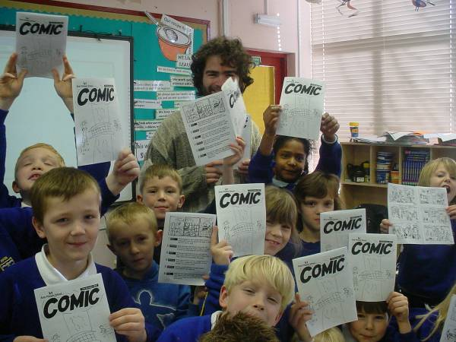

Simon Gurr at Avon Primary

Selected strips are included in this document as examples of the work produced but the complete comic-books can all be viewed on the Great Reading Adventure website at www.bristolreads.com as PDF downloads in the Education: Comics section. Some additional comic strip workshops for young people were held in libraries during half term as part of the project.

Teachers’ feedback on the comic-book workshops

The children were required to think and produce a high quality piece of work. Having a final project so quickly really encouraged the children to keep focussed. “Fun doing comic strip”. “Excellent drawing – now we know what to do if we want to do another comic strip”. “It was so good we think it would be great for other children to have a chance to work with Simon”. “Fun because we got to learn how to do comics. Simon taught us a lot and helped us to see how fun it is”. “It was ‘fantabulous’ and I would like to do it again”. “It’s more fun to make them than to read them”. “I thought it was wicked and I definitely want to do it again”. “It was really fun and I enjoyed it”. They realised how much they can achieve when they work together. They all really enjoyed the workshops. This has been an excellent experience and well worth repeating for future reading projects. There were the two extremes – at one stage you could have heard a pin drop they were all so focussed, and on other occasions, they were all animated and excited.

Excellent workshops – Simon’s workshop was well pitched for Year 3 children. He had really well planned out presentations which broke the storyboard process down into simple steps. All children were able to make up a short story and illustrate it in three steps as a comic strip. Children had to focus on various Literacy themes such as; story beginnings, middles and ends, characterisation and dialogue – all of which feed in well to the Y3 curriculum. The children’s concentration was excellent as they had to work carefully in order to produce their individual comic strips. Most of all, it was great fun for Class 3 and they all have an Avon Primary Comic to treasure. The workshop was great ‘professional development’ for me and I look forward to using Simon’s comic strip format when I work on Myths and Legends with my class next term. The children loved looking at each others comic strips – a really well thought out project!

This particular workshop worked very well with our students as they liked the idea about finding out about Bristol’s history, and as an ex-lecturer in the subject, I was very pleased to be involved. The students involved were able to think about their ideas and put them into logical order which incorporated the literacy aspect. They were all engaged in the process and really liked the idea of seeing their work in print.

Simon and I worked together to reorganise, replan and create a purposeful workshop for younger children. They loved making a comic.

Simon held the children’s attention so well and taught them about how to make a comic using captions, speech bubbles and thought bubbles. The children produced an excellent comic strip each about identity and heritage issues. The children were so enthusiastic and they had such fun! They were amazed at the final comic! Comments: Aliza, aged 9 yrs: “We have learnt a lot about how to write and illustrate a comic”. Briony, aged 8 yrs: “It was really fun!” Gabriel Hughes, aged 9 yrs: “We liked looking at the Bristol comic and learning a lot about our city”. Aliza, aged 9 yrs: “The time went so quickly, we wish that we had more time with Simon”.

All students interested and engaged in activity. This is not the easiest group to work with – Simon held their attention throughout. They produced a lovely comic book which they were very pleased with. They all enjoyed themselves and would like to make another comic strip at some point. This is the second [workshop] I’ve been involved with. They have both been of a high standard – keep them coming! Very beneficial to us all.

The children were really engaged. The sessions were really well thought out and planned. They loved having a product that they created. “It was mint!” “I can draw better!”

This was a new topic for the students. They thoroughly enjoyed working with an artist and the final outcome of their comic book.

All pupils were very engaged and enjoyed the day. The comic was excellent and pupils were very proud of it. “It was really amazing how we made it.” – Mya. “I really liked drawing the pictures.” – Yanaye “I like how all the pictures became one comic. I thought it was brilliant and I read it at home.” – Viviana

More than met expectations! The combination of presenting hard non-fiction information in cartoon form really caught pupils’ imagination, and they loved the idea of presenting their own histories/ autobiographies in cartoon form. Some of the examples were stunning – we never realised the pupils were such great cartoonists, this was such an effective medium for Deaf people to communicate in and it would inspire them so much. JB – “I enjoyed the work and it was interesting. He made me learn and enjoy practicing at home and school. He made me want to draw a lot more now.” SB – “I liked the project with Simon. I enjoyed the drawing. I learned lots of new ways of drawing. I felt proud.” TG – “Simon was clever at drawing. It made me happy to learn more from him.” LH – “Simon was the best person to teach me. I enjoyed learning art/ drawing. It made me want to do more.” AR – “I was so interested in watching Simon talk about cartoons. He helped me learn more and I was so happy as he allowed me to be more involved in cartoon drawing.” RJH – “Simon was great to us. I really enjoyed drawing cartoons like in comics. It was really interesting.” BW – “I really enjoyed learning how to draw cartoons for a comic, then being able to draw my own. Thank you for coming to our school and teaching us.” JM – “Simon Gurr was very helpful to us and we now know how to draw more carefully. Thank you for coming to see us at our school.” RV – “Simon Gurr was amazing. He helped our drawing skills. Having him over was amazing. It was great fun. Having him over was absolutely different thing for us. I would like to thank him for having time to come over.” Simon was great with the kids. He was idolised by one or two! And has become a real role-model for our budding young Deaf cartoonists. Thank you for the project! It is great to see a Deaf contribution to Bristol/ Portrait of a Nation.

Simon was excellent; he was very supportive of the children and enthused them and his talent shone through. The children were very focussed and proud of their booklet which Simon published for them within the day.

The children were fully involved and very excited to be making their own comic. The children were very proud of their work and keen to explain to others how it had been done and which part was theirs. It was good for team work, self esteem, interest in possible future careers and a good male role model to stimulate interest in writing.

The children not only enjoyed themselves, they also learnt the importance and relevance of focused planning before starting to draw. They now understand that drawing cartoons involves much more than just doodling. This workshop will help them to plan for their next storyboarding activity.

Really good workshop, well structured, pitched right, interesting and informative and fun. Students engaged very well with Simon. Students gained an appreciation for a variety of comic styles and how they are produced. They then learned how to create a character and use their own true story to develop a short series of comic strips.

Simon’s introduction and presentation was a hit straight away. All the children were interested and enthused. The project worked exceptionally well as its content linked closely to our curriculum. The children were able to come up with lots of ideas by the end of the first session especially as they were already given some idea of what the end product could look like. Simon’s use of the IWB was good, his presentation was to the point and accessible to all the students. I was absent for the second workshop, however did see the end result. The children were so keen to show their work. The experience is one that they haven’t forgotten yet and have already made plans to use and extend to our school community. The children were able to reflect on their own experiences and learning of our local environment. They were confident with their drawings especially as ‘inking ’provided a final stand for their work. They were proud to have something of themselves represented in a book.
The creative writing workshops

The creative writing workshops were led by Claire Williamson and Fiona Hamilton and resulted in a collection of poems and short pieces inspired by life in Bristol and by city landmarks, as well as the creation and reinterpretation of myths about the city.

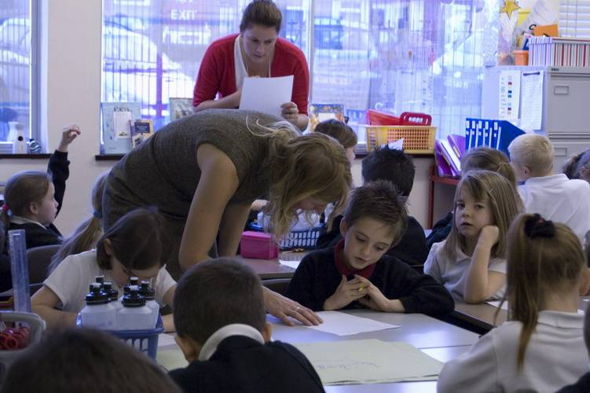
Claire Williamson at Fair Furlong Primary

Transcriptions of all the written work received from schools is included in this document (note: some work has not yet been made available as it was written in the children’s individual exercise books and must be kept in the classroom at least until the end of the school year). The work received can also be viewed on the Great Reading Adventure website at www.bristolreads.com in the Education: Writing section along with selected scans of some of the original pieces.

Teachers’ feedback on the creative writing workshops

[Claire] This was an opportunity for the girls to think, reflect, develop ideas in depth. They not only engaged their imaginations they also learnt a great deal about poetic techniques.

[Claire] [This met expectations] as we’ve previously worked together. The plan ideas were great. The children enjoyed writing the unicorn legend. It linked in with literacy unit of work.

Whole class enjoyed the joint poetry writing as all the children got some input from Claire. They produced some fabulous work from it which I have displayed. They particularly benefited from the group poem activity. Less so the groups that did myths. Claire’s group were very supported by her [but] the other two groups had very little input from her. For them it felt like any other literacy lesson with me.

Our children use speaking and listening games to develop their writing skills so it was helpful as a teacher to experience an author using this style of activities to engage the children. Good to have a different set of games to use. The children benefited from Claire’s expert advice and appreciated her genuine interest in their ideas. “Very interesting.” “Good working with Claire because she was helping us with our writing.” “Claire gave us ideas about what we could do.” “Useful to use the story of Bristol and try to go back into different times and try to imagine what it was like.” The games were “wicked” and “great”. It was particularly useful to us as a Yr 6 class to have a workshop which enabled us to revise how to write letters but to have a very different focus on the topic. It also helped children to expand their imagination when writing. Linking with various skills and styles of writing is an excellent way to go forward with these writing workshops. We hope to be able to have access to such high quality writers again in the future.

[Claire] The children have little opportunity to work with poetry so this was an excellent experience for the children. “Great.” “Fantastic.” “Interesting.” “Fun because you had to make the doors.” Being able to see that people make a living out of writing heightens the value of writing for the children. Long may [the workshops] continue! A great opportunity for children to work with authors; please continue to fund these workshops.

The workshops were so inspirational! The children produced such a high standard of work and Claire really was so enthusiastic. I have enclosed the writing from the second session as you already had the poetry from the first session. The children generated excellent vocabulary, connectives, openings and punctuation. “The workshop was totally lovely and fun and I’d like to do it again.” – Aaron (9) “I loved it so much, I didn’t want it to end.” – Nabil (9) “It made me think about how things travel and important black people and landmarks in Bristol.” – Bean (9) “I felt like I did much better writing using VCOP – Vocabulary, Connections, Openers, Punctuation.” – Aliza (9) “We looked at a poster covered in butterflies called ‘Diversity’. We decided that we are all like the butterflies – we are same, but different! It was really lovely to meet Claire and one day we hope to write just as well as Claire.” – Paris and the class. Claire’s workshop is a really excellent starting point for the project as lots of ideas about identity and heritage issues were raised. Thank you so much for this opportunity.

Fiona had an excellent rapport with the children and brought the history alive for them. They were swiftly put at ease and all inhibitions were forgotten. “It was great fun!” “She is a funny lady!” “I really liked the book; it was easy to read and really interesting.” Keep providing [these workshops]!

[Fiona] The students produced some excellent group poetry. The students were impressed with the poetry they put together as a class.

[Claire] A difficult and disaffected group of students were all happily engaged in writing poetry – all good! They were initially sceptical as it was out of their comfort zones. Once they became interested they enjoyed it and it was good for their self esteem to realise that they could actually write a poem.

[Fiona] Writing workshops were undertaken by our Y5/6 pupils. They produced some good poems but some of the vocabulary was unknown to them so we wondered how much of their own language they had contributed.

The drama workshops

The drama workshops were led by Moira Hunt and Fiona Hamilton. The workshops developed pieces about the participants’ lives in Bristol and landmarks of the city through improvisation, games and other techniques.

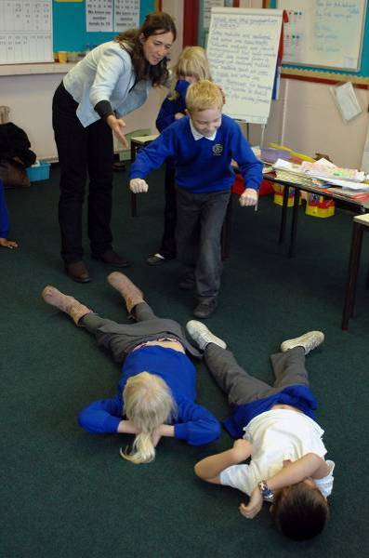
Fiona Hamilton at Avon Primary

One of the groups performed their piece in a school assembly, but the rest have not been seen outside the workshop environment. However, one workshop led by Moira was filmed and may be suitable for public showing in the future (one child who did not have parental permission to be photographed needs to be edited out before it can be made public).
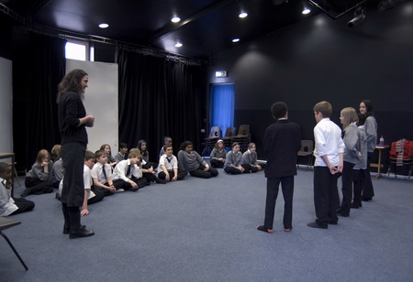
Moira Hunt at St Mary Redcliffe and Temple Secondary School

Teachers’ feedback on the drama workshops
[Fiona] Very well thought out workshop – children were encouraged to think more deeply about their local area. Sentences that came from children’s ideas on day one had been woven into scripts to accompany statues that children performed. Good for children to work in a large group – they find this difficult. Children had to focus on listening and co-operation skills and work as a team.

Fiona is an excellent drama coach with experience and a very engaging manner with the children. These sessions were excellent – well planned and delivered. All children were fully involved throughout and enthusiastic about the activities. The resulting performance was very good and we may well use it in a future Year Group Assembly. Extra work between sessions by Fiona meant that the scripts were adapted and prepared for the following week (which would have been difficult for our students in the time allocated). Positive experience of collaborative working in groups. Developing ideas from the texts. Improvising and refining drama skills. [Please provide] more of the same – length of sessions was just right and amount of sessions worked very well.

[Moira] The drama lesson was aimed at the correct age group, but I thought it might have been based more on Bristol/identity/heritage. The children enjoyed themselves though. Children that I least expected to feel confident in this type of lesson surprised me. Aaron, aged 9yrs: “I had lots of fun and really enjoyed it.” Briony, aged 8yrs: “We learnt a lot and overcame being shy.” Liam, aged 8 yrs: “I really enjoyed the games.”

[Moira] In a three hour session the girls produced two plays of high quality. This was our last workshop. It has been a fantastic experience to be taken off timetable and given the chance to be so creative. Thank you.

[Moira] Children were very engaged with the varied activities, which I think I can reuse in other sessions – the freeze framing when putting together our advert. [Benefited from] working together and co-operating in groups not necessarily their usual work or friendship groupings. Being able to express themselves creatively. One child, who is autistic found it hard to engage especially with the quick-ish change in activities. She did however ‘return’ to the session for a good retelling and enactment of a personal story.

[Moira] Children were all engaged with varied activities. These activities will be able to be used again and built on in other sessions. All except one child – special needs – enjoyed and worked well in groups. They co-operated in different situations.

[Fiona] Very well structured and organised. The workshop enabled the children to explore many themes of Portrait of a Nation. Because it was well structured it brought out the best in many children who ordinarily find drama difficult.

Moira engaged the children in fun activities appropriate to their age and ability. A great chance for them all to practise/ develop speaking and listening skills. “I liked the You game because we had to be fast.” – Emily “I liked making TRex in a group because we had to work together like busy bees.” – Bethan “I liked the traffic light game because we had to be characters.” – Josh “I liked all of it because it was fun!” – Reuben “I enjoyed telling my brave and embarassing stories.” – Olivia “I liked acting out the stories.” – Beth “When we made the TRex, it was fun working in a group.” – Trevin “I liked the way we worked in pairs.” – Mya “I enjoyed being rude and bossy!” – Bethan “I found it funny when we had to act like a fairy tale character.” – Nikita “You’re the best drama teacher!” – Sylvia

[Moira] The workshop provided opportunities for the students to volunteer and act out stories and participate in games. The students enjoyed the experience of lots of roleplay and teamwork. It built up their confidence to work with each other and in front of others (audience).

[Moira] This year 4 class are particularly enthusiastic when talking and love drama activities. They really enjoyed channelling their enthusiasm through this workshop. It reinforces work on listening and taking turns in talking which we work on. It also allowed them to work in small groups and team situation. “It was brilliant. I want her to come back soon, please.” “She is fab, I wish she can come back.” “She is phenomenal.” “It was great. I loved all the great games.” “I loved it. She was great.” I would recommend this workshop to any year group in the school.

[Moira] The workshops were fun for the students. The warm up games were great, and the workshop leader was excellent with the students. The students worked very well with members of the class they would not normally work with. In the group tableaux and drama pieces, they helped each other and produced excellent work. They were very proud of what they had done.

Avon Primary School

Avon Primary is a mixed, non-denominational state school of just under 200 pupils.

Ofsted Report Description, February 2008:

This school is slightly smaller than average. Most pupils attend from the local area. The proportion of pupils with learning difficulties and/or disabilities is above average. The majority of these have communication and literacy difficulties and a minority have behavioural difficulties. Most pupils are White British. Nearly all pupils attend a local nursery before coming into Reception. Children’s attainment is below the expected levels when they join the school.

The school is based in Shirehampton, a former village that has been absorbed into the north-western fringes of Bristol, near to the port of Avonmouth. For Portrait of a Nation, 25 Year 3 pupils aged between seven and eight took part in the workshop programme. As there was not enough time for them to do the creative writing element, these workshops were taken up by 29 pupils in Year 4.

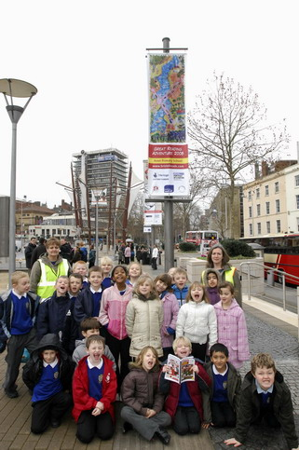
Avon Primary pupils in Bristol city centre to visit their banner

The Avon Primary collage
It’s so colourful! I wish we could do more really big art and the figures really look like us because Gloria showed us how to do our uniform badges. We really like the purple motorway because it’s fun.
The Avon Primary comic: sample strip

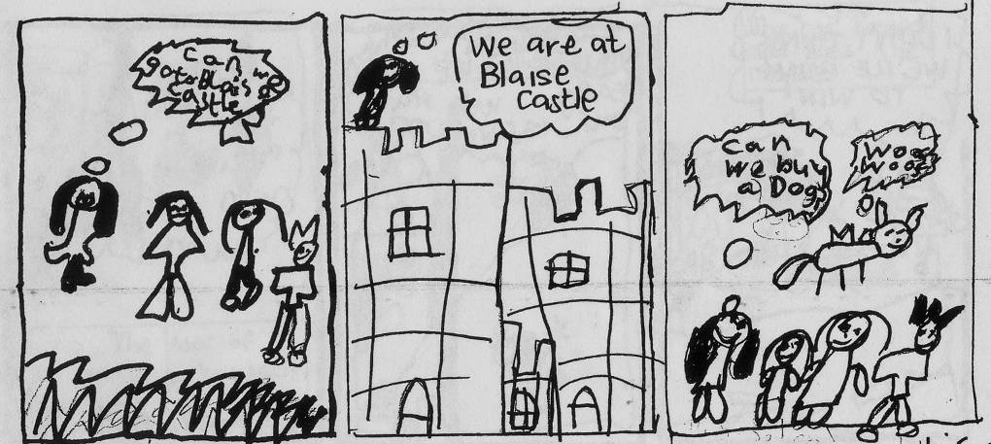

Avon Primary creative writing

Ode to a Tudor Lodge
By: Class 4, written following a visit to the Red Lodge in Bristol

We arrived at a door, wooden and red,
‘I wonder what’s behind this entrance?’
We said.

We crept down some steep, stony stairs
It was like going back to a time, drafty, bare.

We were separated out: girls and boys
to the distant echoes of the teacher’s voice.

Boys wore puffy trousers, waistcoats and ruffs,
Girls wore heavy skirts, short tops, headdresses with tufts.

In the Great Oak Room were portraits: serious and stern,
It feels like they watch you, their eyes move as you turn.

Into the walls were mysterious carvings,
protective gazes over the chests they’re guarding.

And everywhere you looked the Tudor rose
from the ceilings, shield, fireplace, it glowed.

Henry VII ended the war between two rivals
He married Elizabeth of York, for peace’s survival

John Yonge built two lodges, one red, one white,
For his guests to sleep overnight.
We looked at objects precious and old
Chamber pot, sundial, horn cup we could hold.

They wore tall shoes because of disease
so they wouldn’t dirty their feet with sleaze.

Our visit to the Red Lodge was a great event,
learning about the Tudors and what their lives meant.

The Myth of Avonmouth
By: Zach

Before the Romans invaded Bristol was a paradise with enormous palm trees and as clean as can be water. It was really sunny. The grass and hedges were as if they had only just been planted. The rivers were like the sea, full of lamp fish. One day a huge ship full of Romans in shining armour brandishing their swords, docked in the river Avon and unloaded giraffes and lions on to the land and set them free and they ran and attacked the Bristolians and the giraffes couldn’t eat so the Romans put tall exotic plants on the land so the giraffes could be fed. One of the Bristolians shouted “run for your lives it’s an Avon-ness monster!” Another shouted “it’s a camelopard. If you’re not blind you’ll be able to see it!” The Romans built a solid stone temple with many different columns when suddenly it started to rain molten metal and all the animals turned into trucks and cranes. Fortunately the Bristolians escaped into their houses and that’s how the docks was built and if you bash open one of those crates in the docks you might find a bunch of Romans and maybe a Bristolian librarian, if you’re lucky.

The Myth of Avonmouth Docks
By: Jacob and Natalie

Bristol was a beautiful place, with crystal clear water, a huge forest and evergreen grass. The grass was inhabited by the cute little rabbits. The rabbits were happily hopping about and playing with the squirrels in the trees. The weather was a nice sunny day, the water was nice and cool and the rest of the bunnies were swimming in the Avon. The other source of water was from a big lake the rabbits called the Severn. The Bristolians inhabited the forest so the rabbits didn’t get disturbed. The Bristolians were very clever people and made a port. Daily, boats would come and deliver food like cakes and ice-cream. The drinks Bristolians brought from a local trader called Jeremiah. The usual boat Jeremiah came in was a big Japanese junk. This time the food was in there, and some people. The Bristolians said “maybe they’re tradable people”. “The people on the boats aren’t going to be traded” said Jeremiah “they want to … ATTACK!” The army of people were Romans. The Romans fought with their spears, the Bristolians were defenceless. The Bristolians grabbed the spears and snapped them. They ran in to the huts and they went ablaze. The fight ran straight on to the ship. They fought. The bloodshed knocked off a crate. The giraffe said “what is this stuff? Hmm … I should call it water!” The Romans unpacked the special packages and the giraffes they ate the special flowers that were seven hundred metres tall. The Romans built a giant temple with fancy columns with weird patterns on them. The Bristolian chief said “who put this pile of shiny rocks here? I need to talk to that Caesar guy.” The chief walked up to the guards and they impaled him. The chief was screaming “help me!” The Romans held a secret meeting in the boat. The Roman emperor said “we must attack the Bristolians”. The soldiers saluted and retreated to the island. The animals and Bristolians held an even more secret meeting in the bunny’s burrow hidden behind a log. The Bristolians decided to burn the boat but the bunnies hadn’t invented fire yet. The lions attacked Caesar and the bunnies broke in into the boats cabin via the air vents, ripped the maps back to Rome, threw the captain overboard and broke all the tools that you use for the map. The Bristolians built a big wooden cage, jumped on to the back of a giraffe. The giraffe picked the cage up, waited for the bunnies to jump out and they did and dropped the cage over the boat. The bunnies painted a big giraffe green and it scared the Romans and they ran to the back of the cage. The Romans couldn’t escape because the door was barricaded by dead bodies. Suddenly, it started to gently patter with rain. The Bristolians thought “we should get the bunnies back in to the burrow, it’s just started to rain”. They grabbed the bunnies and jumped in to the burrow. One bunny said to his carrot “my precious” like Golem from Lord of the Rings but the Lord of the Rings trilogy wasn’t invented yet so that bunny was very ahead of his time. It then weirdly started to rain metal but everything beautiful turned to metal. The giraffes turned into cranes, the flowers turned in to wind turbines, the lions turned into trucks and the cage turned into a crate. The animals used themselves to help the Bristolians because they helped the animals. But never open one of the crates because the Romans might be inside ready to take battle against the Bristolians for the second time.

City of Bristol College, Lawrence Weston

Two groups from the Lawrence Weston campus of City of Bristol College took part in Portrait of a Nation. City of Bristol ranks in the top ten per cent of colleges in the UK and has over 42,000 students; 7,000 of whom are full-time. Lawrence Weston is in the north-west outskirts of Bristol near the M5 motorway, and is dominated by a large post-World War Two housing development.

Eight First Year Transition students made a collage and a comic book. Another group of students took part in drama workshops. The Transition programme is aimed at young people who have previously attended a special school or had extra support in a mainstream school. Supported by a personal tutor, the students improve their communication, information technology, number and literacy skills and work towards the EDEXCEL Skills for Working Life qualification.

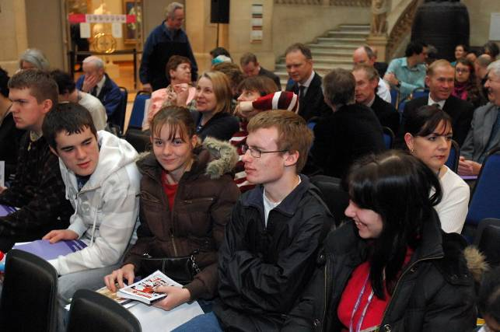
City of Bristol First Year Transition students at the launch of Portrait of a Nation.

City of Bristol College, Lawrence Weston collage

As the students at Lawrence Weston come from all over the city, they focused on Bristol icons for their collage, including the Clifton Suspension Bridge, ss Great Britain and Concorde, as well as putting on more personal items such as photos of themselves.

City of Bristol College, Lawrence Weston comic: sample strip

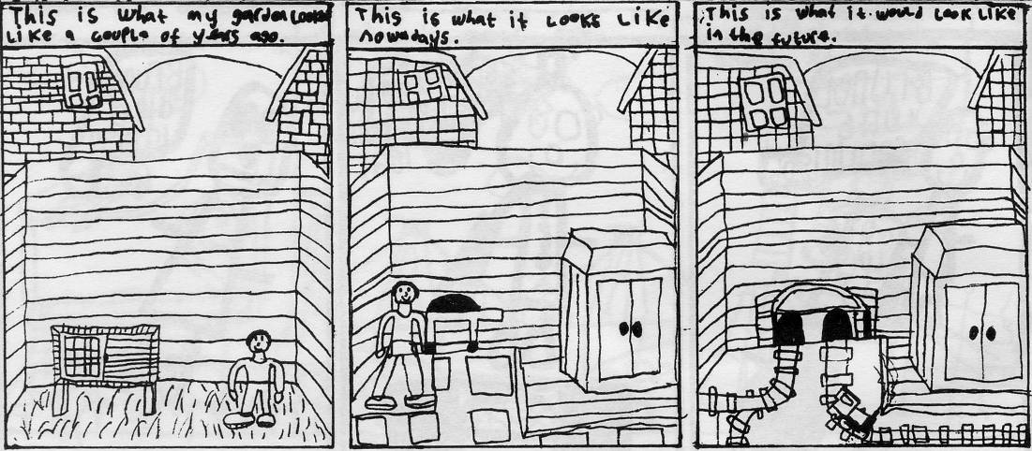
City of Bristol College, Soundwell

Three groups of Transition students took part in Portrait of a Nation from the City of Bristol College, Soundwell campus. Seven made a banner, 15 created a comic-book and five did creative writing. Soundwell is to the east of the city, in South Gloucestershire.

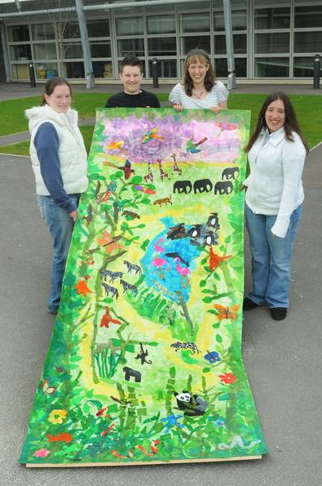
City of Bristol College, Soundwell students

City of Bristol College, Soundwell collage

The students at the college wanted to create a collage that celebrated Bristol Zoo, a favourite attraction for both locals and visitors. Their tutor wrote to a colleague:

As well as the kudos of their work being displayed, the students also learnt a great deal about planning and working effectively as part of a team, and the whole process has been recorded and will be an integral part of their accreditation.

City of Bristol College, Soundwell comic: sample strip

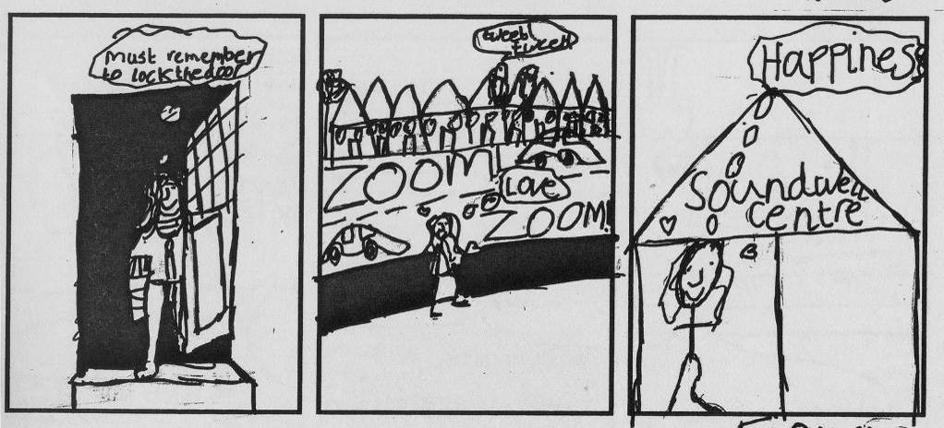
City of Bristol College, Soundwell creative writing

Baby pink curtain
Winnie plays in lime green grass
Sunny tree breeze
Dad’s black tatty shed
Birds fluttering water-bath
Leafy trees stretching

By: Christina

Dark room, light blue walls
Laminate floor, reckless room
Football on tv

By: Steven

Dark sky, large bright moon.
Fox glimpsed tip toes summer night.
Badgers in starlight.
Birds eating bird seed.
Sleeping dog cosy in grass.
Colourful flowers.

By: Jack

Playstation games blast
Football players in team shirts
Evening sun smiling
Midnight blue carpet
Shiny mirror in hallway
Catching the bright sun.

By: Kyle

TV stands alone
Deep sea blue in darkness wakes
Xbox comes alive.
Peering through windows
Staffy dog playing with stems
Mam gathering washing
I love casting spells
Wand is bending in my hand
My room looks like hell.

By: Lewis

I am the blue that runs the colour
I am the Lion that roars the animal
I am the chips that sizzle the food
I am the oak that sways the tree
I am the robin that packs the bird
I am the sun that shines the weather

By: Kyle

I am the rose in my mother’s vase.
I am the evening that relaxes the day.
I am the Spain that bakes in the sun.
I am the December that runs up to Christmas.
I am the toddler that plays in the garden.
I am the painting that tells a story.

By: Jack

I am the black that dances the colour
I am the fish that tornados the animal
I am the chocolate that crushes the food
I am the conker that spikes the tree
I am kestrel that soars the bird
I am the wind that blows the element

By: Lewis

I am Devon I like the sea
I am the microphone that sings High
School Musical
I am painter that paint people
I am May that brings flowers
I am Tina Turner that sing songs
I am blue that make night time light

By: Christina

I am the dog that sleep through the day
I am the strawberry that is soft
I am the rose that is bright red
I am England that is brilliant
I am leather soft sleep through the day
I am jumper that keep people warm

By: Christina

I am in Cameroon hot-sunny
I am night sends darkness
I am a fork that lifts food
I am the robin that chats to the birds
I am dead 6ft under
I am weather windy shakers
Clifton High Lower School

Clifton High Lower is a non-denominational selective independent school of around 230 pupils. It is located in Clifton, just beyond the city centre, an area that was incorporated into Bristol in 1835 and is famous for its elegant Georgian terraces.

Twenty-eight Year 4 pupils, aged eight and nine years, took part in Portrait of a Nation.
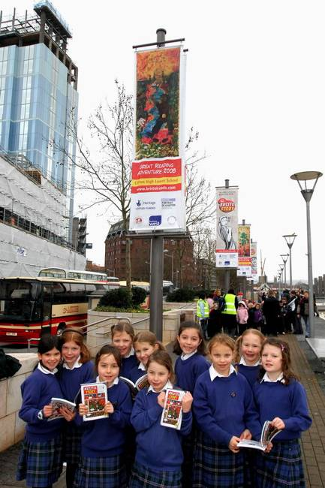
Clifton High Lower School pupils visit their banner in the city centre

Clifton High Lower School collage

The pupils at Clifton wanted to tell the story of the Bristol giants who dug the Clifton Gorge in their collage. The giants also featured as narrators in The Bristol Story.

Clifton High Lower School comic: sample strip

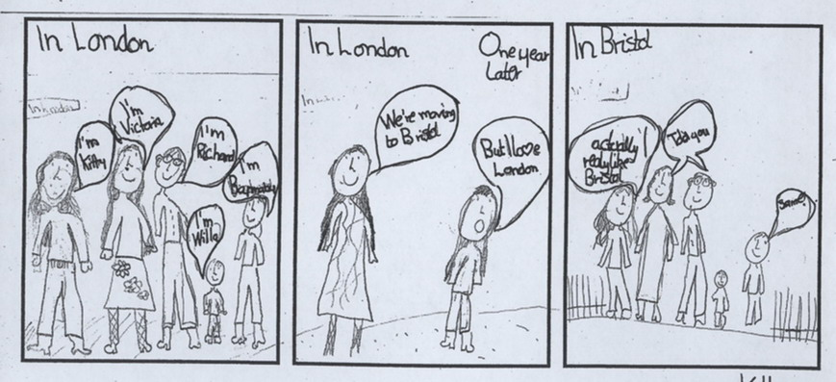

Clifton High Lower School creative writing

This was a class poem devised and performed as a group.

The Giants and the Gorge

I am Goram
Avona’s so gorgeous

I am Vincent
Avona’s so gorgeous

Which one to choose?
I’m Avona

You two build a gorge
Then I’ll decide

(Digging)

Hurry up!
Goram is so lazy
I like Vincent better

I want to marry you Vince
my prince!

Colston’s Girls’ School

Colston’s Girls’ is an independent school of 350 girls aged between ten and 18. It is located on the Cheltenham Road near the city centre. It was founded in 1891, using a legacy from Edward Colston, an eighteenth-century merchant and benefactor, who endowed several Bristol institutions. In September 2008 Colston’s Girls’ will become a non-fee paying Academy and its intake is expected to grow to 700 in the next five years.

Seventeen pupils in Year 9, aged 13 to 14, volunteered to take part in Portrait of a Nation.

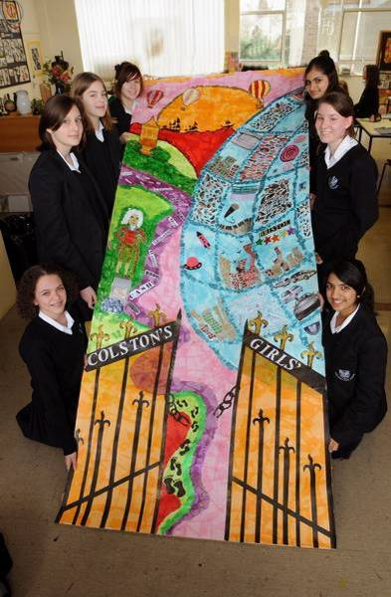
Colston’s Girls’ School pupils with their collage

Colston’s Girls’ School collage

On our banner on Bristol and the slave trade we wanted to show the relevance of it in modern Bristol. The gates across the bottom of the piece are our school gates opening onto the Bristol we know today. The chain that hangs broken on the either side symbolises the abolishment of the slave trade and freedom. We chose to include the mirrored sphere by @Bristol because it reflects modern Bristol but looks to the future. It shows cars, music and the new buildings. There are footprints snaking through the picture to link Bristol’s past with its present and future. On one side is the @Bristol globe and on the other is Edward Colston, the founder of our school and many other buildings around Bristol. He was a huge benefactor but he made his money from the slave trade. He is surrounded by words; negro, sale, auction, cash, children. These bring more meaning to the pictures and hopefully hint at the realities of being a slave. We made our banner colourful and vibrant to reflect the life of Bristol and make it attractive to look at.

Colston’s Girls’ School comic: sample strip

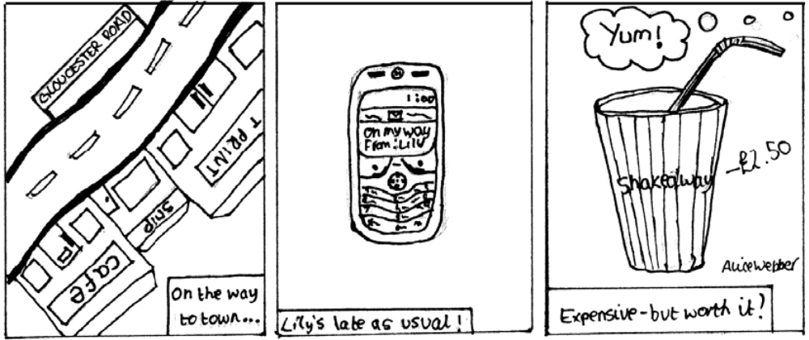

Colston’s Girls’ School creative writing

Cabot Tower
By: Gillian

Looking down over Bristol
Al the things that I see
Are beautiful yet ruined
A lot like me

I am older than all these people
That scurry round and round
So long ago Cabot sailed away
Inspired by the places he found

So now I stand empty
Forlorn and alone
They shut me down, as I’m unstable
So I sit in this park, my home

I am like a tooth
That sticks out of the land
Strong, yet crumbling
Not any more very grand.

Keeping My Balance
By: Emma

I wobble
I wobble
I walk.

I’m walking
past red bricked buildings,
the tigers, roaring at
Gloucester Road.

I walk
past lumbering buses
the mammoths, lumbering
down Gloucester Road.

I wobble
And I walk,
over the grey, aged pavements
the tortoises I balance on…
Down the street.

I wobble
I walk…

Death of the School
By: Fatima

Fifty years or more have passed,
The memories stay but the school does not.
Perished within the fragments of time.
Until all that’s left is dust –
Crumbling away at the hands of man.

The Sailors Ghost
By: Savannah

Standing on the dark flaky wood of the docks
I stare into the empty air.
The salty, chilling breeze washes over my tongue
and the taste of regret creeps down my throat.
Slowly I lower myself to the ground
melting into the dusty wood.

I dip my toe into the water,
and it laps over my skin.
I stare at the boats,
rocking gently.
The place is lonely, a dream, floating distantly away from life.

The water mirrors the wide, white sky,
Distorting the clouds in ripples.
The docks are drowned in history
drifting away from the present.

I stand again,
Hours have passed, lost in the vast water.
I turn.
100 years rush past me as I take a step
and leave.

Poison
By: Hannah

Like an eel it snakes through the city
Trickling through its sludgy pits of silt
Sucking mud-soaked history into its black depths
As it slips through its oasis,
Stolen away from the unsinkable stone.

What journeys have, as they slid creaking hull,
Made their way out of the swell?

Which proud vessels has its murky poison
Slicked calmly over?

Bristol Cathedral

The cathedral stands as intricate as coral,
Its delicate structure lies deep in the heart of Bristol.
Planes and cars float around like seaweed
Slimey and slithering polluting this beautiful aquarium.

The patterns in this building show true beauty
The rose window, the honey comb grooves.
This place of workshop has a real history to it
Standing strong as iron for hundreds of years.

There’s an eerie feeling in this big old place
So quiet, so still from the outside world.
You can almost see Bristol’s past in front of you
But now as I leave it drifts off into the dark, dark shadows

The Locket

A sense of wilderness fills the air, colours of the rainbow, shades of grey.

Prawn-pink flamingos with an elegant ballerina’s pose.
Humming birds, delicate beads in a swirl of shell, each with a song accompanied by the sun.

Collaged frogs, with soft smooth skin, with water like thousands of mirrors swaying, whooshing. Their calls dark, deep, light and shallow.

All-wise lions, with million years of history, musky, loud – their sound drums in your chest. Fierce warriors in battle.

The creatures of the world, caught in a locket.
City Streets
By: Elizabeth

To whoever is not looking at the sky
this Monday morning,
but instead to the hard pavements,
thick,
and sticky,
and a magnet to the eyes
that stare at the gait
of their stone-stuck feet,
with disbelief.

Hurry up! Hurry up!
The chant repeated all over the city.
But ancient rock obeys not time,
for being beyond it.

Oh, so slowly.
The dead flow.
treacle coloured,
and warm beneath
the grey crust surrounding.

Red too,
where the heart beats.

We are Bristol

We walk along the stone pavement where so many other feet have stood.
We have had problems in our past, bad points and good, that we can never forget.

We look into the Glass Window with its multicoloured reflection.
We see ourselves and our friends around us, we are all so different but similar, we are multicultured.

We look up at the new intricate metal building thinking of the future.
What will become of us? What will disappear for ever and what will be preserved?

We are Bristol.

We have had the slave trade.

We are Multicultured.

We are looking to the Future, ready for what comes.
The Downs
By: Lily

You walk over the hills,
There you see the fields.
Wide and stretched,
They seem to go on forever.
Winding roads divide this place.
And give it shape.

This shape fits into Bristol.
A space for people to walk.
A place for animals to live.
The crunchy leaves widen across this area.
And the trees spread their roots
And grow for years on.

At the edges of this place there are views.
Views of history.
Views of home.
Paths guide us around,
We pass brushes and benches.
People flying kites.
Without the downs
People would have no place to run.
Birds would have no place to fly freely.

A Distant Memory
By: Alice

Natural and pure,
A place to be treasured

Simple beauty at its best,
Not yet ruined by the hand of man

A place for fund,
& relaxation

No shape, edgy buildings
To get in the way.

But for how long?
One day the pearl of Bristol
Will be just a distant memory.

Shades of Contrast

Dark, is the unknown
The unquestioned, the unapproached
Nobody wants to be curious
It stays locked away untouched
Unused by the people of Bristol

Light is the explored
The desired, the welcomed.
Everyone wants to be there
It’s busy, lively like a source of love
Used by the people of Bristol

Bristol has two sides
Light and dark, loved and hated
But in our modern society
They are equal.

Sea Walls
By: Ellie

Bronze,
A summer sunset at Sea Walls,
Warm, inviting, and surreal,
It puts you in a bubble,
A bubble of memories,
Of good and bad.
Funny, and upsetting.
The rumbling of rush hour traffic below,
The screaming of joyful children,
As the icecream van jerks round the corner.
Watching frisbees fly around people’s heads
Seeing people laugh with their friends.

The evening drags on,
The sun dies down,
And eventually children tire
The frisbees take their final flight,
The dogs make their last leap for freedom
Finally, it’s me and the moon.

Henleaze Lake
By: Bridget

The city’s alive and moving,
cars swelter as they hoot their horns.
alleyways and crevices conceal
many mysteries.

and in a nook, a little cranny
hides a haven amidst the bustle.
around are houses, roads and pathways
yet this place holds no sense of time.
The water’s glimmering and glistening
the wildlife’s placid, at ease
And as a swim in the lakes deep waters
or spring from the high mounted boards
the stress of a city sweeps past me
and a wave of serenity sweeps over me
in this little heaven on earth.

Elmfield School for Deaf Children

Thirteen students from Elmfield School for Deaf Children took part in Portrait of a Nation. They were aged 11 to 15. Elmfield is a mixed, non-denominational community special school of around 60 pupils who can attend from the ages of three to 16. When the pupils reach secondary-school level, they take their classes at the mainstream Fairfield High School in Horfield, a suburb to the north-east of the city near the M32.

Ofsted Report Description, November 2006:

This is a small school that caters for pupils with severe and profound hearing loss. Attainment on entry is well below average, because of the nature of the pupils’ special needs. Nearly a third of pupils have additional special needs and all have a statement of special educational needs. The majority of pupils are White British, although a small number of pupils are refugees and/or asylum seekers. For most pupils, British Sign Language (BSL) is their first language. The school serves ten authorities and the socio-economic background of pupils is varied, although nearly a third are eligible for free school meals.

Because of difficulties of incorporating workshops into their school timetable, Elmfield were only able to complete a collage and a comic-book.

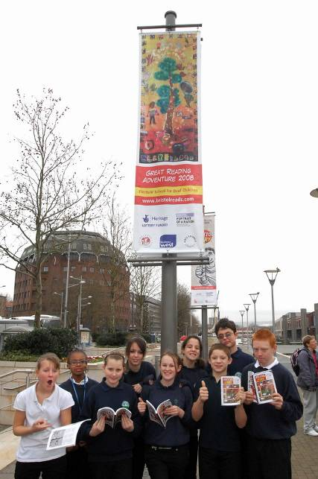
Pupils from Elmfield School for Deaf Children visit their banner in the city centre

Elmfield School for Deaf Children’s collage

The young people provided comments on the different elements in the collage:

Waving hand – I made a hand. It says ‘hello’. It’s stripy because it’s funny and is waving to both Deaf and hearing people.

Girl in stripy jumper – The girl is me (J). I have a stripy jumper, jeans and my favourite boots.

Hot air balloon – I made a hot air balloon because the people inside are waving. It is a Bristol image and Deaf people could be inside.

All the bright colours on the banner mean that people in town will look up at it.

Bristol Rovers – The Bristol Rovers picture has a pirate. Rovers are my favourite team and from our area. I can’t remember why Bristol Rovers have a pirate, but both Deaf and hearing people support Rovers.

Suspension bridge – I found a picture of the bridge on the internet. The bridge is in Clifton. It is an important Bristol landmark.

Other pictures – I found a picture that is the view from the suspension bridge and one of the ss Great Britain, that is Brunel’s ship. We all learned about Brunel two years ago.

Number handshapes – These show the Deaf way of doing numbers, so hearing people can look at them and learn how to count in BSL.

Bristol City sign – This is for Bristol City football club I support. My friend Taylor made the Rovers one so I made a City one.

Elmfield school – I drew these letters and Sophie cut them out they are drawn over the Elm tree, the logo for our school. Elmfield School is part of Bristol.

You can see the flag by @Bristol. A famous cartoonist called Simon Gurr saw it and thought it looked great.

‘Welcome’ hands – I made hands showing the BSL sign ‘welcome’ meaning welcome to Bristol. I used different skin colours. People come to England and then Bristol with different skin colours and all can learn sign.

People new to Bristol see the flag and see Deaf people, sign language and different places in Bristol.

‘Sign’ hands – I made the hands showing ‘sign’ because of learning to sign and it is important everyone is aware of sign language.

‘B’ ‘L’ handshapes – The B and L mean Bristol so people can see what it looks like in our language.

Deaf club – Because it is important part of Deaf community in Bristol. People come to meet friends and communicate and have drinks, play skittles, hold parties, sports etc. It means Deaf can have social life similar to hearing.

Four crossed arms – All the races are represented, Deaf can be any race, all together in unity.
Tree made of hands – Because it is the symbol of our school and we sign so it was appropriate.

Hearing people can realise that signing is our way.

Rainbow hand – Deaf people use hands for signing. Rainbow because it’s beautiful colours, both together = beautiful signing. Hands are important to us, signing is beautiful and we want everyone to be aware of this.

Elmfield School for Deaf Children’s comic: sample strip

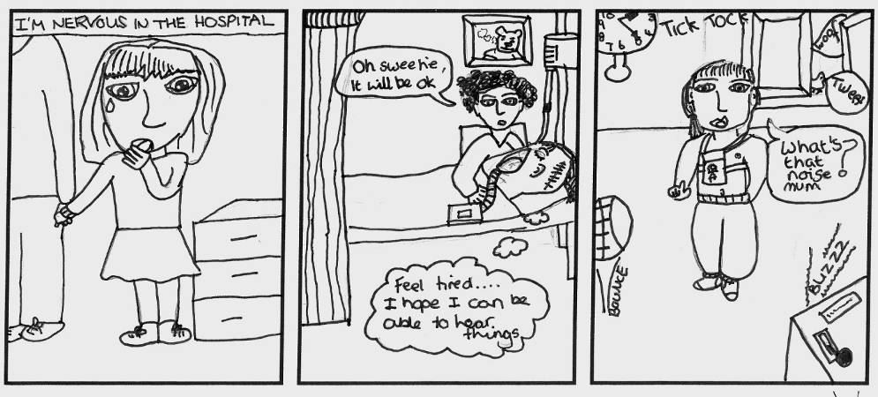
Fair Furlong Primary School

Thirty pupils in Year 3 from Fair Furlong Primary School took part in Portrait of a Nation. They were aged seven to eight. Fair Furlong is a mixed, non-denominational state school of around 300 pupils. It is based in the Withywood/ Hartcliffe area of Bristol, a large-scale post-World War Two housing development to the south-west of the city.

Ofsted Report Description, February 2007:

The school serves an area of significant social disadvantage. Children start school with standards that are significantly below expectations. Currently, nearly 50% of pupils are entitled to free school meals. The proportion of pupils with learning difficulties and disabilities is above the national average. Most pupils are of White British heritage.

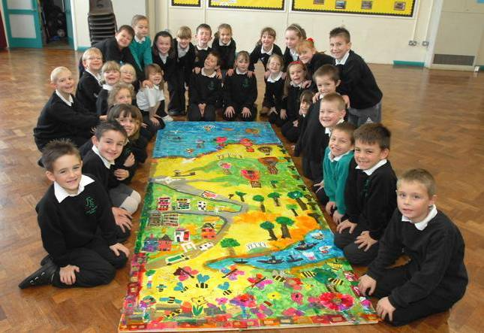
Fair Furlong Primary School pupils with their collage

Fair Furlong Primary School collage

The pupils at Fair Furlong were keen to include some of Bristol’s hot air balloons in their collage.

Fair Furlong Primary School comic: sample strip
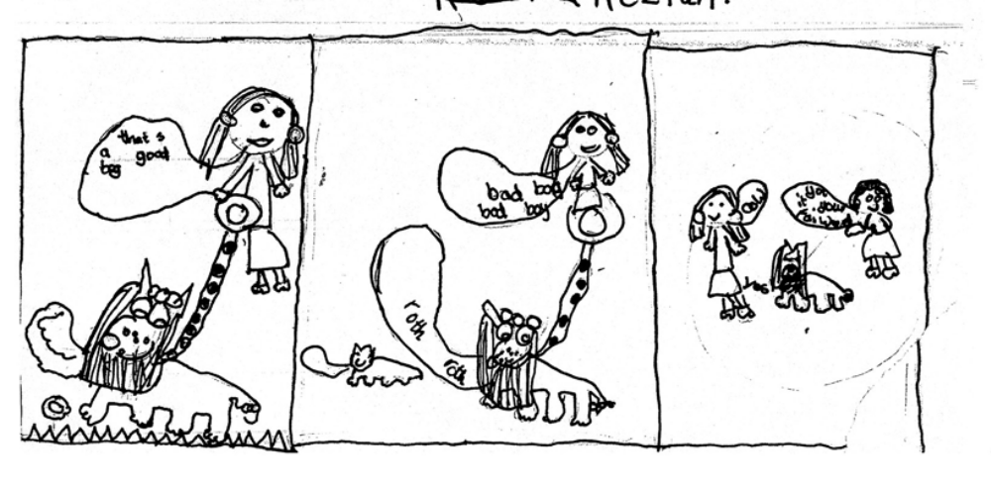
Fair Furlong Primary School creative writing

How Bristol was transformed from a swamp to dry land with a river.
Back in the days of the days of the distance, up on the hills of Hartcliffe lived the last two remaining unicorns, with diamond-tipped, twirly, shiny horns. One was called Dash, because she could run like the wind and one was called Bristley, because he had a rough black fur. All the other unicorns had been eaten by the nasty fish Swamp-Spiker who lived in the slimy marsh down below the hills of Hartcliffe.

Up on the hill there were fields of colourful flowers and the sun always shone. But down in the swamp it was wet, rainy and soggy. No one would want to live there. It was sticky, smelly, gooey and muddy.

The unicorns know that after they have died it was to be the time of the natives. They could feel the new age coming in the tingle of their glittery hooves. They knew that they have to get rid of the bad fish Swamp-Spiker before the natives would come.

The unicorns trotted down to the edge of the swamp.They could feel the menace of Swamp-Spiker through their hooves, which shook as they got closer.

Swamp-Spiker could smell a unicorn at a thousand paces, so he was waiting in the seaweedy grasses of the marsh. His bony, spiky back looked like a rock in the water. His enormous tail lurked in the gooey, squishy mush.

As the unicorns approached, with their fiery breaths and their stabbing horns, Swamp-Spiker jumped high out of the marsh and swiped with his huge tail and blew a jet of water from his angry mouth and his blow hole making a fountain of poisoned water.

The unicorns knew this was their last moments, so they decided that they would channel the sunshine from the hills of Hartcliffe down into the swamp to dry up the evil, slimy sea and kill off Swamp-Spiker. So they raised their horns and the caught the bright sun beams in their horn-diamonds to dry the land. They knew they would be burnt up in the sun’s heat, but it felt the right thing to do as their last act.

The swamp mostly dried, apart from a river and the unicorns were mostly burnt, but Dash and Bristle weren’t burnt, but encrusted in golden sunbeams and were taken by the natives as their symbol, who named the town Bristol, after Bristle. Swamp Spiker was trapped under the hot, dry ground where the native Bristolians made their city. Sometimes you can still see the water from his blow hole burst up like a fountain in the city centre. And you can see the golden encrusted Dash and Bristle on top of the council house on College Green.

Clifton Suspension Bridge
By: Lauren

It has green lights.
You have to pay 50p if you want to go on the other side.
It has windows
It has doors
It usually wobbles and shakes
When you cross the suspension bridge, if you look down your tummy will go funny.
I like the Suspension Bridge, Mummy.

Clifton Suspension Bridge
By: Dom

I see a suspension bridge with people walking on it.
There are cars and people.
There are kids rushing.
Can you see it?

Clifton Suspension Bridge
By: Jake

Lights on
Lights off
Run up
Run down
Half bridge
Not half bridge
Noisy
Not noisy
Cars go vroom
Cars don’t go vroom
Woods are here
Woods are there
I can see
What can you see?
The suspension bridge.

Clifton Suspension Bridge
By: Kayley

I like the suspension bridge because of the lights
You have to pay 50p to walk across.
It is scary because it is wobbly and you might fall.
My friend’s teddy fell in the water
Ouch, said Ashley.
Wanna come across?
Oh no, Oh no, said Ashley, don’t pinch me.
I like it at night because the green lights come on.
Yes, yes, said Josh and Ellie and Mummy and Daddy and Kayley.
I like it, Mummy, said Kayley.

Clifton Suspension Bridge
By: Ellie-Mae

I like the suspension bridge because it has glittering green lights and I can see it out of my window. It has no lights in the day.

I like the suspension bridge because it is peaceful and quiet.

Clifton Suspension Bridge
By: Toni

Bridge shiney, glittery at night
It is glowing at night and the colour is green
The bridge is good and sparkly, you know.
The bridge is gorgeous.

Clifton Suspension Bridge
By: Kezioh

It is big
It is long
It is wide
It’s got water
It is high
It has lights
It is tight
It is good
It’s got iron
It’s got lines on
On the water, it’s got boats on.

Clifton Suspension Bridge
By: Bradley

The suspension bridge
At night
The lights circling
Green flashing
The children dashing
The cars grinning
The suspension bridge

Clifton Suspension Bridge
By: Jake

When it is night time the suspension bridge is lit up in different colours.
If you want to cross it you’ve got to pay 50p.

Clifton Suspension Bridge
By: Bethan

“Good morning, lovely, you look shimming!”
Your beautiful lights at night shimmer a lot
It looks like a little fairy has dropped some fairy dust on you
I love the suspension bridge.

Clifton Suspension Bridge
By: Megan

This suspension bridge is sparkly, high, glittery at day.
This suspension bridge is glowy, shiny, green at night.
There are people running, shoving, pushing past.
Cars are going broom broom!
I can see it from my house!
Can you?

Clifton Suspension Bridge
By: Holly

At night the bridge lights up green
Sparkling brightly in the morning
It reflects in the water and if you are in a car you have to pay 50p to get across.
Sometimes you can see it at night.
It is sparkly, glittering and beautiful
It is glittery and flittery
Sparkly and glowing and flowing
People dashing, people flashing, people crashing, people passing.

Clifton Suspension Bridge
By: Stephanie

Suspension bridge swinging
Suspension bridge clinging
Suspension bridge flinging
Suspension bridge weeping
Suspension bridge shining
Suspension bridge flying
Suspension bridge staying
Suspension bridge staying
Suspension bridge smiling.

Clifton Suspension Bridge
By: Caitlin

Glittery, sparkly, shimmery, green lights glowing every night.
In the morning and the afternoon the metal glitters.
Cars cross, vans beeping, children screaming, ambulances screaming “Get out the way!”, “Coming through!”
People sleeping and babies weeping.
I LOVE CLIFTON SUSPENSION BRIDGE!
WOW!

Clifton Suspension Bridge
By: Sharon

Bells ringing
People swinging
People rushing
People running
People laughing
People singing
People dancing
People digging
People shouting
People talking
People lazing
People walking
People walking
People messing
People guessing
People parking
People honking
I like the Clifton Suspension Bridge.

Clifton Suspension Bridge
By: Ben

River running
People rushing
Cars paying
Light reflecting
Visitors viewing
Suspension bridge shining
Muddy water
There are street lights
Glowing lights

Clifton Suspension Bridge
By: Charmaine

Cars crashing, motor bikes dashing, all gleaming, children screaming!
Lights green, children mean
Motor bikes racing,
People walking along the suspension bridge.
Cars zooming along the suspension bridge.

Clifton Suspension Bridge
By: Deanna

From my house I can see the suspension bridge glowing in the sky.
I can see the green lights lighting up on the grey clouds.
Look over there, there’s the sparkly, glowing, shiny suspension magical bridge.
I wish I could fly there.
“Wow” what a nice suspension bridge.

Clifton Suspension Bridge
By: Declan

Suspension bridge sparkling in the night
Suspension bridge is high up
Suspension bridge, people rushing
Suspension bridge has nice curves on the side
Suspension bridge is very long
Suspension bridge is massive
Suspension bridge is regal

I can see the suspension bridge

Clifton Suspension Bridge
By: Brodyn

At night the suspension bridge it sparkles and glows
The colour is green
Cars on the bridge
I like the bridge because it moves and grooves when the lorries go across and the cars
There are traffic jams on the bridge
I can see it
Can you?

Clifton Suspension Bridge
By: Ryan

The suspension bridge is very busy.
People are dashing, cars rush to get to the other side
The suspension bridge in the dark lights up with green, sparkling, glowing light
Can you see it out of your house?

Clifton Suspension Bridge
By: Chelsea

Good morning, beautiful
You look gleaming.
Today should
We see if
Any body wants
To drive over
You? Yes, come
On then. Here
Comes a person.
People are driving
Over you. Yes
And people are
Walking over you.
People running. And
Dashing over you.
Wow, now people
Are rushing over
You. Why? Well
Let me tell
You. OK maybe
Because they are
Going shopping or
To the park
Or going to the zoo.

Clifton Suspension Bridge
By: Lucy

I can see two suspension bridges.
I can see one that people can cross and drive along
And one twinkling in the river.

Clifton Suspension Bridge
By: John

It is big
It is long
It is nice
It is colourful
It is high
It is white
It is above rock
The water is nice
People like the suspension bridge, it is nice.

Clifton Suspension Bridge
By: Dillon

I love the suspension bridge because it is shiny and glittery and when I go on it it makes me wobble.
I can see the suspension bridge.
Can you?

Clifton Suspension Bridge
By: Paige

The suspension bridge is long and nice.
I can see people walking on the bridge.
It is a big one.
She is nice.
A person was on it all the time.
It glows at night.
It is a wonderful suspension bridge.
I can see a chain.

Clifton Suspension Bridge
By: Jay

The suspension bridge in the night
The lights glow green.
It is over the water.
Children dashing on it and cars driving.

Clifton Suspension Bridge
By: Brittany

They go on that Clifton Suspension Bridge
It is big, the bridge.
People are in their cars
People run down the bridge
People are sitting
People watch the cars
People watch
People racing on their bikes
People racing in their car
People are fast
People are good.

Clifton Suspension Bridge
By: Chloe

The suspension bridge is busy.
People are dashing.
Cars are rushing.
The suspension bridge
Is glowing in the dark night sky.
Gleaming lights are flashing as shiny star light.
I can see the suspension bridge from my window as dazzling bright light.
The suspension bridge is sparkling tonight.
I can see it loads of times at night.
Can you see it loads of times at night?

Clifton Suspension Bridge
By: Brandon

From the trees of Leigh Wood
Lies the sparkly huge
Suspension bridge.
The suspension bridge’s lights
Glow at night.
I can see it but can you?
People rushing over the glittery suspension bridge.
People feel proud when they walk past it.
The suspension bridge.
I can see it, can you?
Hannah More Primary School
Twenty-eight pupils took part in Portrait of a Nation from Hannah More Primary. The school is located near to the medieval heart of the city at St Philips, an area that was heavily bombed during World War Two. It is a mixed, non-denominational state school of around 150 children that takes its name from the Bristol-born Hannah More, a pioneer of education for the underprivileged and a campaigner against the slave trade.

Ofsted Report Description, May 2006

This growing inner city school is situated in an area of major redevelopment. There is a high level of deprivation and two thirds of pupils are eligible for free school meals. About two thirds of pupils are also from minority ethnic groups. A quarter of pupils do not have English as their first language and most of these pupils are at an early stage in learning English. Nearly a third of pupils have learning difficulties. A significant number of pupils join or leave the school other than at the usual time. Children’s attainment on entry to the Reception Year is very low.

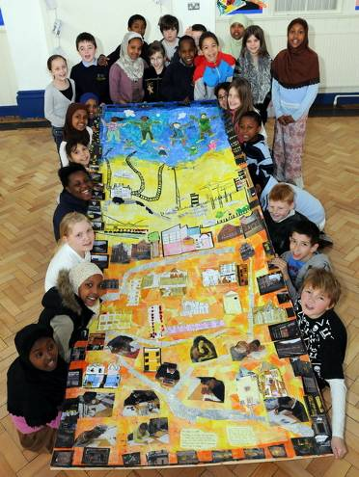
Hannah More Primary pupils with their collage

Hannah More Primary’s collage

The pupils at Hannah More included photographs they had taken of themselves and of the area around their school in their collage.

Hannah More Primary’s comic: sample strip
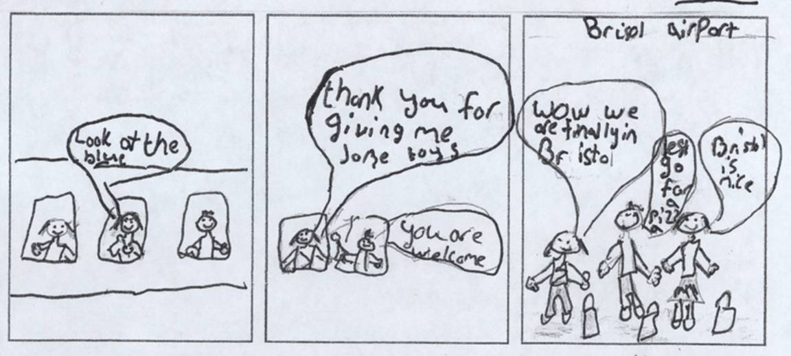

Hannah More Primary’s creative writing

Year 5 class poem.

Made in Bristol

Falcons and adders
Wererabbits and Gromit
Cartons, tobacco
Concorde and chocolate
They were all created in Bristol

Battles and bridges
Coal and soap
Flour and bread
Buildings and cranes
They were all created in Bristol

Cars and planes
Ships and chains
Unicorns, dinosaurs
Giants and pirates
They were all created in Bristol

Hillfields Primary School

Twenty three pupils from Year 3/4 at Hillfields Primary School took part in Portrait of a Nation. They were aged seven to nine. The mixed, non-denominational state school has around 275 pupils and is located in Fishponds, a suburb to the north-east of the city centre that was mainly developed in the Victorian period.

Ofsted Report Description, September 2006

Hillfields Primary is a large school with a wide mix of ethnic groups. Most pupils are from families of White British heritage but there are a rapidly increasing number of pupils joining the school with very little English. Generally the school accepts a significantly greater number of additional pupils into all year groups than is usual. In the last two years many pupils are from Somalia. The proportion of pupils eligible for free school meals is much higher than average. For many years the school has identified a large proportion of pupils as having learning difficulties and disabilities and this continues to be the case. Children start in the Nursery with standards that are much lower than is expected for their age.

The artists were particularly impressed by the enthusiasm and commitment of the children and teachers at this school, and ten pupils from Hillfields will be representing Bristol at the Portrait of a Nation finale in Liverpool.

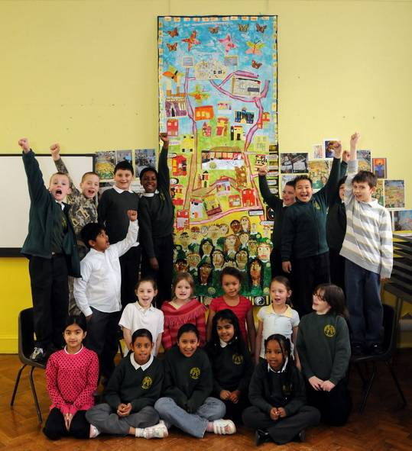
Hillfields Primary pupils with their collage

Hillfields Primary School’s collage

Our banner was based on Our Community. It had a central focus of Hillfields School, with roads based on our local area (we made curricular links with Geography). We went on a local walk of our surrounding area and the children drew local landmarks and roads which were then put into our collage. In the foreground, each of the children created themselves and we thought about all the different languages and faiths that are celebrated in our school. The background is made up of poetry from our butterfly poems about identity and our butterflies show that we are all the same, ie human, however we all have our own personalities and differences. The buildings in the banner represent local landmarks. They were drawn and put into our collage: Cossham Hospital, the local Gurdwara, The Mosque, a local Church, local shops and our homes on the Hillfields estate.

Hillfields Primary School’s comic: sample strip

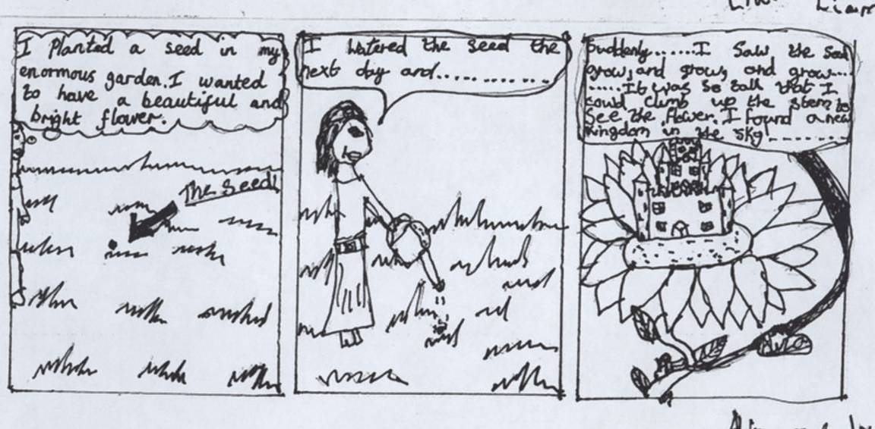

Hillfields Primary School’s creative writing

How Have We Managed to Meet Here?



In Class 3/4M we have been thinking about how we all managed to end up in class together, here in Fishponds, Bristol, as our heritages originate from all over the world: India, Vietnam, Sweden, Belgium, Somalia, Italy, Britain, Ireland, Hungary and Bangladesh and Pakistan.

In a Fishponds Summer have you ever noticed the butterflies? Their wings are colourful, delicate and fragile like skin. They are unique, meaning original and different, and yet all the same.

We thought of some stories and poems to explain how the butterflies would end up here in Bristol. Here are some of our ideas:

Jordon and Gabriel’s butterfly was hungry and looking for food.
Dagmo and Mahwish and Nehad and Sonny’s butterflies came to visit friends and relations.

Beau and Corrin’s butterfly came on holiday to Bristol and liked it so much, he decided to stay!

Briony and Joe’s butterfly was escaping a giant, hairy spider who spun sticky, spooky, smelly webs.

Tahmeena, Marcel and Paris’ butterfly wanted to escape its prison cocoon and see as much of the world as she could in her small life time.

Liam’s butterfly needed to rest after a long journey to find pollen.

Nicole and Janvi’s delicate and gorgeous butterfly was looking for food and shelter.

Dannielle, Nathan and Chris’ butterfly flies for fun and food. A nervous butterfly, who likes to stay away from people, but is always busy.

Shannon’s beautiful black, blue and pink butterfly came to a lovely field full of flowers as her old house blew away in the wind.
Just thinking about these papery, distinctive, pretty, precious butterflies who are here for different reasons, but are all the same and how they came to be together in a class in Fishponds.

A butterfly story
By: Beau and Corrin
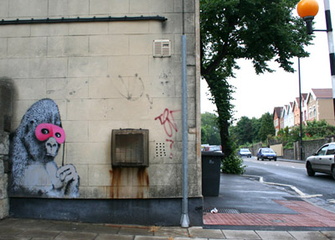
One day, a butterfly set off for his holiday. His name was Joe!
“I’m going on holiday” he would say, so he spread his wings and lifted into the air. He was a well travelled butterfly and this latest holiday would take him far from America- his home and his heritage. Lately he had been getting bored and so he knew it was time to go.
It took him a long time to fly across the world, but he was looking for a landmark- the gorilla with the pink glasses that Banksy had created. He stopped on a wall on Fishponds Road and rested. He looked below and there it was; the graffiti of a gorilla in pink glasses. Now he knew he was in Bristol!
He loved Bristol and decided not to leave. He wanted to enjoy his short life!

Butterfly, Butterfly
By: Tahmeena, Marcel and Paris.
Beautiful butterfly,
Magnificent, elegant, graceful butterfly,
Escaping from her prison cocoon.
She wants to see as much of the world as she can in her small life span.
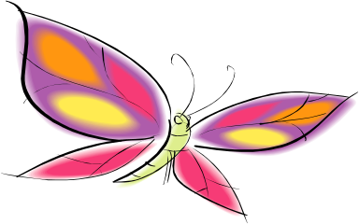
Identity
By: Dagmo and Mahwish
Beautiful butterfly,
Flying fast
Flapping her wings
Travelling so far.
Friends and relations,
Amazing bright colours in the sky.
All of them different
Yet the same.

Butterfly Beauty
By: Nehad
Butterfly, busy visiting fresh flowers.
Butterfly lazing in the hot sun.
Butterfly has brothers and sisters,
Friends and relatives,
Butterfly, butterfly-the same, but different!

The Fearful Butterfly
By: Joe and Briony
There was once a colourful butterfly.She lived in Bristol and her cocoon had been in a shed in a garden.
When the colourful butterfly had escaped from her cocoon,she met an enormous spider.The spider wanted to play with his new friend, but the butterfly was scared and flew away.
The spider made the biggest web and tried to catch his friend to talk….. “Butterfly why do you fly away from me?” the spider asked. Butterfly replied; “You are hairy and ugly and you will eat me!” Spider spoke his last words;
“You have judged me by my appearance and my skin, you do not know me and mow I do not want to know you!”
The moral of this story is: Never judge someone by their appearance. Appearances can be deceiving!

Hungry Butterfly
By: Gabriel and Jordon
The very hungry butterfly
Looking for some flowers.
Swooping from side to side with his delicate wings,
Never giving up his journey
That little determined butterfly.

Colourful Butterfly
By: Janvi and Nicole
A colourful butterfly
Finding food
There isn’t any food,
So she searches for shelter
In the city of Bristol,
This delicate, beautiful, gorgeous butterfly.

A Resting Butterfly
By: Liam
A resting butterfly
After flying a long way
T o find a flower to collect pollen from.
He is black, blue and yellow
He is delicate and fragile
A resting butterfly.

Hungry Butterfly
By: Dannielle and Nathan and Chris
Lovely butterfly.
A butterfly in Summer time, nervous and scared.
She flies in the sky looking for food.
She flies for fun.
She is beautiful and always moving on.

Friendly Butterfly
By: Shannon
A beautiful black, blue and pink butterfly came to a lovely field of flowers as her old house blew away in the wind. The butterfly was a friendly butterfly, but she was sad when she lost her house.

Opening Doors

When I open the door I see people praying. They are kneeling on mats on the floor. I see rows of long pews. Large stained glass windows throw colours all around the Church. Mosaic tiles are dotted over the floor. When I look up I see the roof full of wooden beams. The Church smells beautiful; Fresh flowers, polish and varnish mixed together. In the front of the Church Jesus stands fixed to a gold, shiny cross.
By: Liam

When I open the door to the Mosque I see lots of people praying to Allah. I smell a kind of perfume that you only get in Saudi Arabia. I can hear people reciting the prayer!
I can see lots of patterns on the carpet. And when you go to the praying room, there’s praying mats everywhere and it has magnificent patterns.
Sometimes when I smell, I can smell spices. When I hear, I can hear famous Qur’an recites and the Arabic sounds so beautiful!
By: Nabil

When I opened the door, guess what I saw?
I saw a beautiful field, with the blazing sun shining straight on my face. The sight was irresistible, it made me feel all warm inside. I smelt the vegetables being pulled from the earth, I saw the strawberries growing on the land-“Oh how I love this place!”
I felt the soft, new grass under my feet like a blanket.
“What a glorious, amazing place I have found!” The branches on the dotted trees waved their branches welcoming me. The quaint, bright colours seem radiant in the sunlight. I could see the butterflies flapping their identical wings. They reminded me of us-the same, but different!

By: Tahmeena

When I opened the giant’s door I entered a grass field. Ahead I saw a passageway between two rocks that led to a giant’s cave. I could smell the worst thing, it smelt worse than a dog’s bottom. I kept walking until I came across a mansion. There were two young giants using it as a doll’s house. They thought I was a doll! Their hands were cold and hard. “This doll is real!” “Oh, Oh!” I cried. The giants became angry and picked me up and threw me into an old mine. This mine is full of gold! I tried to carry the gold and leave, but footsteps were heading my way! I’m glad that Bristol has lots of hot air balloons because I caught hold of a passing basket and flew away…..
I’m definitely not going through that door again!
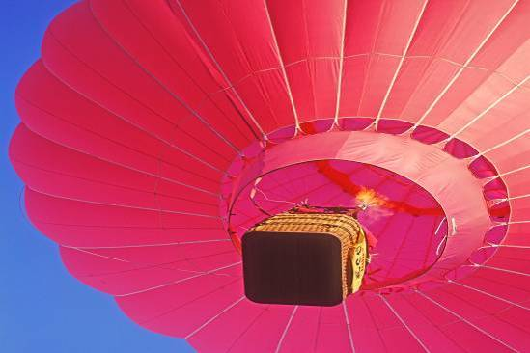
By: Beau

When I opened the door to the cemetery I saw a path. It was all muddy and slippy. I felt scared! There were lots of grey stones. I felt sad and alone! I could smell dampness and I could hear lots of people crying. The air seemed wet!
By: Joe

When I opened the door I saw the playground and the bushes. I saw the sun, the rain and together they made a rainbow!
I heard the sounds of a school: shouting, laughing, singing, chattering, screeching, moaning in the playground.
I could feel the ground beneath my feet that was hard and grey. I could see the building walls and a mural. I could see children dressed in a green uniform playing games and kicking footballs. I could see my dream of a field for our school with soft blades of glistening, shining grass for the future.
By: Janvi

When I open the door to my Dad’s Indian restaurant I see lots of people eating dinner. I smell delicious food and ice cream. I can hear a girl asking; “Who’s the cook? I just love the food!”
I can taste curry, rice, chapatti , dhal and chicken. I say to my Dad; “Can I have some more?” I feel very, very excited, nervous and great. I even feel the food as well in my tummy!
By: Aliza

When I open the door I see my bed – comfy and warm, my Bratz cover makes me feel happy. There are High School Musical posters on my wall and they cheer me up if I am sad. The smell of mum cooking tea wafts up the stairs and through the door. I see my clothes on their hangers and my party dress waiting for my birthday.
By: Corrin

When I open the door, I can see inside a haunted house. The house is spooky and cold. There are cobwebs and eyes everywhere. I can hear a witch laughing and I can smell the witch’s clothes. I can taste contents of the cauldron. I can feel hairy spiders!
By: Dagmois

When I opened the door I saw a fantastically beautiful colourful rainbow arched over the River Avon. Don’t you wish that you could see the same as me?
High up in the sky I could see a red, blue, green and pink air balloon floating gently over the Suspension Bridge. The sound of the hot air going into a balloon echoes in between the cliffs.
By: Aaron

When I opened the door I saw a cemetery. I opened the black gates and they creaked. I walked along the grave stones. In my imagination I could see skeletons coming out of the ground. I heard something snap behind me. I was frightened.
By: Sonny

When I opened the door I could see chocolate on the shelves. I could see rows and rows of Crunchies, buttons, Mars bars, Snickers and Twix. I wanted to buy all of the chocolate! The smell of the chocolate filled my nose: dark chocolate, milk chocolate, and white. I could see children waiting in a queue chattering excitedly, money jangling in their pockets.
By: Marcel

When I open the door I see a really fun party. People are wearing party dresses and playing games. I can smell perfume from the mummys and I can smell chocolate and cream cake. I can hear children screaming and laughing. I can taste the sandwiches and sausages on sticks.
By: Dannielle

When I open the door to my church I see people praying and singing religious songs. I go inside. The people welcome me. I smell polished wood, varnished floor and lots of fresh flowers. Beautiful colours jump from the windows as the sun shines through them. Rows of pews with handmade cushions stare back at me.
By: Nicole and Kayus

When I opened the door of the aeroplane in the sky, everywhere was blue! The clouds were fluffy and white and they looked like pillows to sleep on.
I looked below and the ground looked like a Monopoly board. The houses looked like plastic play houses on a game board because they were so far away and so tiny! As the plane flew on and time passed the light became dark and we knew that soon we would be home.
By: Bryony

When I opened the door I saw a dark and spooky cemetery. Suddenly this skeleton rose out of the Earth. Next a vampire flew past me looking for blood. He stopped and told me I had to follow him. He took me to a pillar by a gravestone and opened the marble door. My Dad was sat through the door with the controller to the computer game, and now I knew this wasn’t real, it was all a game!
By: Nathan

When I open the door I see a sport’s car. The car is perfect. I could see the wheels shining on my car. I look inside the car and I can see a leather steering wheel and a long dashboard.
By: Chris

When I open the door in a mosque I see some people praying to Allah. I can smell some incense. I go upstairs and I see some magnificent, beautiful prayer mats on the wall, I touch soft cushions on the floor. I can hear some people singing! I can see patterns on the floor and no colours on the walls. I can hear the chanting and I follow.
By: Paris

When I opened the door I wondered what was on the other side, then I opened it! It was pitch black and then a monster came and popped up into my face! Suddenly I woke up. It was all a dream!
In my dream the monster was very scary. He had very, very sharp teeth, he had some blood on his fangs. He was green and horrible. This monster comes out in Bristol haunting the dead in the churchyard. When a person is buried, the monster digs a huge hole and opens the casket and drinks the blood of the dead person.
By: Gabriel

When I opened the door to the cemetery I felt sad and alone, I could smell damp and unhappiness and I could hear lots of people crying. The air seemed wet!
By: Joe

Kingsweston School

Kingsweston is a non-denominational community special school of around 150 pupils who can attend from the ages of two to 19. The high garden-walls around the school are the last remains of a Tudor mansion but the school itself was built in the 1930s, originally as a Dower House and then becoming the first primary school in the large post-war housing estate of Lawrence Weston. The ward of Kingsweston, which is in the north-west suburbs of the city, also covers Coombe Dingle, an area developed in the inter-war years, and Sea Mills, an old Roman settlement that became a garden estate after the First World War.

Ofsted Report Description, January 2007

Kingsweston School is a large and complex organisation. Most pupils are taught at the main site, but the school also operates what it refers to as ‘satellite class bases’ in partnership with… local schools. Almost all pupils speak English as their first language and a very large majority have a White British background. The pupils have a wide range of learning difficulties and virtually all of them have a statement of special educational need. In most cases these statements identify autism, severe learning difficulties, moderate learning difficulties or difficulties with speech and communication as the primary disability. There are more than twice as many boys as girls on roll.

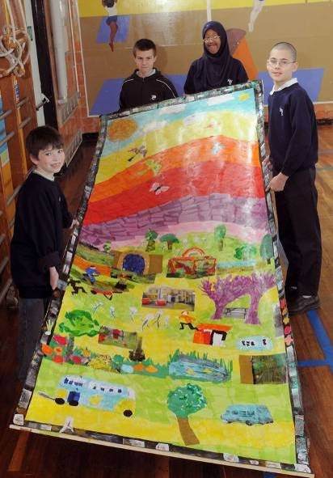
Pupils at Kingsweston School with their collage

Thirteen pupils in their early teens took part in Portrait of a Nation.

Kingsweston School’s collage

The pupils at Kingsweston have included images inspired by their school’s garden in their collage.
Kingsweston School’s comic: sample strip

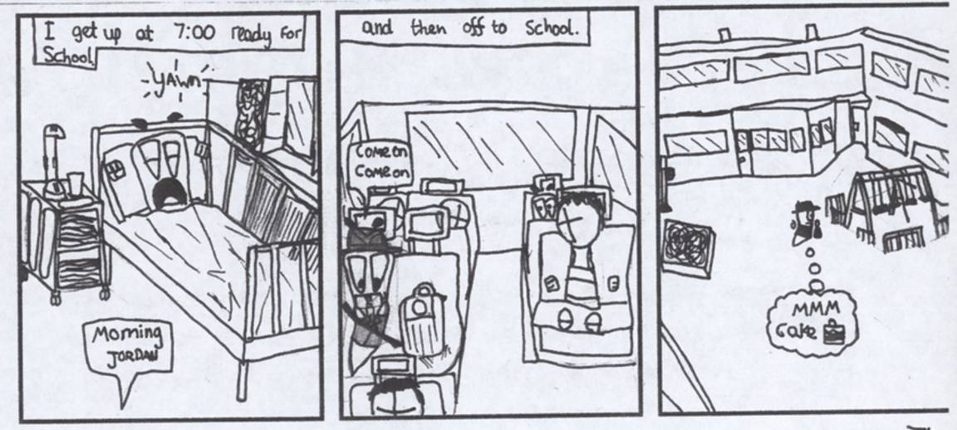

Kingweston School’s creative writing

Secret Garden

At Kingsweston House School, there is a secret garden. The garden has a large pond, hedges and a high wall.

During the day, when it is sunny and the sky is white, you will find in the garden:
An apple tree with round red apples and long brown branches.
An oak tree, with acorns; A tall coconut tree.
A door made of wood
A nice, tidy mouse
A tiny tigerfish
A wooden bench where Angelica sits crying because she misses her nan. She can’t stop crying because she’s so sad.
Beautiful flowers, ten yellow daffodils and a red rose.
An old man, with a walking stick and an old lady with lots of wrinkles.
A big light green caterpillar.

As evening falls, the grey moon comes out and the yellow twinkling stars:

When it gets dark the apple tree becomes a vicious boy-eating tree with scary red and black eyes.
The oak tree becomes a talking tree, he has a mouth with which he talks to the mice and the stars.
The coconut tree grows arms and legs and talks. It starts throwing coconuts at people.
The door becomes a golden, magical door, that opens on its own, without a key.
The mouse becomes an angry, messy werewolf, with sharp teeth.
The tiny tigerfish becomes a massive, purple whale, spouting pondwater.
The daffodils and roses grow tall and bend over to drink water from the pond, because they are thirsty.
The old man becomes an angry rottweiller, who is very bossy. The old woman becomes a happy poodle, very hairy and wearing a big bow in its hair.
The caterpillar becomes a wiggly dark green snake, sleeping in the grass.
On the wooden bench, Angelica is still crying, but she is also happy because she is looking at the baby photos of her nan playing with her and hugging her, as a baby.

When the new day comes, all the strange and wonderful things stop their party. Everything goes back to normal.

Little Mead Primary School
Nineteen pupils took part in Portrait of a Nation at Little Mead Primary School. The mixed, non-denominational state school has around 250 pupils. It is located in the suburb of Southmead, in the north of the city, an area developed in the inter-war period then expanded further after the Second World War.

Ofsted Report Description, January 2008

Little Mead Primary School is larger than the average-sized school with an attached Nursery. The school was opened in September 2006 following the closure of two local primary schools, and the number on roll is increasing. The school serves an area of Bristol with significant social disadvantage and a very high proportion of pupils are entitled to free school meals. The majority of pupils come from White British backgrounds but the proportion of ethnic minority families has significantly increased this year, including those who speak English as an additional language. A small proportion of pupils who attend the school are in the care of the local authority.

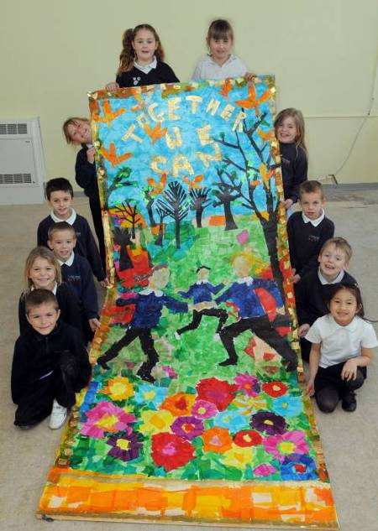
Pupils from Little Mead with their collage

Little Mead Primary’s collage

Little Mead’s collage includes the leaves which are the school’s symbol and the school’s motto of Together We Can.
Little Mead Primary’s comic: sample strip

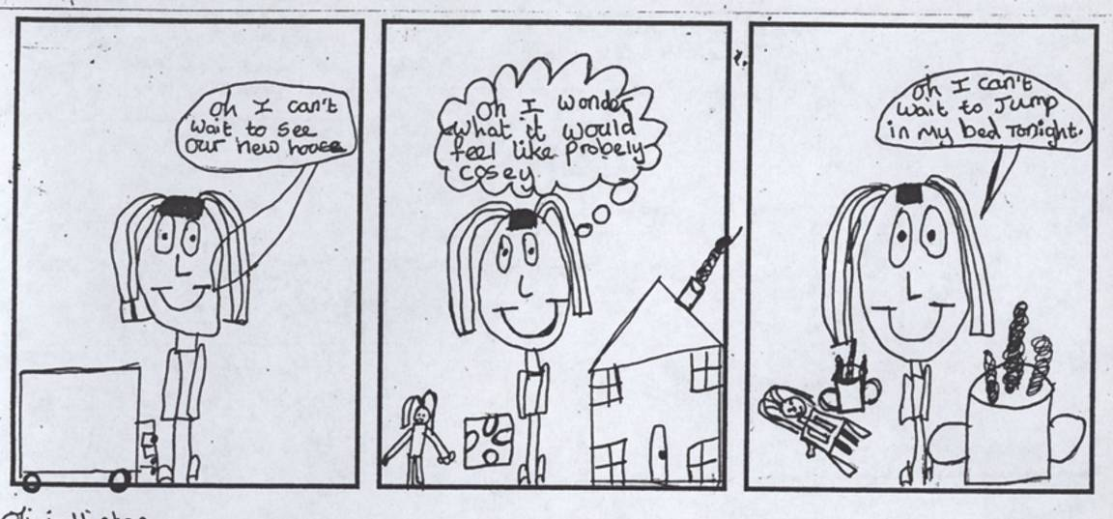

Little Mead Primary’s creative writing

Group poem by Year 6 pupils.

Bristol Round

Concorde and cables
Chocolate and cartons
Copper and candles
They’ve all been made in Bristol

Bridges and boats
Bristol and Pero’s
Banana and Suspension
They’ve all been made in Bristol

Glass and soap
Trams and trains
Cars and planes
They’ve all been made in Bristol

Blankets and robots
Self-raising flour
Paper and ribbons
They’ve all been made in Bristol

Wallace and Gromit
Films about nature
Wildscreen, Explore
They’ve all been made in Bristol

Shot towers and pirates
Myths and legends
Giants and dinosaurs
They’ve all been made in Bristol

Battlers and builders
Sellers and shapers
History-makers
People like us
We all make the story of Bristol

New Oak Primary

Three groups of pupils took part in Portrait of a Nation at New Oak Primary. There were 31 Year 6 children, aged ten to 11, who did collage, creative writing and comic-book workshops, and two groups of 25 children, one each from Year 4 and Year 5, who did drama. New Oak was created in 2006. It was threatened with closure in 2007 when there were plans to incorporate it into a new three-18 years academy, but this was shelved. The school is in Hengrove, a southern suburb.

The Year 6 pupils were another particularly enthusiastic group of participants in Portrait of a Nation, led by a supportive and imaginative teacher, and they might well have been chosen to represent Bristol at Liverpool if it was not for the fact that they will have transferred to secondary school by the time the finale takes place. As not all the sites could complete the full programme of workshops, some additional sessions were allocated to New Oak because the school had made such good use of this opportunity.

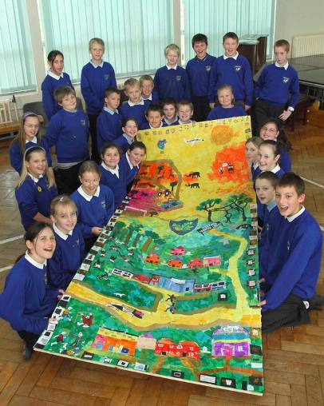
New Oak Primary pupils with their collage

New Oak Primary’s collage

Working with Gloria was great fun. The transformation of the large blank pieces of card into what you see here was amazing. Gloria helped us to think about our local area and what is important to us in our part of Bristol. We divided the banner into sections – our local community, the amenities, the people, the buildings; our memories of growing up in the area; the activities we take part in; we also included aspects of Bristol that are significant to us for example the building of Concorde, the Balloon Fiesta, visiting the Zoo. Gloria helped us to bring our ideas to life. Showing us how to use vibrant colours and how to get the perspective right, she also helped us to show the figures as moving characters not just static. Our School logo is at the centre of our banner as this is one of the most influential places in our lives. So we also included our school building as well as children playing together. Gloria was very keen that everyone took part and that we all felt that we had contributed to the making of the banner. Some of us concentrated on producing the background whilst other groups took responsibility for particular aspects. Learning to work together and accepting that we were able to rely on each other were major aspects of the whole process. We would like to say a huge thank you to everyone who made it possible for Gloria to work with us, and an extra thank you to Gloria for enabling us to produce a banner that we feel shows that the community of New Oak Primary School in Hengrove is a worthy part of the wider community of Bristol.

New Oak Primary’s comic: sample strip

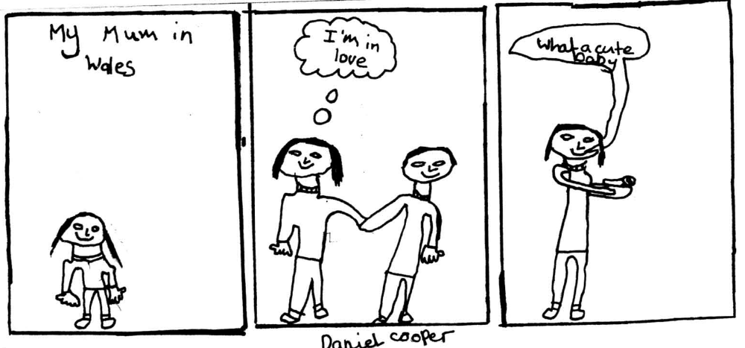

New Oak Primary’s creative writing

The Hengrove Legend
Back in the days before humans had even been thought about, before time was being counted, there was a place called Henwood, which as the name describes, was full of hens and trees.

The hens were very happy under the trees, because they were oak trees and there were always acorns to peck at and worms and ants to eat.

There were predators, such as foxes and eagles that stalked the hens, but nothing was more feared than the Devil Dragon that lived under the earth. No-one had ever seen a Devil Dragon, but the stories made their hearts tremble. Even the trees were afraid. But most of the time, everything was happy in Henwood, with only the occasional hen getting snatched by a fox, or carried away by an eagle.

On one snowy Winter morning, the trees were acting strangely. They shook, their trunks swayed, even though it was a very still icy day. The hens looked up from their acorn stores and clucked to one another. They could feel the tremors underneath their feet and they could only imagine what was coming!

The small tremors turned into big rumbles and the big rumbles turned into huge cracks between the trees and that is when they saw it. The Devil Dragon had arrived with his huge belly. His claws were made of steel. His wings were pink and purple, with razor-edged tips that ripped into the old oak trees and felled them into the cracks in the ground. His legs were as sturdy as columns and his blood was as hot as lava.
His fiery breath was like an explosive sun, burning and spitting, consuming the branches of the tallest oaks.

The chickens screamed in panic, as the sharp fork-like dragon-tail speared the hens alive and fed them into his mouth, gated with sharp teeth. None of the hens stood a chance, disappearing into the Devil Dragon’s mouth one by one. The trees collapsed down into the hole created by the Devil Dragon’s eruption.

The Devil Dragon was not going to be satisfied until he had burned all the trees, so he flew up high into the sky and swooped down towards the last clump of oaks. But the Devil Dragon had misjudged his dive and flew straight down into the hole from which he came. The whole world shook at his crash landing and some of the dragon’s body emerged through the ground.

For a while this area was named Hengrave in honour of the hens that died that day, but later people forgot that the hens had ever lived there and so they called it Hengrove after the few remaining trees that you can see by the school that now stands there.

If you look carefully, you can still detect signs of the Devil Dragon. Sometimes you can see his wings in the beautiful sunsets over Hengrove. Sometimes you can feel the warm wind of his breath on a Summer’s day, but you can always see his legs, which are the pillars on the gates of the school and the gates are made from his steel teeth and claws. If you look towards the Horizon, you can picture his big belly sticking out, making Dundry hill.

And the school is named New Oaks after the little acorns that grew into baby oak trees years after the hens had died and Hengrove had forgotten about the Devil Dragon, but we know don’t we – when we see the sunset and feel his warm breath on our cheeks.

Postcards from the city: today and in the past

January 24 1828
To Stacey

I miss you. I wish you were here. I’m staying at Temple Street. The flat I’m staying at has lovely views of Queen Square. I went on a wonderful walk near the High Street. I’m having a fantastic time. Tomorrow I’m going to Michael’s Hill for some fun with my new friend. And all I hear everyday is seagulls.

Love Somer

To Dad

Writing to say hello I’m in Bristol. I can see the Galleries in the distance. I see a part of Trinity Quay. I see Castle Park. I’m living in Nelson Street. Yesterday I went to the RSPCA Animal Clinic, my dog was injured. She had a bad leg. How are the planes going? Can you take me on the A380 please.

See you soon. From Curtis

PS Bye for now!!!
6 April 1800
Dear Danny

I am staying at Bristol and it is spectacular! Amazingly, they have done well with their buildings (like the Equestrian Theatre)! I enjoy going to Queens Square each day for a couple of hours and I play bowling with a couple of other people. Their names are Joe, Eddie and Scott and they enjoy a couple of hours of bowling as well. I’m off now so I’ll write to you again soon!

Best wishes Mitchell

Dear Georgina

Hi. I’m in Bristol at Temple Street. I’m having a great time and I’m missing you lots. Next I’m going to Queen Square today but yesterday I went to Church Lane. I went past the Temple Gate and went past where you were born at College Green Street.

I’m coming back soon. Bye. Love from Carly

Dear Mia

Hi. I’m in Bristol and staying near the Cathedral. The weather is lush. I’ve just walked to Queen Square and the park. Tomorrow I am going to Clifton to see the Suspension Bridge with friends. I am having a great time. Wish you were here.

Love from Laura

1250
Hi Jim Bob Jnr

I wish you were here. I’m staying at Frog Lane. Tomorrow I’m going to Brandon Hill and then I’m going to the castle but to get there I have to go across the river and over the cross roads. You will like Queen Square. They play bowls there.

Love from Jim Bob

Dear Somer W

I’ve been having a great time here except for the disgusting people who keep throwing their waste in the River Avon. Hope your poems are getting along well.

Truly best wishes Stacy L

PS I live at number 16 on Corn Street. I have the biggest house on the street. See you soon!! XXX

1606
Dear Travis

I am staying in the hotel in Queen Square where you can see through the window people bowling. I go for a walk to see the priory at Whitefriars. I like a holiday. The tavern on Pithay Bridge has fantastic food. It’s healthy food.

Love from Leanne XX

PS Happy Birthday to you.

Dear my mate Sprite

Hi! I’m in Bristol now! It’s astonishing that I’m here when Liverpool are playing Bristol City. Since I’m such a supporter I’m off early to the game. Hope I get there in time, Bristol has a lot of traffic problems! As I found out when I was exploring today. It took hours to get from Mitchell Lane to our hotel at Old Market Street.

Your best mate Eddie Brine

To Samoul Park

I went to Queen’s Square today to play bowling with my Gran. She loves it. Firstly we went to College Green to have lunch but my Gran forgot the sandwiches. We stayed there for a bit and played bat and ball. A couple of minutes later we went to pay for the boat trip down the River Avon. Finally we went home and had tea and went to bed. It was a great day.

Best wishes Georgina

Dear Corbin

In Bristol it is amazing because I’m right next to Temple Meads. I look out the window and see the first class trains. I walked up Castle Green as a result of that I walked past the Galleries. There were very nice and colourful shops.

Best wishes Scott

1794
Dear Chelsie

I am staying at Sasha’s house on the High Street. Yesterday I went over the bridge which runs across the Avon River which of course smells of sewage. It is much bigger than Great Great Grandad said in 600. On Saturday I walked through Queens Square where people were bowling. I had a go myself but I wasn’t very good! I also went through Corn Street which was jam-packed with people.

See ya from Sophie XX

PS On the way back from Queens Square I went along Kings Street. It was great because I saw a lot of very old buildings. Bye!

Dear Bunny

You’d love it here! Grass everywhere, greener than you have ever seen in your life. Brandon Hill would be one huge playground for a bunny like you. Only trouble is everyone comes here for their afternoon walk. I am staying in George Street.

1800
Dear Courtney

Today I visited Bristol. On Queen Street it was very posh and romantic but then I went to the Grove on the Avon River because it is nice and relaxing.

Love from Nicole

Dear Adam

I am having a great time where I am staying at Frog Lane. I met lots of new people at Lime Kiln. I have a hangover. See you soon.

Your dear friend Curtis

1815
Today I have been to Queens Square and it was busy and I bought you something but I’m not going to tell you what. After I went through the city centre to Broadmead. It was quite quiet.

From Triple H

Dear Bill Bob Joe

How are you? I am good! I am living in the hotel by Wine Street. Where are you living?

Did you know my dog is dying? And I’m living right next door to a famous actor. I got you his autograph for you.

Have you been to the theatre? If you have not, you can go with me and watch it with me and get some pop corn.

Speak to you soon. Best wishes Travis

Early 1700
My stay at White Lodge, has been terrific. The staff have been kind and I loved it. In my hotel room you could see St Michael’s Church out of my window.

On my last day I walked to St James’ Church. It was a very magnificent sight. Can’t wait to see you soon. From Chris
Dear Bob

I am staying in a place called Queen Square. The seagulls are squeaking. It’s absolutely fab. The view is spectacular of the fish. I am going to a place called Hotwells. Hope you write back.

Harry

Dear Olivia

As you know I am in Bristol and I am having a great time. I wish you were here, you would it enjoy so much. The other day I went for a walk. I went to Brandon Hill Nature Reserve and then went to Cabot Tower. It has changed so much I couldn’t believe it. I am staying at a place called Clifton Hill. The houses are so tidy and they make you so welcome.

Best wishes Laura

Dear Laura

I am off to Bristol!! Everyone’s really nice and welcoming but I’m missing everyone at home. There’s lots of ice cream, landmarks, icecream, the ss Great Britain, but the ice cream’s really creamy. The Victoria Reservoir has to have the best turkey. You’d love it!! I went to the Park called Victoria Park. It’s amazingly cool. It’s a really green place. After I went to the Mall Galleries. It’s huge.

Wish u were here too – Ollie XX

1800
Dear Mrs Sloober

It’s lovely here at City Hotel on Queens Parade in Bristol waking up every morning, hearing the wildlife outside. Did you know I love football? Sunday morning it was great. A football match was on. I can’t believe it. Bristol City vs Bristol Rovers was an outstanding game. 12-0 to Bristol City. The best score I’ve ever seen. Bristol has amazing facts and great history. They’ve got amazing tours you could go on. You should come one day. It’s not that long from London.

Best wishes Ross

11/4/1697
Dear Emily

My visit to Bristol is amazing! I have been staying in the White Lodge, where all the food and drink is wonderful. Yesterday I visited St Michael Church. Inside was beautiful and the stained glass windows were so colourful and bright. Tomorrow, I am thinking of visiting the Bowling Green. It is also called the Queens Square. I have to cross the River Avon every day to get into town.

I hope to see you soon. From Ellie
1922
Dear Chin

I’m in Bristol in Pithay Bridge and Gate. It’s nice where I’m staying. I’m just outside the city wall. It is nice all over. It’s called the River Avon. There is a Bridge that leads to the city. It’s called Pithay Bridge.

Love from Chin

1600
To Laura

I’m living on Corn Street. It’s really busy and the people are really nice. I visited Wine Street, Broad Street and the High Street. Corn Street Market is fantastic! There are lots of things you can buy and trade. I’m really missing you and I wish you were here. I didn’t realise there is so much to do, like boat rides and going to churches. The place where I am staying is very pleasant and welcoming. The food is delicious and really scrummy. The rooms are luxurious. Wish you were here.

Best wishes Stephanie

PS I visited the River Frome.

Opening doors

Open the door on Bristol
By: Ross
Open the door,
And let the breeze flow through,
Maybe the sun might
Just shine down on you,
Or maybe there’s a dog rummaging in the garden

Go and open the door.
Maybe there’s a Victorian house,
Or a medieval castle,
Or a magical city.

Go and open the door.

You might just hear the
Birds chirp, or cat purring
Waiting for tasty bites,
Go and open the door.
Even if there’s not much there,
Go and open the door,
You’ll never know
What you will find in Bristol

I open the door to Fry’s chocolate.
The sweet smell of sugar, mile and cocoa. I have chills through my spine from the nice cool chocolate. A big truffle lolly right in front of my eyes, it’s a dream. I open the door, a big chocolate fountain. I hear “eat me, eat me.” I take a bite of the deliciousness. A lift opens, I go up and up. Higher and higher till I get to the top. The door closes behind me. I look around. I faint. I wake up.
Chocolate talking to me, this was a dream.

In the bedroom
In the bedroom there are books and toys but one book is special. It opens a portal to a wonderful land of colours. There are red people, green dogs, brown and green grass, orange glass, In another door there is a green monster, a dinosaur with a long neck. In another there is a cave man in a pool that lived in the prehistoric ages. It is me!!!!

The ancient Thecodontosaurus (the Bristol dinosaur)
Go and go into the boulder door. Maybe you will see red flashing eye, moving, with red blooded claws.

Go and go into the boulder door. Maybe you will see a spiky thrashing tail, with skulls on the floor.

Go and go into the boulder door. Maybe you will see dripping red jagged teeth.

Go and go into the boulder door. Maybe you will see a strong powerful flamethrower coming towards your way!!!

Go and go into the boulder door. Maybe you will see a whole fleshy body of the Thecodontosaurus.

Go and go into the boulder door. Maybe you will be dead or alive, with your darkest dreams!!!

Bristol poem
By: Stacy
Open the door you might find something special, open the door you might find the suspension bridge, open the door, you’ll never know what you will find. It’s up to you what you will find, it’s your mind. IT’S BRISTOL!!

Bristol City
Open the door and Ashton Gate will be noisy there. Walk on the shiny grass. And see Steve Brooker. And see the squad. And see their sparkling boots in the air. Walking in the crowd. Seeing all the players kicking the ball in the back of the net. Open the door and play football with all the squad. Open the door and smell the freshly cooked hotdogs. Open the door and see the dream of your life.

The story walking through the doors
By: Somer
Go and open the door;
Even if there’s pirates.
And even if they’re sleeping.
Open the elm door.
Maybe the day is breathing.
If it is balloon day.

Walk to the door.
Even if it’s on the floor.
That was destroyed.

Run to the elm door.
Even if there are panicking people.
Because they are bombing Bristol.

Go through the mirror and see yourself as THECODONTOSAURUS.

Ahhhh!

The hidden dinosaur
By: Martin
Go and open the tooth. Maybe you will see a talk whacking the trees.

Go and open the tooth. Maybe you will hear a voice like a roaring noise.

Go and open the tooth. Maybe you will see a red flashing eye moving.

Go and open the tooth. Maybe you will live or die by the dinosaur with his powerful flamethrower coming that way.

Ahh! The Thecodontosaurus.

The metal gate
By: Bradley
I open the metal gate. I walk through and land in Hengrove Park. The first thing I see is the enormous swirly slide. I run as fast as I can to get to it. I’m here! I go really fast down it. I was going so fast that I jump the fence and land on a swing. When I finished I was so worn out I had to get a drink. Slurp!

I opened the door
A chocolate butterfly led me to a door. We were in Fry’s chocolate Factory. The sweet scent of chocolate reaches my nose. In front of me there is a luxurious chocolate fountain dripping down. There is a bowl of little marshmallows sitting by the side of it. The butterfly brings me them and I dip one into the chocolate from the fountain. I move on and the chocolate butterfly disappeared. It is nearly time for me to leave, but before I do I have got to have a taste of this yummy chocolate animal.

It’s a delicious butterfly!

Open the door, please
By: Josh
Open the brass handled gate. Take the path down already smelling chocolate coming out of the chimney.

Taste the fudge centre, watch the fountain flow.

Look at the gooey caramel centre and the Turkish Delight before it dries.

Fry’s chocolate factory
Open the door, open the door, smell the waft of fresh chocolate.

Open the door, lick the air, eat the chocolate, lick your lips.

Open the door, open the door, jump with joy, eat some sweets, shout out load with candy cries.

The door shuts. That was the best day ever. The waft goes away but my tummy says “Hooray”.

Pirate HQ: Danger: Keep Out
By: Curtis

Open the door and walk the planks,
Open the door and fight with my sword,
Open the door and sail the ship,
Open the door and fire the cannon,
Open the door and cross the sea,
Open the door and wear the eyepatch,
Open the door and say arhrrrr,
Open the door and let your parrot talk,
Open the door and eat raw meat and chicken legs,
Open the door and see the map,
Open the door and find glorious TREASURE!!!!!!!

The zoo
By: Laura
Open the door,
Open the door to a stable
See what’s inside. A zebra.
To see what is inside
You need to open a metal door to a lion.
Open a glass door of a spider.

My door of black thorn
By: Olivia
The thorn door, roses surrounded me. “Prickly!!” Hands cut as soon as I touch it. The black rose. “Ow!!” The thorn sticks into my neck. Darkness, shame, depression, fish? I’m in the soft current of the Bristol channel, like jumping on fluffy clouds, spinning round a whirlpool and land slowly and safely on the ground. As I rise from the water the bubble pops. I start floating on stars of Bristol sky floating into dreams.

Bristol City
You walk into the ground, with a lot of sound around, thinking about the songs to sing, ee ii ee ii oo up the league we go, with the red and black kit. You walk into the ground with the munchiest game around. With my city tracksuit and hat to watch Bristol City kick the ball about.

Come on you reds!

I open a door
By: Emily
I opened the door to the roof of the Council House. The bright shine of the golden unicorn reached my eyes. I touched the unicorn, It felt like solid gold. The unicorn picked me up and gave me a ride around Bristol. I saw the suspension bridge and ss Great Britain. Then the unicorn slowly disappeared and I appeared next to the door of my house.

Departure
I opened the door. There are security men with guns. Then I walk over to check-in. We show our passports. They ask me questions:
What’s your name?
How old are you?
Do you have any one with you?
We go to Gate Two (where it said) Announcements “Can Gate Two get their boarding cards ready?” “Boarding cards, please” an air steward announces.
I see loads of people.
I am on the plane ready, set go!
In the air. I looked over Bristol. The houses and people get smaller and smaller like toys. Goodbye, Bristol. See ya soon!

The pirates
By: Curtis
I open the door. People flee. I look around. I see nothing but the wrecked ship I’m staring at. I hear pirates. I try to run but Blackbeard spots me. They have me up. I pull out my knife. I cut the rope. They caught me again. They made me walk the plank. I jumped. There was a sea monster with his mouth wide open. He gobbled me whole. I woke up. It was all a dream.

The Bristol door
By: Nicola
I opened my door into a cave. I heard silence ticking, tick tock, tick tock. I went into another door and there was a dinosaur. I went and saw the giants Vincent and Goram and Avona. Then we went to Fry’s and then we went home and I imagined that the giants said “Come and see us again!” The end.

Pirates’ door
By: Carly
Open the door you might find a parrot on a wooden table by the glass ship.
Open the door you might find an under water world with under water wreck.
Open the door you might find a map by the nice pirates wearing rags.
Open the door you find treasure in a cave on the sand with something special. It’s a jewel. It’s Bristol!

The dog kennel
By: Sophie
Go through the dog kennel door and see what is inside! You’re on a dinosaur!
You drink fresh water but notice you’re a German shepherd! You can see the door on top of a Thecodontesaurus! You jump on it but slip and fall in the door!
You land on a seat, in the terrible heat! But what is this? You’re normal but wearing pirate clothes. There’s a port! You go on it and see a man selling cigars! There’s the door! You go through the door!
Go through the kennel door! You fall in a big post of chocolate! You swim down to the bottom, but you can’t hold your breath any longer! There’s the door, “Swim through!” You land on your feet. In the middle of a street! There’s a restaurant so you go in it to eat. You eat roasted pig, but don’t like it, so you spit it out! People chase you so you go through the door.
You’re at home. The microwave hasn’t pinged yet! So you don’t need to move; sit back and relax!!!

Open any door to Bristol!
By: Chelsie
Open the oak door.
Certainly there are swishing rainbow balloons in the lilac sky.
Go and open the door and feel the blowing breeze on your face on the suspension bridge.
Go and open the oak door and see the busy rush-hour on the dashing streets of the city centre.
Go and open the door, join the crowd of speedy shoppers in The Galleries.
Go and open the door, and see the great ss Great Britain on show among all of the other shiny boats.

Letters from history
99 Stone Road 81 Swampy Woodlands
Stony Beach Tree Avenue
Pebble Town Dirty Swamp
TS19 7LA TN14 9SQ

27/3/79 879BC

Dear Avona and Vincent

I am writing to you to congratulate you on your marriage. I think you deserved Avona more than me, and I am really happy for you both. Never the less, I still have a happy life in Swampy Woodlands. I have made a couple of new friends. Obviously I miss you, but I am happy if you are happy.

Moving on, I have been thinking about moving to where you live. I thought it would be fun because then we could be next door neighbours!
I hope to see you soon,

Love from

Goram

The Unicorn Samson Street
78 Uni Road 39 Sam Road
Uni Street The Sams
BA1 8GN B94 5SP

Dear Unicorn

I am writing to you to say that all of the unicorns are travelling towards our town and knocking over all our bins, causing chaos. Please come and tell them to shoo shoo.

Furthermore, I need to inform you that as your horn and your body are so big, please do not step on anyone. As there have been complaints about injuries to townsfolk.

Therefore, I am offering you a job called Pony Express where you can pull people along to different places. Where you can realise the full force of your body weight all day long.

Yours sincerely

Georgina B

Sargent’s office France
Bristol Battlefield
Hengrove Bomb Shelter

27 March 1915

Dear Sarge

As I shiver over here it is torture with how cold it is. I’m finding it hard to hold my weapons. Nevertheless, soldiers are dying to save their country and to do their jobs. We all need water and food, plus we need recruits to help us save England!

At the moment I am in a shelter waiting for them to let their guard down. There are peaceful moments when I stare at the poppies, may be I’ll take one home. I hope we see each other once again at the end of the war!

Yours sincerely
Adam

84 Bridge Town 48 Vine Lane
NRN B891 BS14 9RN

Dear Isambard

Your bridge had loads of people on so it was obviously very strong. You must be impressed.

Excitedly I met Vincent. We said that the party was massive. I liked the fireworks. And I think that everyone was happy.

Yours sincerely

Tarzan

21 Funky Field 51 Swampy Woodlands
Sandy Beach Tree Avenue
Bubble Road Ducky Pond
IS19 XMT STD14 NSQ

Dear Avona and Vincent

I am writing to you to congratulate you on your marriage and also how I sill live at Swampy Woodlands.

Obviously, I miss you both and as long as you’re happy I don’t mind. While you have been living happily I have been building a better house for me to live in. Vincent, you did fairly won Avona. Well done!

Hope to see you soon again, also how are you getting on?

Best wishes, Goram

268 Frog Belly Road 3 Bunkett Road
England Liverpool England Bristol
BS24 8FU BS01 9QJ

Dear Mark Barruad

You are a fantastic owner. I am now five years old. I was born in 1884. I love you lots because you feed me and groom me.

Are you ever coming to see your long lost pet? Please come home. I do miss you lots, Mark.

I’ll write to you again soon, Mark. Hope to see you soon.

Yours sincerely

Your best dog Nipper. Love you.
38 Miston Road 42 Wizcraft Road
Knowle Knowle
Birmingham Bristol

24 June 1348

Dear Monk Chen

Having to watch most of my friends dying here is dreadful. I got attacked at one point where I was just strolling down a street. The person I got attacked by was a person who had a disease. He was coughing up black blood, the horrible disease was called the Black Death. I was frightened to death at that moment and now I have lumps on my armpits.

The lumps on my armpits are called Bubous. Most of my neighbours have it. I’m very unfortunate because I’m the first one to get it. People say I’m going to die very soon because it is that serious.

Best wishes

Sister Stacy

William, King of England 87 Crossway Road
The Big Castle BS4 2SU
London, England Knowle
England, Bristol

17 December 1066

Dear William

Bonjour! Your work has inspired me! I know that you defeated Harold and crowned yourself king.

I want to be your Lord of Knights who can rule other parts of the country. I know that Anglo-Saxon Society in England was destroyed in the afternoon. I will be your humble servant.

Yours faithfully

Mr Dr Professor Brine the Traitor

Dinkido 16 Prencess Women
U210B 18 B226P

Dear David Jones

I’m writing to you to get transferred because my captain is a stupid captain. He dances around the room.
My nick name is Ostin Powers but my real name is Owen. My friends play footstick and jump on each other at the port rooms. I want a transfer please.

Yours sincerely

Captain Fienes

BS14 NS7 The pirate
Mowcroft Krall Pirate Street
Hardcliffe BS14 9SN

Hello friend

Arrrrrrr, matey. Want to go on a quest with me and my friends? Arrrrrrrr let’s go. We’ll go about a mile, matey. Who are they? The pirates. I killed the dragon and we got the treasure. We are the masters of fire.

From Joe Weaver

King’s Road 47 Red Die Road
Bristol Bristol

2/ 4/ 1135

Dear King and Queens

I should inform you that the roads are full of dead bodies and people dying because of this dreadful thing. People will rebel if you do not do anything for us. Dare you to disagree that the streets and roads are a mess? Clearly you do not know that people are dying. People will over throw you and take your throne and kingdom away from you.

Yours sincerely Dragon Seeker

Brother David 4 Shanghai Road
Whitecroft Road Asia
England

24 June 1348

Dear Brother David

Here I am in Asia. It’s very hot, therefore I’m sweating. I’m having a fantastic time.
However, there’s a disease going around and I’m absolutely panicking. There’s people dying and coughing up blood.

Please be careful, don’t come over here, and be careful over in England because it’s spreading over to England.

Best wishes Somer Wilson
22 Boat Lane
Morocco
M21 496

66 Ship Avenue
Tunisia
T21 49V

16 August 1235

Dear Blackbeard

I am the captain of the Barbary Pirates (also known as the Salee Rovers, Turkish Pirates, Barbary Corsairs and Algerian Rovers) and I am writing to tell you about things you might be interested in. We have prisoners which we captured from France, Spain and Italy and there are abandoned ships in the Mediterranean, all good enough to commandeer away. The prisoners are not Muslim because that’s our religion and we will not arrest our own good people. During the timespan of now and next year, 1236, I will like to meet with you.

Yours sincerely

Captain Dursey

University of the Dinosaur in Bristol
Professor Dooda
University of Bones and Fossils in France

Friday 1 March 1866

Dear Professor Dooda

I am writing to you from Bristol. We are researching a new dinosaur.

We have found some of his DNA samples and we are working on it right now.

It’s called Thecodontosaurus. It’s alive! We have put it in a cage. It’s quite big. It’s strong. I’m writing with my left hand because it bit my hand off yesterday. Post me a letter as soon as possible.

Yours sincerely

Professor Pirret

87 Wallingford Road
BS4 1SW

Buckingham Palace
97 Central London
BS19 2AQ
Dear Your Royal Highness

I am writing to tell you about the terrible war. My big brother joined the war, now he is dead! Now my closest friend has joined the war. I have no-one but my house.

I don’t even know when the bombs will go off. I sit in one corner shivering. I’m scared! I was walking down the street, all I see is wrecked houses and loads of weeping widows.

I demand this war is stopped. Loads of innocent people have lost their lives because of this war. It must be stopped.

Yours sincerely

Curtis Smith

203 Hazlebury Road
Knowle, Bristol
BS14 9EU

17 Blackberry Street
Clackmill, Bristol
BS99 8WX

27.03.08

Dear Nipper

I went to my school this morning and went into the library… I found a dusty book… Brushed off the dust and read: ‘The fabulous book of Nipper.’ I opened the book and started to read each page with very much interest to each subject in your life.

I am sorry to hear about your owner but I am happy as well for you with your happy achievement. As well as I am very pleased that HMV is around!

I started laughing when I heard where you got your name from! Do ankles taste very nice, I wonder?

Love from Sophie

PS I like music too! BYE!

Dinosaurland in Bristol Cadogan Road
BS Fire BS14 9XG
Bristol Hengrove

Dear Thecodontosaurus

I regret to inform you that your current behaviour in the streets of Bristol, it will not be tolerated.
So I demand you not to fight or shout in the streets. However, you are causing loads of trouble or you could fork out your wallet for £1,000,000.

I have been counting people that you have killed so I have had enough. Even there is people rapidly running away from their homes, so please stop.

Yours sincerely

Harry Hilton

Witch Road 67 Exmouth Road
BS6 3BC BS14 1BD

03/04/1348

My Dear Brother Arthur

I am talking about the Black Death. I know you don’t like talking about it.

The Black Death is deadly but why does it kill people and a number of them? Our mum has got the disease to go away.

My neighbour next door was coughing up black blood and his wife is crying every night. I cannot get to sleep.

There are so many bodies. I can’t walk to the pub for a drink. It’s awful. I want them to be buried but there are six in each grave already. The water is polluted.

Everyone around me is dying but I don’t want Mum because I can’t cook yet. Please can you help our mum.

Yours insincerely, your brother

PS Are you feeling OK?

97 Buckingham Palace 601 Wells Road
Central London Hengrove
BS18 2AQ Bristol BS14 9BA

Your Royalness

I am writing about stopping the war.

At the time of the war I was in agony from being shot in the leg. Luckily I was cured by a nurse, Florence Nightingale.

It was heroic, but damn right awful over there. I would hope you consider stopping the war. There were horrific and terrifying people over there. We were all petrified.

Conditions over there are tasteless, disgusting and nasty. The trenches are damp, and water drips from the fields. It was cold and miserable.

How much agony it was you don’t know. It was scary, terrifying, jaw dropping, gob smacking. I hope you consider my letter and get back to me.

Yours faithfully

Stephanie Hodgson

North Africa
Novers Ocean
Cave 21

North Africa
Wash Away Cave

1235 January

Dear Blackbeard

I am a pirate that would like to complain about the noise you make and violence you make too. My pirates can’t get any sleep because you make too much noise, and in the morning they are that tired they fall asleep while washing the decks.

I am disgusted with your dress code. It doesn’t make you look professional at all. Your attitude is disgusting towards your fellow pirates.

Dropping off the new parrot for next door I heard you say unpleasant language to one of your pirates.

Consider to clean up your act!

Yours pirately fellow

Laura Powell

23 Blue and Red Road 85 Jet Engine Road
England Bristol China Town
MR39 4SM BJ11 0MP

April 9 1970

Dear Engineers

I am so amazed, consequently words fail me!

The hefty engines are as deafening as a rocket taking off but there is immense power to make them go faster than sound speed. It is good because it’s made in Bristol.

There are three bad things about Concorde. It is too much money to run, it lets out too many fumes and the ashtrays and luggage compartments are made by French people.

Its first flight was from Filton and it was in 1969.

Thank you for reading my letter.

Yours sincerely

Brian Trubshaw

Lundy Island The Pirate HQ
18 Pirate School 17 Pirate Road
Lundy BZ7 434
BYZ 7439 Pirate City

To William

Arrrrrrr, my matey, you scoundrel!

You kill innocent people, I’ll slit your throat!

The fight was glorious. Obviously I won. My crew are the champions of pirate college.

I will win the pirate quest to become the greatest pirate.

My best pirate is Joe de Weaver, my vice-captain. Only I know the code.

Arrrrrrrr, my crew’s percentage is 1000%, they’re the best. I’m yearning for a win but I will win.

62 Bowstord Street 48 Pirate Road
Whitchurch Knowle
Bristol Bristol
BS5 1SW CS6 1SQ

Thursday 27 March 2008

Dear Blackbeard

I’m writing to tell you that you are nasty and that you have killed a lot of people in the past some years. You have all my pirates fighting for their lives because of your fighting all of the time.

First of all you have killed all of my men with your nasty behaviour because of them telling you what to do and look what you have turned into because of them so please stop please.

Years ago you were nice and later on you was kind so place please don’t change. And there are not a lot of my men left because they are dying with bruises everywhere, cuts and broken things.

Yours sincerely

Pirate Sargent

901 Skull ID 86 Stone Age
West Forest Rain Forest
Oceana Oceana
9182 582 9183 982

Pre-history

Dear Scientist

I have discovered one 1-metre long dinosaur. I found its footprints in the forest. Quickly, get over here and help me find out more about this creature.

You will have to bring weapons. They have sharp pointed teeth, spikey claws, long tail and massive green eyes.

He can kill us if we aren’t careful. Luckily he doesn’t eat meat.

Look him up on the internet and find out more about him, when you have, some see me and we will hunt him down!

Yours faithfully, Your scientist friend

Laura

Shake Cave SOM Stone Cave HOT
South Forest North Forest
Oranca Oranca
555 555 222 HHH

Pre-history

Dear Dinosaur

I’m writing you that there are scientists trying to hunt us down so stay in your cave but you can only go out at night.

Quick as a flash I leave my friend’s cave. The scientist came looking for me last night but I hid in the bushes. Suddenly, he got me, the scientist. So I scratched him and ran rapidly down the path. Two years later my best friend got killed by a scientist.

Four years later and the forest is coming endangered by more and more scientists but other dinosaurs are giving birth to Tyrannosaurus Rex and they will eventually die.

Yours faithfully

Georgina Webb

Morocco
Pie’ gold
25655

Ocean Wave 2
Wash 2
1235

Thursday 27 March

Alright Blackbeard

I just got the latest coordinates for ye gold and ale, arrr. Got a Bristolian tied up here, arrr. What do I do with he?

Also we’re in the middle of a…. hay arr! Watch where you’re going with that thing…. a war.

By the way, how’s Patchi? I got him a few seeds.

Yours pirately

Captain Hazzard

PS The seeds are peach and pear flavour.

Blueberry Street 101 Walsh Avenue
Bristol Bristol
BS9 2PU BS14 9SQ

Dear Nipper

I am very interested about your history. Nevertheless I wish I could meet you because you look like the most cutest dog I’ve known. I love dogs and am glad to hear that your other master drew a picture of you by the recorder. If I could go back in time I would save your master.

Love from Nicole
PS I love music.
3 Corn Hill Drive
Walsh Avenue
Hengrove
BS14 9SN

Thursday 27 March 1135
Dear Your Royal Highness

I am writing to you because I am very concerned about the recent battle, including my dear friend.

During that gory battle, my friend was very badly injured as a result of getting shot. So basically I would be happy if you sent the king to defeat the enemies.

I am so disgusted in the things I saw, eg fighting horses, spears everywhere, that it would be a great opportunity if you sorted this mess out.

Yours thankfully

Chelsie

St George CE VC Primary School

Nineteen children aged between nine and 11 took part in Portrait of a Nation from St George Primary, a mixed, Church of England state school, tucked away in the heart of the city near St Brandon’s Hill.

Ofsted Report Description, November 2005.

St George’s Church of England Primary School is a small community school near the centre of Bristol. Parents send their children to the school from many different parts of Bristol because of its small size, its central location, and the individual attention it can give to pupils. Half of the pupils come from white British or European backgrounds but a very wide range of other heritages is also represented. These include Black British Caribbean, Chinese and Asian Indian backgrounds. Twenty percent of pupils speak English as an additional language. An above average proportion of pupils is eligible for free school meals. The proportion of pupils with learning difficulties or disabilities is above average. The number of pupils who join after the Reception year or leave before Year 6 is higher than average.

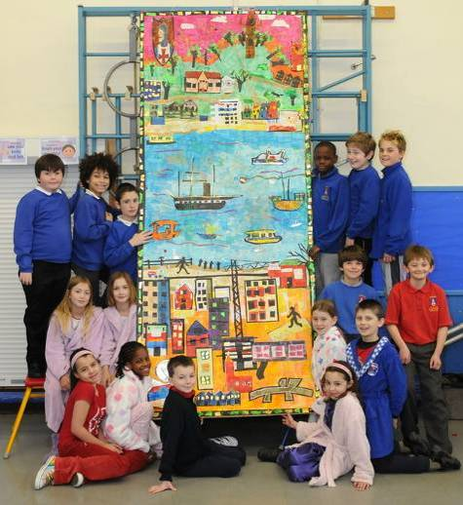
St George Primary School pupils wearing pyjamas on National Reading Day

St George Primary School’s collage

We made the banner by sticking on small strips of tissue paper and then covering it with glue. Then the whole class split into three groups and each one planned a different part of Bristol. One group planned the harbour, one the city and the other group our locality, Brandon Hill. We chose important landmarks that we all knew well and felt were an important part of our city. We looked on the internet for pictures of these and then sketched them. We hope that this banner will encourage people to visit Bristol. We also hope that it will help people to understand how we feel about our city and the special things in it.

St George Primary School’s comic: sample strip

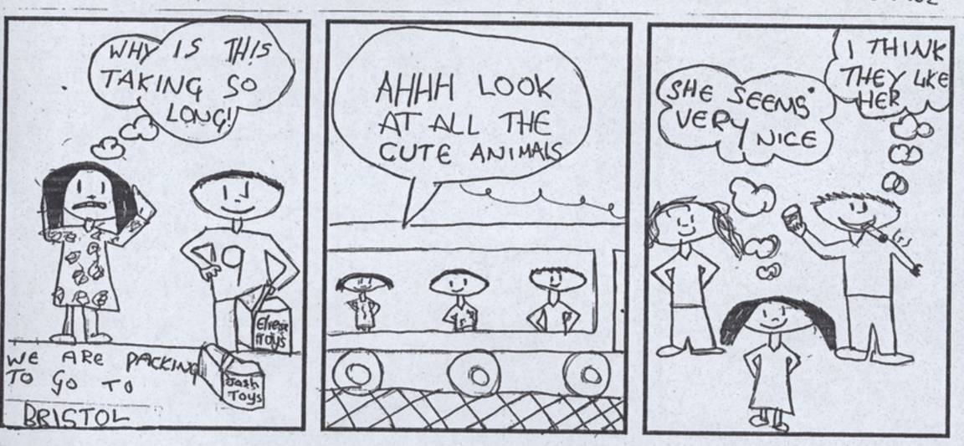

St George Primary School’s creative writing

The Myth of St George and Brandon’s Hill
By: Mig, Sean, Kyle, Dani, Taylor, Chazz and Claire Williamson

A long time ago in the dry ages, there was a town called Bristol. It was as flat as a table in the King’s dining room. The weather was always sunny. So sunny, that it was really hard to see. There was an awful drought.

All the water had been drunk. All the plants had been eaten, even the sheep had no grass to nibble. The soil was hard and dry like lava. Everyone in the town was slowly dying of thirst.

There was a boy called George who was servant to the king of Bristol. He wore raggy hand-me down clothes and his hands were dirty, scabby, bleeding and worn out from all the work he did. One day George looked out of the castle window and saw that all the plants had died and he was so thirsty, dying and desperate, that he started to cry.

As his tears hit the stony ground, it sounded like drums beating. The ground shook like an earthquake and huge cracks appeared in the land. Out of one of the cracks rose an enormous blue shape, like a tsunami.

‘Oh my! What’s that?’ shouted George. He ran to the edge of the castle walls, but couldn’t escape the humongous, gigantic, sweaty, sticky head of what appeared to be a dragon.

‘Peace!’ said George, ‘I don’t mean you any harm.’

‘I heard you crying,’ said the dragon, ‘I thought I could help.’

‘How can you help?’ Asked George.
‘I’m a special dragon with water pumping through my veins. I can bring water to the land.’

‘What’s your name?’ Asked George.

‘My name is Brandon,’ said the dragon, ‘What’s your name?’

‘It’s George,’ said George.

So Brandon began to fill the cracks with water. The biggest crack was called the Avon Gorge because it was gorgeous. As soon as the water hit the ground the plants began to luminate green. Trees began to stretch up towards the sky and buds burst open like exploding fireworks.

When the water and plants returned everyone in the town cheered, ‘Whahooo!’

The towns people were so thirsty that they scooped up the fresh water and some dived into the new rivers and lakes. Chew Valley Lake and Blagdon Lake were formed and the ponds of Eastville Park were born. Ducks and swans paddled on the water and there was a peaceful feeling to everyone in the town.

‘Thank goodness for George’, said everyone, ‘He saved us!’

The king called him to the palace and gave George a golden sword, as a reward.

‘Always use this special sword,’ said the king.

‘Wow!’ said George, ‘This is the most fantastic thing I have ever had. I will treasure it always.’

George used the sword to cut down plants and trees to feed the people of Bristol, including the poor people; like he used to be.

George and Brandon used to enjoy chatting together and sharing each others jokes. They were the best of friends. George would scratch Brandon’s itchy bits with his golden sword.

Everyone loved George, until one day the king called him to the palace and said:
‘George, you have to do something about this dragon. You need to use that special sword I gave you to slay the dragon, because he is flooding Bristol. We will soon be swimming in water and it will be all your fault.’

So George went home and thought hard about a plan. The last thing he wanted to do was kill Brandon.

George went to bed feeling glum. He was so upset, he was weeping in his sleep. He dreamt of an amazing hill right in the middle of Bristol.

When he woke up the next day, George went to talk to Brandon about his dream and the king’s request. Brandon was very upset that the king had told George to kill him.
But George had an idea that made Brandon feel better. It wasn’t the best solution, because George and Brandon wouldn’t be able to see each other, but they could still have their chats.

George called his best, strongest, unbelievably muscley, determined friends together and they began to disguise Brandon as a hill. They covered him in grass. They covered his spikes with plants and hedges. They made paths over his scales and a wood over his legs.

The water that was still trickling from Brandon was made into a fresh, clean sparkly waterfall, which ran into a pond. Brandon’s head was at the bottom and his nostrils made Jacob’s Well.

But there was one problem, his tail was sticking out of the top of the hill.

So they decided to make a tower around it, so people wouldn’t know that Brandon was there. This is now called Cabot Tower.

The king called George to his castle once more. George was worried, because he was scared that the king would execute him for not killing Brandon.

The king asked George for the golden sword back. George’s heart was beating so fast, he thought he was going to faint.

The king said, ‘Bow your head before me.’

He thought the king was going to behead him with the golden sword. George felt ashamed, but instead of cutting off his head, the king said: ‘I knight thee Saint George, protector of Bristol. Arise St. George.’

The king thanked him for making such a wonderful, maginificent, spectacular hill in the middle of the city.

He added: ‘When I die, you can be king of the city, but meanwhile I will build a school in your name. It will be called ‘St George’s Primary, Brandon Hill.’

George used to spend his lunchtimes sitting on the hill, talking to Brandon. Their motto was: ‘Forward together, knowledge, skills and attitudes for life.’

We know that Brandon is still there because his breath pulls the tide of the River Avon in and out as he sleeps.

George never became king, but he is still remembered by all the children that go to St George’s Primary on Brandon Hill.

George did kill a dragon once, but that’s another story...
Spring on the Hill
By: Green Dragon Class

It is Spring on Brandon Hill
Every tree silent and still
Pink, red, white blossoms budding
Over rocks, little waterfall flooding.

Squirrels scuttle, looking for food
Animals enjoy a cheerful mood
The sun in its afternoon hours
Makes a silhouette of Cabot Tower

The amber sun bows-out over Bristol town
Rings the sky like a golden crown
The nightime stars glow silver lining
Tiptoeing, the baby foxes pining

The oldest foxes of the wood
Scavenging for any food
Behind the restaurants, in trash bins
Munching on crusts, licking leftover tins

Baby foxes crunching May bugs
Slurping slimy, squishy slugs
Lamps flood paths with golden light
Dawn chorus calls the end of night

The foxes find their deep-den holes
Hiding away with badgers and moles
The sleeping city yawns and stretches
Pigeons come and sit on benches

The mist swept away by the day
As workers walk in the sun’s rays
Every tree was silent and still
For it was Spring on Brandon Hill

Bristol is Our Home

Chocolate and Concorde
Wallace and Gromit
Leroy Lita the footballer
Pero’s and Banana Bridge
Bristol, Bristol is our home

Great Western Railway
Boxkite and buses
Cables and cartoons
Self-raising flour
Bristol, Bristol is our home

Cabot Tower
Robots and blankets
Films about butterflies
Giants and dinosaurs
Bristol, Bristol is our home

Pirates in Bristol

In the 1600s Barbary pirates started building ships
building ships
building ships

The most fearsome of all were the Barbary pirates from North Africa
most fearsome of all
most fearsome of all

Barbary pirates based themselves on Lundy Island in the Bristol Channel
Lundy Island
Lundy Island

They raided towns and villages around the channel
raided the towns
raided the towns

and lurked outside ports
outside ports
outside ports

waiting for merchant ships
merchant ships
merchant ships

so they could carry off cargo and crew
cargo and crew
cargo and crew

Dinosaur in Bristol: a drama script by Year 6 pupils

Did you know?

Know what?

Know this?

What?

That Bristol...

Yes?

Bristol...

Yes?

has it’s own dinosaur!

(Pause)

Don’t believe you.

It’s own dinosaur. You see...

Where?!

It was called Theco - donto - saurus

Theco - what?

Theco - dont - o - saur - us

Saw us?

Thecodontosaurus. AND - it lived over 200 MILLION YEARS AGO!

Are you sure?

When most of the area was under water. AND...

Yes?

It was discovered in Clifton...

In Clifton?

Yes, Clifton. In 1830

1830?

Yes, 1830.

Right.

(Pause)

Where is it now?

St Mary Redcliffe and Temple Secondary School

Two groups totalling 54 pupils aged 11 to 12 took part in Portrait of a Nation from St Mary Redcliffe and Temple Secondary School. This mixed, Church of England state school has around 1,500 pupils and includes a sixth form. Redcliffe was a separate township until the 13th century when a bridge was built across the river, linking it to the rest of Bristol. The presence of the magnificent St Mary Redcliffe church, parts of which date from the 12th century, suggests this could once have laid claim to being the city’s true centre.
Ofsted Report Description, June 2007:

The school is much larger than average. It has been a specialist humanities school since 2004 and this is reflected strongly in many aspects of the school’s curriculum and in its positive contributions to the community. The majority of students are White British; a larger proportion than average are from mixed race and minority ethnic families. The percentage of students entitled to free school meals is well below average though the socio-economic background of students is varied and a significant minority come from disadvantaged backgrounds. The percentage of students with learning difficulties and disabilities and the number with a formal statement of special educational needs are well below average. Students’ attainment on entry to the school is generally above average.

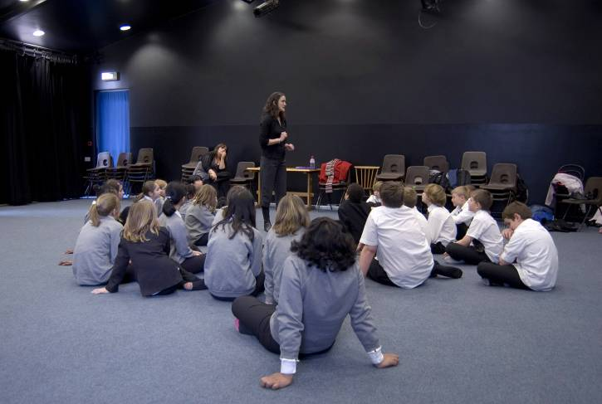
St Mary Redcliffe and Temple students during a drama workshop

The school was unable to find sufficient free slots within the pupils’ timetable to make a collage, so their sessions were re-allocated to Weston Park Primary.

St Mary Redcliffe and Temple’s comic: sample strip

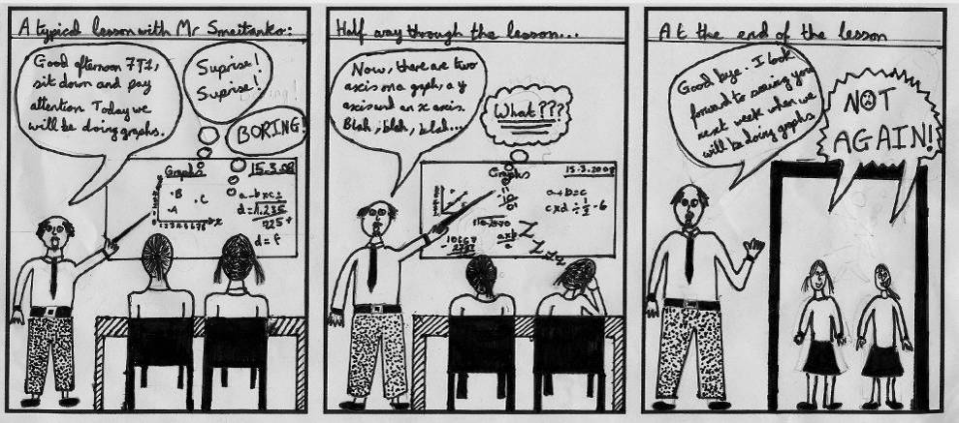

St Mary Redcliffe and Temple’s creative writing
This poem was written as a group poem by Year 7 students who then experimented with ways of speaking it aloud

Our City
Sitting by the docks
on dewy grass
looking at sun
gleaming on river water

A mass of thick green grass
tall urban buildings
with windows winking
in the background

The library opens
pages of letters in a neat line
a shelf of colours
strips ripped across spines

Bins tipped over
on pavements
horns beeping
wheels screeching

Rough uneven bricks
next to a heavy red wooden door
with a black iron handle
- come in

Blue, green, red graffitti
sprayed on a wall
messages from someone
outside school

Night-time in Bristol
blue lights
on the Suspension Bridge
standing out against the dark
Teyfant Community School

Teyfant Community is a mixed, non-denominational primary school of just over 400 pupils located in the large post-war housing development of Hartcliffe to the south-west of the city. Twenty-six pupils took part in Portrait of a Nation.

Ofsted Report Description, May 2005:

Teyfant Community School is larger than the average primary school. It serves a community of high unemployment and social need. It has 15 classes including; one Nursery class and two classes in each year group from Reception to Year 6. Because of its reputation for supporting pupils with special educational needs, it draws pupils outside its immediate catchment area. Attainment on entry is well below average. Pupils achieve well. The number of pupils who are eligible for free school meals is well above average at 42 per cent. The number of pupils who have special educational needs is also well above average at 43 per cent, and the number of pupils who have statements of special educational needs is also well above average at 3.2 per cent. The vast majority of pupils are white British with a small number of mixed race pupils.

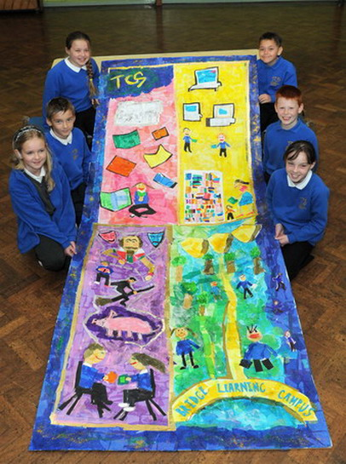
Teyfant Community School pupils with their collage

Teyfant Community School’s collage

The pupils at Teyfant wanted their collage to include reference to the literacy projects currently taking place at the school.

Teyfant Community School’s comic: sample strip

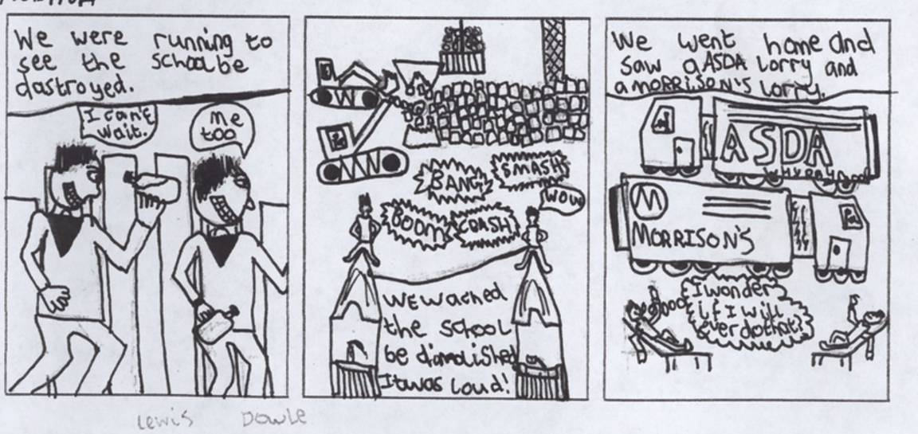

Weston Park Primary

As St Mary Redcliffe and Temple Secondary School was unable to fit in their allocated collage workshops, a 16th school was added to the project, Weston Park Primary. Thirty three children, aged seven to nine, made a collage and also had comic-book workshops. Weston Park is a mixed, non-denominational state school of around 230 pupils on the Lawrence Weston housing estate to the north-west of the city.

Ofsted Report Description, May 2006:

The school is working in challenging circumstances. A very high proportion of pupils are eligible for free school meals. The proportion of pupils with learning difficulties and disabilities is higher than in most schools. There are very few pupils from minority ethnic groups. When children start school, they have limited skills and knowledge.

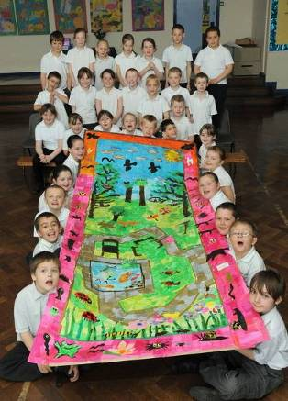
Weston Park Primary pupils with their collage

Weston Park Primary’s collage

Weston Park pupils used their collage to celebrate the local wildlife.

Weston Park Primary’s comic: sample strip

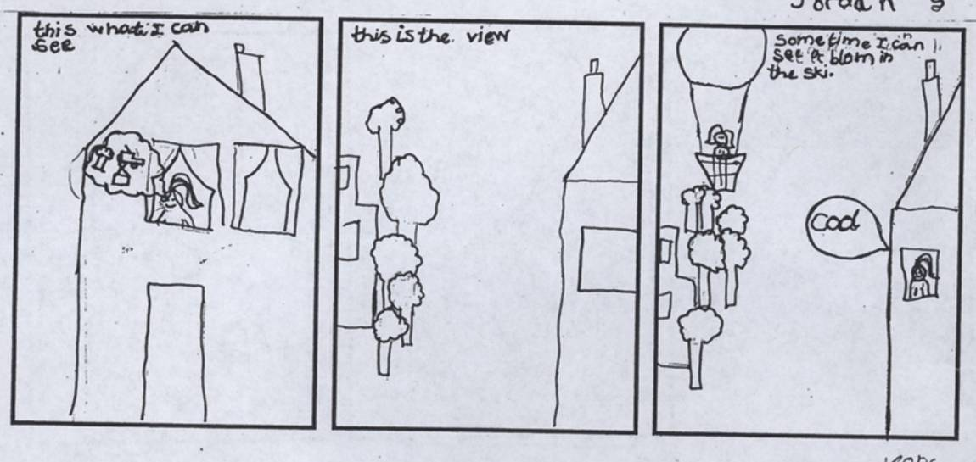
Half-term library workshops

As some of the schools were unable to take up their full quota of workshops, four two-part comic-book sessions were provided to local children during the half term holiday through branch libraries. These were located in Bedminster (a former Roman settlement south of the river, that was once a flourishing industrial area but suffered post-war decline); Bishopston (an area with a particularly large student population in the north of the city, and home of Gloucestershire County Cricket Club); Cheltenham Road (near the centre of the city); and Stockwood (in the south-east). Around 30 children attended in total.

Bedminster Library comic: sample strip

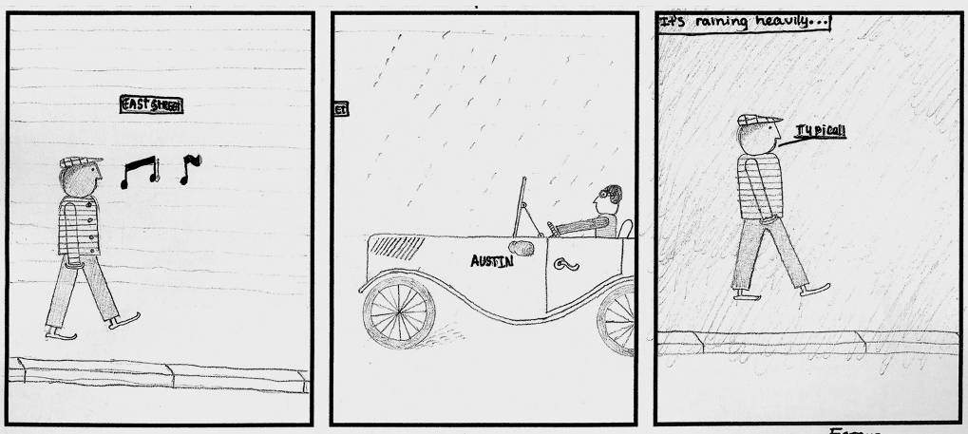

Bishopton Library comic: sample strip

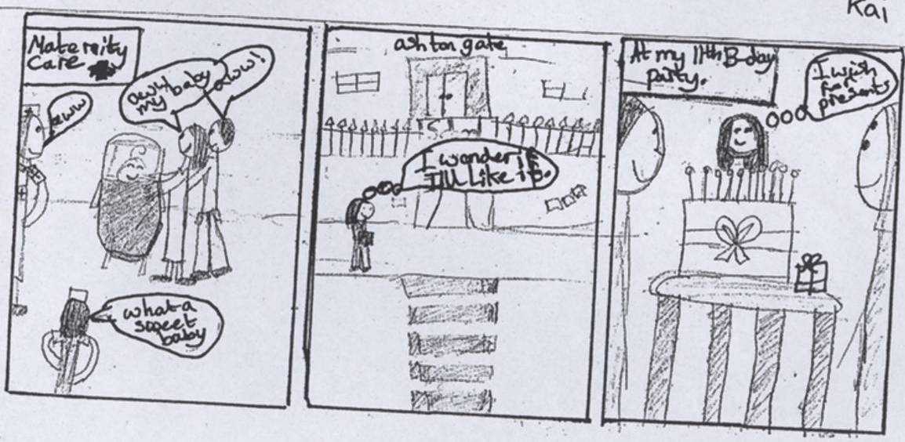
Cheltenham Road Library comic: sample strip

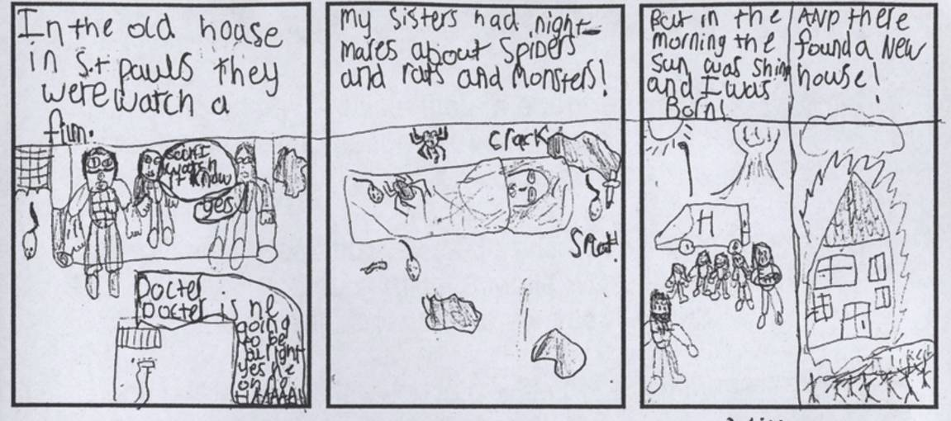

Stockwood Library comic: sample strip



