Small Island Read 2007

Mary Hoffman’s Amazing Grace

Activity Sheets

Pack Contents

Feedback Form – to be completed by pupils (may need adult assistance when writing comments).
Colouring Sheets – suitable for nursery and reception pupils. Could also be linked to research assignments for older children in which they find out about the characters depicted and the other parts Grace likes to play.
Puzzle Sheets – suitable for KS1 (Scottish P1-2) pupils. Test knowledge of the book as well as basic writing skills.
Question Sheet – could either be used in teacher-led group discussions at KS1 (P1-2), testing knowledge of the book, or as a starting point for self-directed talking opportunities/ small-group discussions with older pupils.
Migration Sheets – background information and activities suitable for KS1 (P1-2) and KS2 (P3-6).

In addition to the activities on these sheets, Amazing Grace can be used in the classroom in discussion and activity on the themes of self-esteem, gender and race, treating others with respect, what makes us special, sharing stories across different generations, who we look to for support and encouragement, and the importance of having goals. Although the book is classified as being suitable for KS1 reading levels (P1-2), it would also be useful for Gifted and Talented and KS2 (P3-6) pupils in providing a basis for small-group discussions and ‘hot-seating’ in which the pupils themselves take the lead in asking each other questions prompted by what they have read.

As Grace loves dressing up and acting out stories, the book could also be used to encourage children to use their imagination to act out and share their own favourite stories.

FEEDBACK FORM

Please encourage all your pupils to give us their feedback by helping them each fill in this form once they have read the book and done some or all of the activities. Please return completed forms to Bristol Cultural Development Partnership, Leigh Court, Abbots Leigh, Bristol BS3 3RA.

Did you like Amazing Grace?

Yes □ No □

Why?

Did you like doing the activities in this pack?

Yes □ No □

Why?

Do you think you have learnt something about slavery and migration?

Yes □ No □

Why?

Thank you for your help.

AMAZING GRACE COLOURING SHEET 1

Grace pretends to be Hiawatha. Hiawatha is a character in a long poem written in the nineteenth century. He is a Native American. Here’s a picture of a Native American for you to colour.

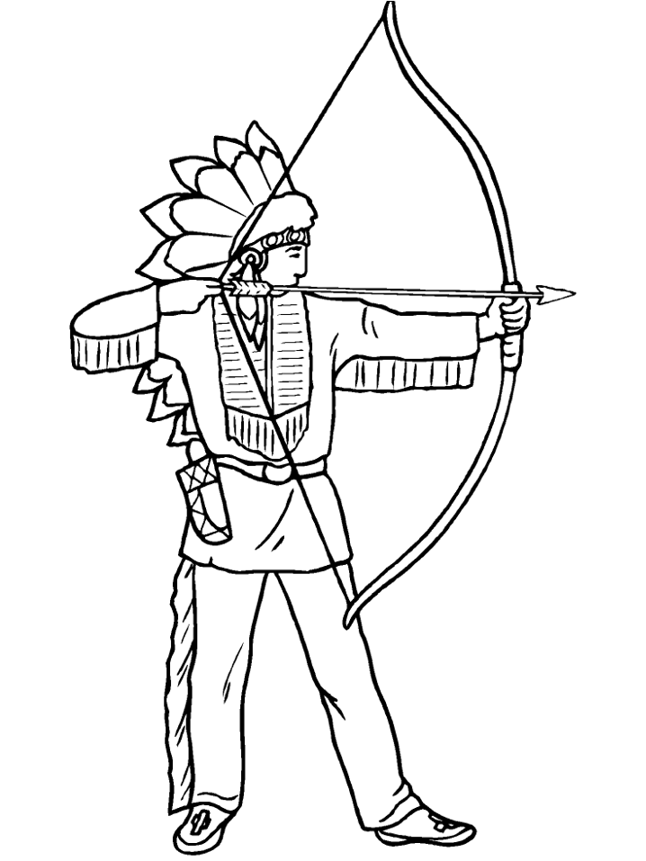
From the http://www.coloring.ws/about_us.htm website.
AMAZING GRACE COLOURING SHEET 2

Grace wants to play the part of Peter Pan. Peter Pan is the boy who never wants to grow up and who lives in Never Land. Here is a picture for you to colour of Peter Pan fighting with his enemy Captain Hook in the cartoon version of the story.

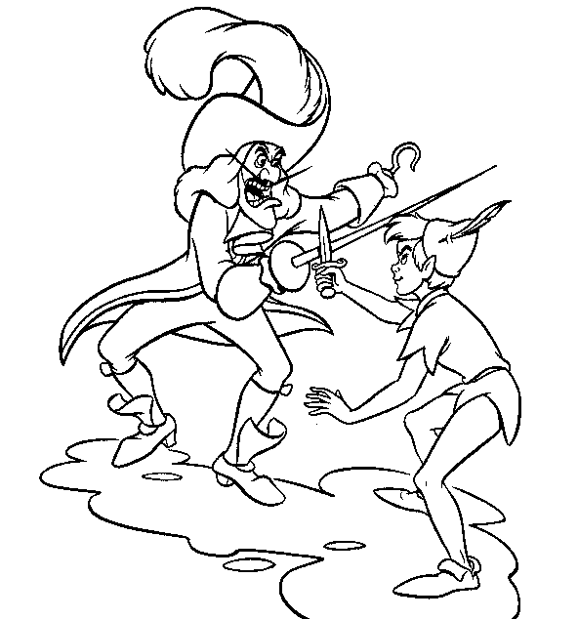

From the http://www.kidscolorpages.com/ website.
AMAZING GRACE COLOURING SHEET 3

Grace plays the part of Anansi the spider. Anansi is a popular character in African folk tales. He is clever and cunning and he likes to play tricks. Here’s a picture of a spider to colour. Draw on to the picture the place where you think the web is hanging.

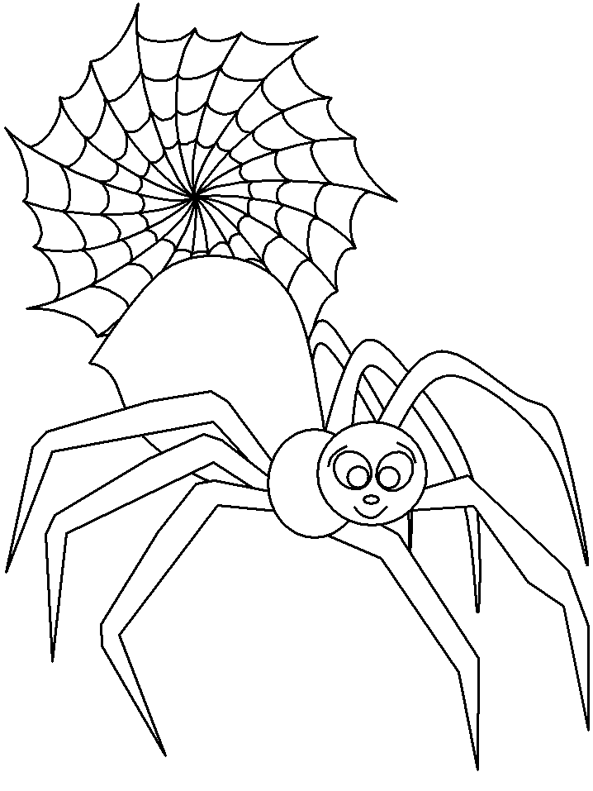
From the http://www.coloring.ws/about_us.htm website.
AMAZING GRACE PUZZLE SHEET 1

Circle the names of parts Grace plays in this book.

ALADDIN CINDERELLA ROBIN HOOD MOWGLI

RAPUNZEL JOAN OF ARC HIAWATHA SIMBA
_______________________________________________________________

Decide whether these sentences are true or false.

Grace gave herself the most boring parts. TRUE/ FALSE
Grace pretended to be a doctor. TRUE/ FALSE
Grace’s cat was called Claw-Claw. TRUE/ FALSE
Nana grew up on the island of Trinidad. TRUE/ FALSE
Natalie was going to play the part of Wendy. TRUE/ FALSE
The play was not a success. TRUE/FALSE
_______________________________________________________________

Make six sentences about what happens in the book. Each sentence has one phrase from columns 1, 2 and 3.

1 | 2 | 3
Grace was | she could fly | on Monday.
Sometimes Nana | took place | liked stories.
Natalie said that | a girl who | on Saturday.
Grace and Nana | Peter Pan was | all the way home.
The auditions | and Ma | not black.
Grace felt | went to the theatre | joined in.

1.

2.

3.

4.

5.

6.
_______________________________________________________________
AMAZING GRACE PUZZLE SHEET 2

Fill in the grid using the clues below and find the secret word in the shaded column.

1
2
3
4
5
6

1. Grace wanted to play the part of _ _ _ _ _ _ _ _.
2. The ballet dancer was called _ _ _ _ _ _ _ Wilkins.
3. Hannibal crossed the Alps with a _ _ _ _ _ _ _ elephants.
4. Grace pretended the _ _ _ _ _ _ was a jungle.
5. Grace hid in the _ _ _ _ _ _ horse at Troy.
6. Raj had the part of _ _ _ _ _ _ _ Hook.
_______________________________________________________________

In this passage from Amazing Grace, all the punctuation is missing. Write the passage out again, putting the punctuation back in. Don’t look at the book to check your answer until you’ve finished!

you cant be called peter said raj thats a boys name but grace kept her hand up you cant be peter pan whispered Natalie he wasnt black but grace kept her hand up all right said the teacher lots of you want to be peter pan so well have to have auditions well choose the parts next monday
_______________________________________________________________

Look at the big picture in the book of the children putting up their hands. There’s Raj, Grace and Natalie sitting together. There’s also a boy in a yellow T-shirt, a girl in a spotted dress, a boy in a stripy top and a boy in a hat with their hands up, and another girl and boy who are looking away.

Imagine there is a ‘think’ bubble above each of their heads. What do you think they are each thinking at this moment?
_______________________________________________________________

AMAZING GRACE QUESTION SHEET

- Grace loves all kinds of stories. Where does she get her stories from?

- Grace also likes to act the stories out. What are some of the parts she likes to play? Why do you think she likes these parts?
- What is your favourite story? Why do you like it?
- Grace uses her imagination to pretend she is different people. What does the word ‘imagination’ mean? When do you use your own imagination?
- Grace wants to play Peter Pan. Why do Raj and Natalie say she can’t play the part? Do you think they are being fair to Grace by saying this? Why?
- Grace still keeps her hand up. Why doesn’t she put it down again?
- Ma tells Grace that Peter Pan is always played by a girl in pantomime. How does Grace feel when Ma tells her this?
- Why do you think Ma starts to get angry when Grace tells her what Natalie said? What does Nana say to make things better?
- Nana takes Grace to the theatre. Why do you think she wanted to show Grace the ballet dancer?
- Grace dances round the room like the ballet dancer. What has she learned about herself by going to the ballet?
- Everyone votes for Grace to be Peter Pan. Why did they choose her?
- Nana says if Grace puts her mind to it she can do anything she wants. Grace’s goal is to play Peter Pan. What are some of your goals? Write a short story or draw a picture that shows how you would achieve one of your goals.

AMAZING GRACE MIGRATION SHEET 1

Grace’s Nana grew up on the island of Trinidad in the Caribbean.

Many people have come from the Caribbean to live in Britain. We use the word ‘migration’ to describe the movement of people between places.

The picture below shows a young Caribbean boy arriving at Victoria station in London in 1962.

Look at him as he walks down all those steps carrying his big suitcase. What do you think he is thinking? He might be excited about coming to Britain and curious about what he will find here. He might also be a bit frightened about being in a new country and sad to have left people behind in his old home.

Write a poem to go with this picture.

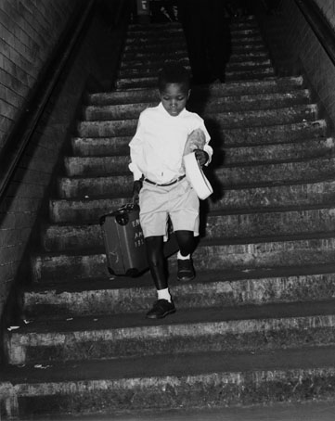

Image courtesy of Science and Society Picture Library/ NMPFT Daily Herald
AMAZING GRACE MIGRATION SHEET 2

People have been migrating to Britain for thousands of years.

When the last Ice Age ended 12,000 years ago nobody was living in Britain as it had been too cold. Gradually people moved here from around the world and made it their home. They are still moving here today.

Here are the names of just a few of them:

Afghans
Malaysians
Argentinians
Zambians
Indians
Normans
Guyanese

Germans
Romans
Albanians
Cambodians
Ethiopians
Mexicans
Algerians
Russians
Yemenis

Hungarians
Omanis
Finns
Fijians
Malis
Armenians
Nicaraguans

So Britain is made up of lots of different people from different countries, different races and different cultures, with different religions, different ways of speaking, different food and many other differences. What makes them the same is that they are all human beings.

People also migrate around Britain so you may be born in Bristol, but your parents may have moved there from Liverpool and your grandparents may have come from Hull and your great-grandparents may have come from Glasgow. So you’ve a little link to all these places inside you.

Get together with your classmates and find out all the different places, here and abroad, where you and your family or the people that you live with have come from.

Now mark on the maps the places around the world and in Britain where you have links. Look in an atlas to help you find where the places are.

AMAZING GRACE MIGRATION SHEET 3

MAP OF THE WORLD

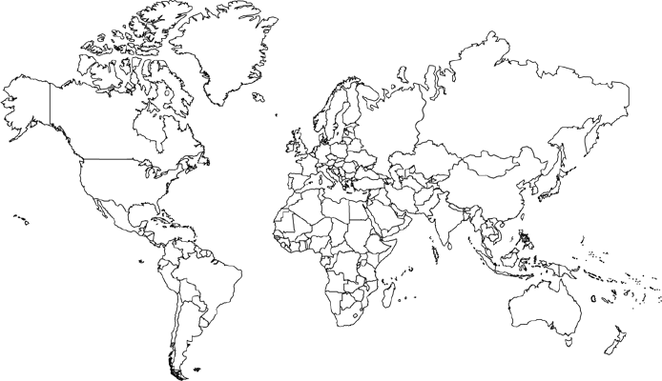
AMAZING GRACE MIGRATION SHEET 4

GREAT BRITAIN AND NORTHERN IRELAND
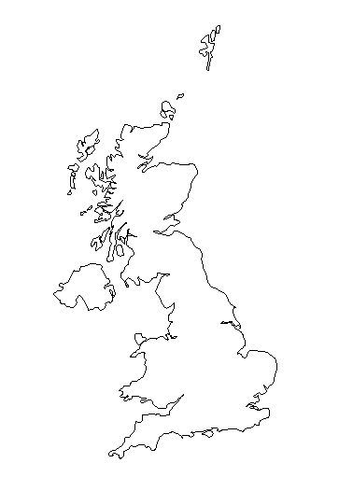
AMAZING GRACE MIGRATION SHEET 5

Some people choose to migrate between places. Some people have no choice at all.

In the seventeenth and eighteenth centuries millions of Africans were carried by ship across the Atlantic Ocean from Africa to the islands of the Caribbean. They had been captured and taken away from their homes to work on the Caribbean sugar plantations as slaves. This was called the Transatlantic Slave Trade. Nana is probably descended from enslaved people. Britain stopped being part of the Transatlantic Slave Trade in 1807, two hundred years ago.

Some of the enslaved people from Africa were only little children.

Olaudah Equiano was born in an African village. When he was a boy he was captured by raiders from a neighbouring kingdom and sold to slave traders. He was taken across the Atlantic in a horrible, stinking ship. He was sick and miserable, and the sailors beat him. He was first taken to Barbados in the West Indies and then to Virginia in America. He was bought by a man in the British Navy. He learnt how to read and write, and when he grew up he wrote his story, telling people of all the cruel things that had been done to him and all the terrible things he had seen.

Olaudah Equiano was someone like Grace who put his mind to it and did what he wanted to do.

Although it was hard and it took him many years, he was able to save enough money to buy his freedom. He came to live in Britain where he worked to end the slave trade. He knew he was good at talking to people and so he travelled around the country making speeches about what a wicked thing the slave trade was. And because he never gave up and because he used his talent, he helped to stop the Transatlantic Slave Trade.

Imagine you are taken away from your home and family, and carried off upon a slave ship to a strange land thousands of miles across the sea. What would you think about and do to give you hope and courage?

