AMAZING GRACE COLOURING SHEET 1

Grace pretends to be Hiawatha. Hiawatha is a character in a long poem written in the nineteenth century. He is a Native American. Here’s a picture of a Native American for you to colour.

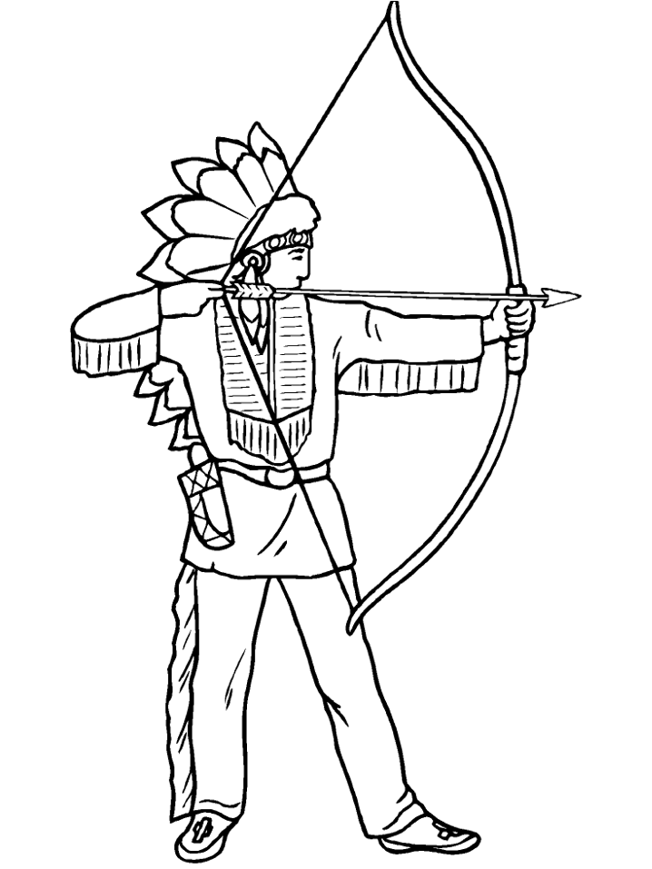
From the http://www.coloring.ws/about_us.htm website.
AMAZING GRACE COLOURING SHEET 2

Grace wants to play the part of Peter Pan. Peter Pan is the boy who never wants to grow up and who lives in Never Land. Here is a picture for you to colour of Peter Pan fighting with his enemy Captain Hook in the cartoon version of the story.

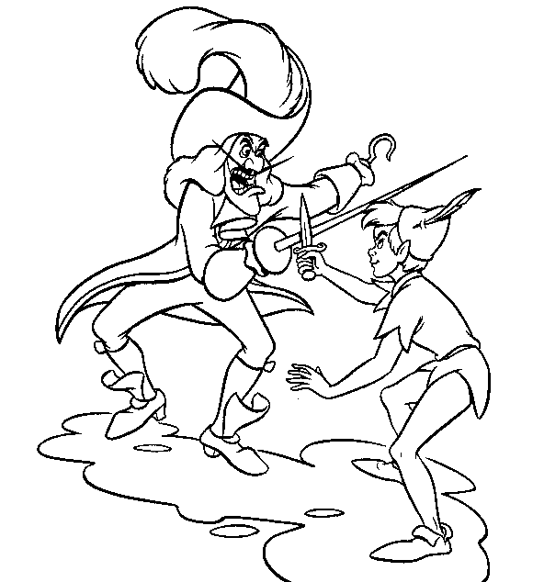

From the http://www.kidscolorpages.com/ website.
AMAZING GRACE COLOURING SHEET 3

Grace plays the part of Anansi the spider. Anansi is a popular character in African folk tales. He is clever and cunning and he likes to play tricks. Here’s a picture of a spider to colour. Draw on to the picture the place where you think the web is hanging.

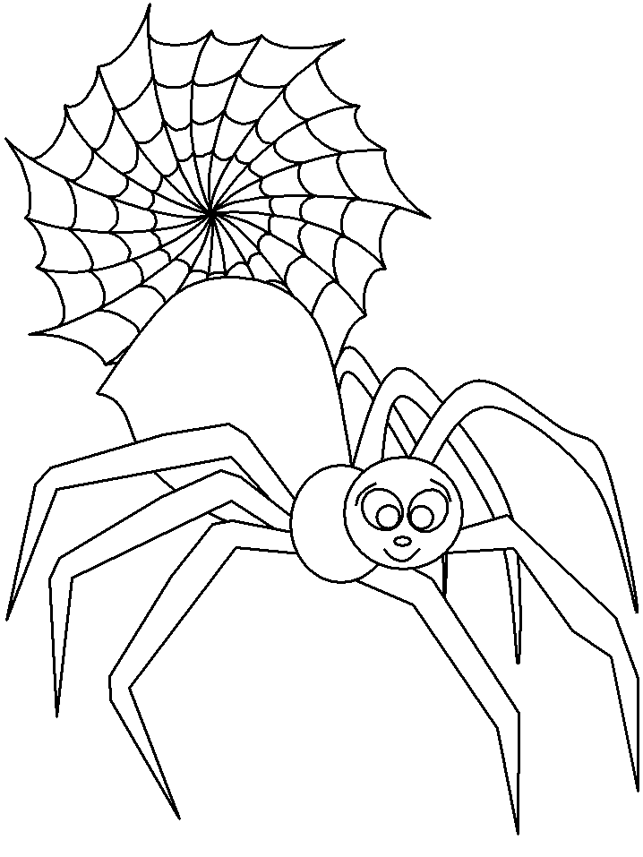
From the http://www.coloring.ws/about_us.htm website.

