AMAZING GRACE MIGRATION SHEET 1

Grace’s Nana grew up on the island of Trinidad in the Caribbean.

Many people have come from the Caribbean to live in Britain. We use the word ‘migration’ to describe the movement of people between places.

The picture below shows a young Caribbean boy arriving at Victoria station in London in 1962.

Look at him as he walks down all those steps carrying his big suitcase. What do you think he is thinking? He might be excited about coming to Britain and curious about what he will find here. He might also be a bit frightened about being in a new country and sad to have left people behind in his old home.

Write a poem to go with this picture.

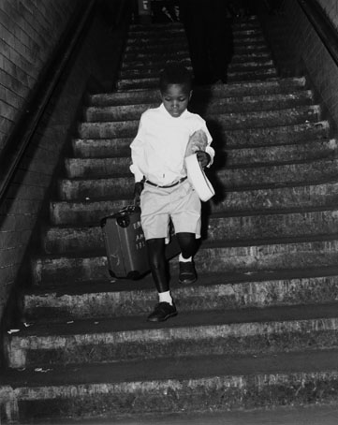

Image courtesy of Science and Society Picture Library/ NMPFT Daily Herald
AMAZING GRACE MIGRATION SHEET 2

People have been migrating to Britain for thousands of years.

When the last Ice Age ended 12,000 years ago nobody was living in Britain as it had been too cold. Gradually people moved here from around the world and made it their home. They are still moving here today.

Here are the names of just a few of them:

Afghans
Malaysians
Argentinians
Zambians
Indians
Normans
Guyanese

Germans
Romans
Albanians
Cambodians
Ethiopians
Mexicans
Algerians
Russians
Yemenis

Hungarians
Omanis
Finns
Fijians
Malis
Armenians
Nicaraguans

So Britain is made up of lots of different people from different countries, different races and different cultures, with different religions, different ways of speaking, different food and many other differences. What makes them the same is that they are all human beings.

People also migrate around Britain so you may be born in Bristol, but your parents may have moved there from Liverpool and your grandparents may have come from Hull and your great-grandparents may have come from Glasgow. So you’ve a little link to all these places inside you.

Get together with your classmates and find out all the different places, here and abroad, where you and your family or the people that you live with have come from.

Now mark on the maps the places around the world and in Britain where you have links. Look in an atlas to help you find where the places are.

AMAZING GRACE MIGRATION SHEET 3

MAP OF THE WORLD

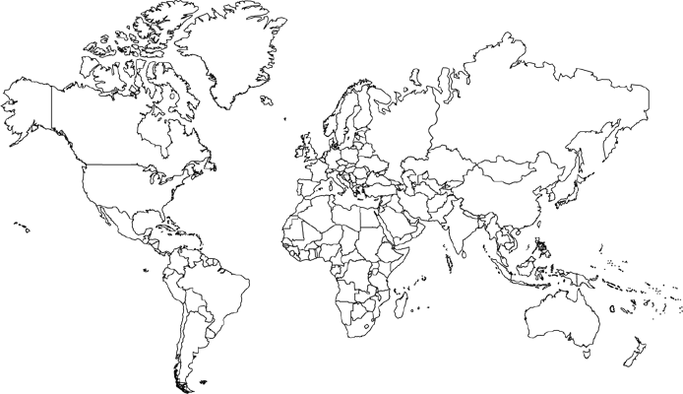
AMAZING GRACE MIGRATION SHEET 4

GREAT BRITAIN AND NORTHERN IRELAND
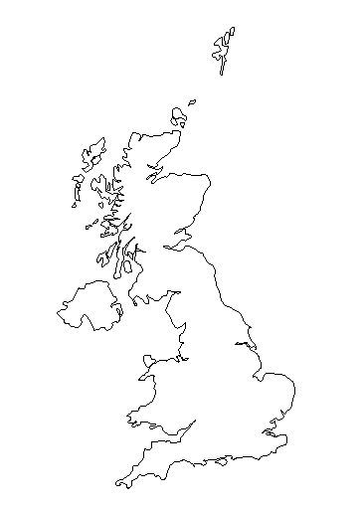
AMAZING GRACE MIGRATION SHEET 5

Some people choose to migrate between places. Some people have no choice at all.

In the seventeenth and eighteenth centuries millions of Africans were carried by ship across the Atlantic Ocean from Africa to the islands of the Caribbean. They had been captured and taken away from their homes to work on the Caribbean sugar plantations as slaves. This was called the Transatlantic Slave Trade. Nana is probably descended from enslaved people. Britain stopped being part of the Transatlantic Slave Trade in 1807, two hundred years ago.

Some of the enslaved people from Africa were only little children.

Olaudah Equiano was born in an African village. When he was a boy he was captured by raiders from a neighbouring kingdom and sold to slave traders. He was taken across the Atlantic in a horrible, stinking ship. He was sick and miserable, and the sailors beat him. He was first taken to Barbados in the West Indies and then to Virginia in America. He was bought by a man in the British Navy. He learnt how to read and write, and when he grew up he wrote his story, telling people of all the cruel things that had been done to him and all the terrible things he had seen.

Olaudah Equiano was someone like Grace who put his mind to it and did what he wanted to do.

Although it was hard and it took him many years, he was able to save enough money to buy his freedom. He came to live in Britain where he worked to end the slave trade. He knew he was good at talking to people and so he travelled around the country making speeches about what a wicked thing the slave trade was. And because he never gave up and because he used his talent, he helped to stop the Transatlantic Slave Trade.

Imagine you are taken away from your home and family, and carried off upon a slave ship to a strange land thousands of miles across the sea. What would you think about and do to give you hope and courage?

