Our Stories Make Waves

An artists’ collective of playwrights, painters, film makers, musicians, singers actors poets, performers, currently based in the South West region and formed in 2005. OSMW provide creative and innovative Projects for public performance, Exhibition, and Education.

Previous project: Brunel 200 Making Waves (see www.brunel200.com)

Current project Arts Council England funded I WITNESS project

In partnership with the Great Reading Adventure, OUR STORIES
MAKE WAVES delivered 16 OPEN SUITCASE school assemblies and 12 follow up workshops in drama, clay modelling, creative expression
writing.

Participating schools: Sefton Park Infants,
Hannah Moore,
St George’s Primary
Colston Primary
Cheddar Grove primary
Elmlea Primary School
Parsons Street Primary
Oldbury Court Primary
Red Maids Junior School
St Matthias and Dr Bell Primary
Fair Furlong Primary
St Barnabas Primary

Cotham School
Colston Girls School
St Bernadette’s School

OPEN SUITCASE 1 Valerie Mower and Ruth Pitter

‘We devised 3 interactive drama pieces
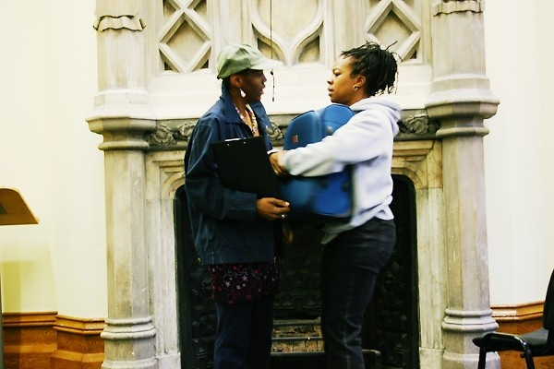

‘We devised 3 interactive drama pieces based on Small Island, Refugee Boy and Amazing Grace books, covering themes of journey, loss, identity, self esteem and racism. The pieces were visually performed by us using speech, cloth and song. Throughout the performances we engaged the students to talk about the impact of the drama they were witnessing, and encouraged discussion on the issues raised.’

OPEN SUITCASE 2 Valda Jackson and Ros Martin
Using scarves, props we brought to life three generations of Bristol people’s own stories: INEZ, a grandmother, FAUSA a mother and BOBBY’S.
On the theme of dreams, students were taken on journeys to see what happened to each person’s dreams.
Each story lent itself to each of our READING ADVENTURE books.
Music played opening and closing assembly: ‘Refuge’ courtesy of Alphonse Daudet Touna.
I STAND TALL

I stand tall,
Tall in the shadows of ancestors
I carry myself.
My head held high.
Dauntless
and undeterred by others penetrable gaze.
I distinguish myself
Only by repeatedly resisting
Others need to define and control
How or what I should not be.

An affirmation repeated by all the children at the end of the assembly

(P.S Remember: Let no-one destroy your dreams)
Ros Martin 2004

WORKSHOPS

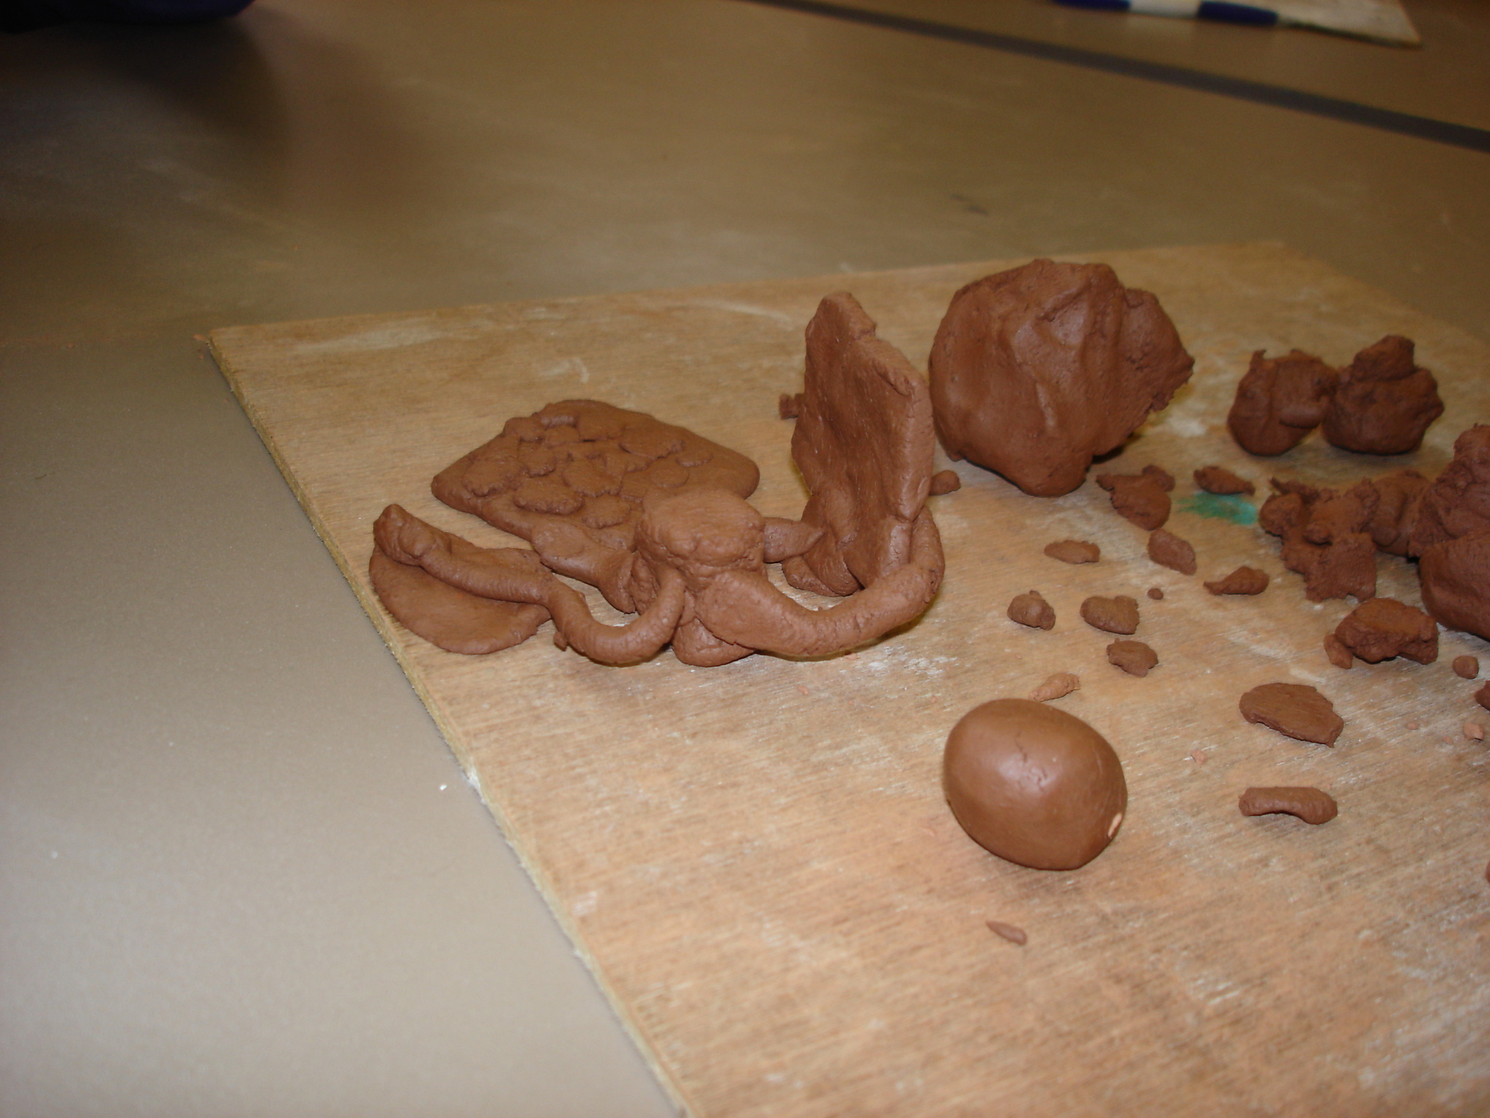

‘Our precious things’ Work from a year five class at Colston Primary School. Students spent a long time diligently modelling objects precious to them only to find at end of the lesson they were told to destroy them.
Message: What you leave behind when seeking asylum in another country
; how you have to build a new life from scratch.

Senses of Freedom

In table groups, capturing student’s creative expressions of freedom.

‘It tastes like:
melted chocolate with biscuits,
feels like:
bubble-bath,
looks like:
lovely food,
smells like:
fresh bread
Sounds like:
a peaceful day in the countryside.’

‘Laughing babies dipped in melted chocolate, it smells of watermelon with a kitten on top’.

‘it smells like: a beautiful rose, tastes like: chocolate melting. It feels like …dripping , it sounds like: relaxing wind’

St Barnabas Primary School year 6.

DRAMA WORKSHOP Hannah Moore school

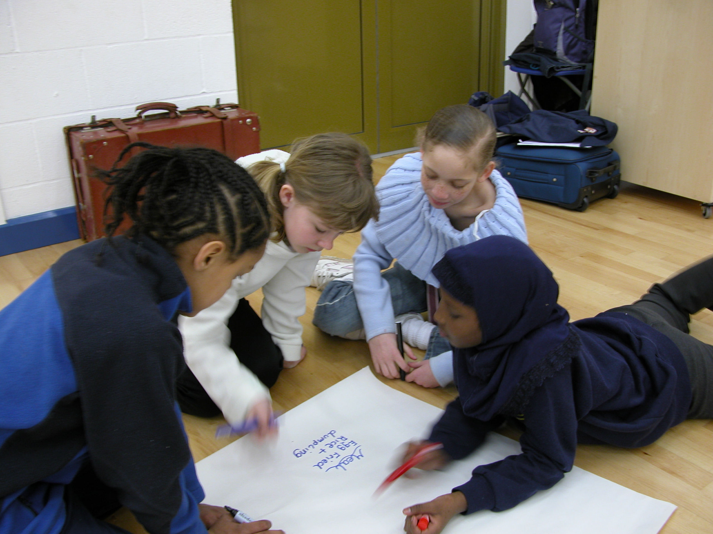

FEEDBACK:

I felt positive excited and thoughtful because she got her thoughts feelings and memories.
It was really interesting.

Students at Oldbury Court Primary School.

Thank you for your lovely assembly, I loved it. You taught us about leaving home and refugee and hopes for the future. Memories are very special too. I leaned a lot of things.

Student Cheddar Grove Primary

A good learning experience we will be doing more role play to address the issues from Refugee Boy.

Teacher St George Primary school

