Tales from the City...
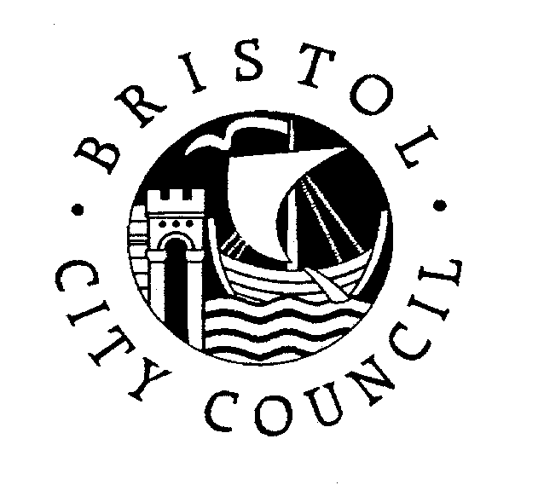

a celebration of writing from young people in Bristol schools - 2007
INTRODUCTION

‘Tales from the City’ is a project designed to recognise and celebrate the best writing of Bristol’s schoolchildren.

All schools are invited to submit pieces of writing from their pupils or students on the subject of Bristol. A hundred or so will be chosen, presenting a range of aspects of our city and written by a range of children of different ages. These will be published in a glossy, professionally produced booklet. Booklets will be distributed to the successful entrants, to each school and to the community (libraries, businesses etc.).

A ‘Gala Celebration’, to which all the ‘authors’, with their parents and teachers, will be invited, is to be held in July.

All the information you need is in the ‘Suggestions for Writing Activities’ and ‘Guidance for Submitting Entries’ sheets. They explain the project in more detail and provide some ideas and information to get you started. There is also an application form for you to copy.

Bristol CYPS is linking up with the University of the West of England in developing the project. We see this as the beginnings of an annual event – one that will benefit literacy, and writing in particular, in all of the Bristol schools.

So please do take a look at the materials in the packs and at the suggestions and information about entries. You will see that there is plenty of scope for your children to have some fun with this.

If you would like all of this information electronically, or if you would like further information at this stage, then do get in touch with me or with Jayne Chaplin-Wyatt, my admin assistant.

I really do hope your school will take part in what is a most exciting venture.

Yours sincerely,

Bryan Webster
English and Literacy Adviser
0117 9031262
bryan_webster@bristol-city.gov.uk

Tales from the City...

a celebration of writing from young people in Bristol schools - 2007

SUGGESTIONS FOR WRITING ACTIVITIES

Writing may include fiction and non-fiction, literary and non-literary, poetry and prose.

Topics for writing should include Bristol in some way, e.g.:

- Bristol today.
- The communities that make up Bristol.
- The geographical areas of Bristol.
- Historical Bristol.
- Bristol’s contribution to the world.
- Features of life in Bristol.
- Personal reflections about Bristol.
- What Bristol has to offer.
- Bristol’s famous sons and daughters.
- Bristol’s sites and sights.

The writing submitted can take a wide range of forms, e.g.:

- An historical report on an interesting event.
- A description of a well-known place, event, or even of the changing faces of the city at different stages in its development.
- Biographical writing about a famous, ‘infamous’ or inspirational Bristol resident
- A real or imaginary diary entry that captures a flavour of life in the city.
- Creative writing or poetry that explores the rich and varied ‘lives’ of people and places.
- Newspaper reports capturing key events in the city’s history.
- Discursive writing – about aspects of Bristol life.
- Persuasive writing – perhaps a repost to a newspaper article about the city’s problems.
- Comparative writing – now and then – how things have changed.
- Personal writing i.e. experiences of living, studying, working in, or simply visiting the city (whether as a long time resident or as a recent arrival).

The above are suggestions and we hope that nothing will limit the imagination of the young people in our schools.

If at all possible schools are encouraged to submit a range of pieces/genres as this increases the likelihood that several pieces will be selected.

Other, non-written, submissions:

- We welcome original digital photography. It should be of a high resolution and submitted as a paper copy and on disk/CD.

- Design ideas. Each of the pages in the booklet that will be produced will have design features – images of Bristol or the events, characters, ideas that are on the pages. Pupils may suggest ideas for these designs – including a sketch (or a computer-designed page). Working on design ideas is more likely in secondary schools where Art and Design lessons and computer software lend themselves to it. Successful ideas will be used in the design of the booklet – with the images developed professionally. Successful page designers will, however, be acknowledged in the booklet that is produced and have the opportunity of attending the celebration event in July.

Helpful Hints and reminders:

- There will be about one hundred pieces of writing in the final booklet. It would be very helpful if each school could limit the number of entries, so that only the best written and most interesting are sent for selection.

- Consideration should be given to length. More substantial pieces may need to be edited. (It is better if the pupil does this) We will not have space for many stories or articles and it is likely that substantial pieces will need to be reduced to excerpts.

- Writing can be hand-written or word-processed. The winning pieces will be set for typing. Obviously, the judges will prefer entries that are easy to read.

- Unfortunately, due to the volume of entries, submissions will not be returned, so pupils should keep their own copies.

- See ‘Guidance for submitting entries’ for further entry details.

Finally, if you have any questions about your application(s), please contact Bryan Webster (0117 9031262) or e-mail bryan_webster@bristol-city.gov.uk )

